**Project Report**

**Staffordshire Ecosystem Assessment**

**February 2014**

Authors:

Oliver Hölzinger, Mark Everard

Prepared for:

Staffordshire County Council, Stoke-on-Trent City Council and the Staffordshire Local Nature Partnership

**Staffordshire Ecosystem Assessment**

Oliver HölzingerA and Mark EverardB

|  |  |
| --- | --- |
| A | Consultancy for Environmental Economics & Policy, 24 Central Plaza, 61 Mason Way, Birmingham, B15 2GE, [oliver.h@ceep-online.co.uk](mailto:oliver.h@ceep-online.co.uk) |
| B | Pundamilia Ltd, 2 Hollow Street, Great Somerford, Wiltshire, SN15 5JD, [mark@pundamilia.co.uk](mailto:mark@pundamilia.co.uk) |

**Suggested citation:**

Hölzinger, O. and Everard, M., 2014: *Staffordshire Ecosystem Assessment*. Staffordshire County Council, Stafford.

**Project partners:**

|  |  |  |
| --- | --- | --- |
| CEEP logo small | Pundamilia Ltd (Striped logo) | C:\Users\Oliver Hölzinger\AppData\Local\Microsoft\Windows\Temporary Internet Files\Content.Word\SBAP.JPG |
| SCClogocolour-1 | cid:0ef4092b-977e-4a44-97d4-35000282fc4b | C:\Users\Oliver Hölzinger\Desktop\A2trustsStaffs.TIF |
| Beschreibung: Natural England Beschreibung: Forestry commision | | |

# Executive Summary

**What is an Ecosystem Assessment?**

Ecosystem Assessment is a ground-breaking way to recognise the value of our national wealth. Our economy and individual wellbeing depend critically on the natural environment that provides us with food, water and raw materials and which provides services such as flood alleviation, climate regulation, recreational opportunities, physical and mental health benefits. It also provides attractive settings in which to live and work, drawing in investment.

The Staffordshire Local Nature Partnership (LNP) has a vision to make Staffordshire a more prosperous and healthy environment in which to live. The LNP believes that economic development can and must go hand-in-hand with protection of the County’s important environmental assets, as a core resource underpinning future wellbeing. Staffordshire’s natural environment is already widely appreciated for the way it supports the rural economy, aesthetic appeal and recreational assets, but it provides society with many more, often unrecognised, benefits beyond these.

We have tended to take the services that the natural environment provides for granted. This is largely because the economic value of the benefits provided is not known, or that their worth is not yet recognised. As a result, decisions affecting natural resources are not as well-informed as they should be, and many such decisions may be taken without realisation of dependencies on the services provided by ecosystems.

Economic tools for valuing the diverse services that nature supplies have been developed over recent years. The UK National Ecosystem Assessment (UK NEA), the first phase of which was published in June 2011, was a global first analysis of the value of a nation’s natural environment in terms of the benefits it provides to society, including its contribution to continuing economic prosperity.[1]

Since 2011, substantial further research and assessment has been undertaken. The Staffordshire Ecosystem Assessment is the first of its kind for a mixed urban and rural county, and has been adopted as a case study for the National Ecosystem Assessment Follow-On (NEAFO) programme.[2]

**What has been valued?** **- Examples of ecosystem services**

Figure I.1 Examples for Ecosystem Services

**Provisioning Services**

**Cultural Services**

**Regulating Services**

**Food**: Ecosystems provide the conditions that support the growing of food.

**Raw materials:** For example timber to construct furniture and for woodfuel.

**Fresh water:** Ecosystems provide surface and groundwater and affect water quality.

**Wild species diversity:** Ecosystems provide everything that an individual plant or animal needs to survive. Species diversity supports medicine and agriculture.

**Recreation:** Accessible greenspace offers an opportunity for recreation, sports, etc. which influences physical health.

**Aesthetic Values & Sense of Place:** People benefit from a views and experience of beautiful landscapes which also improves mental health.

**Climate regulation:** Vegetation captures and stores carbon; trees and greenspace mitigate high temperatures in urban settings.

**Moderation of extreme events:** Ecosystems create buffers against natural hazards such as reducing flooding events by flood storage and slowing water run-off.

**Water and air quality improvement:** Micro-organisms and plants capture and decompose pollutants from air and water bodies.

Note: The above is a selection of ecosystem services and not an exhaustive list.

*Source:* ***TEEB, 2010 and UK NEA, 2011.***

The overall aim of the Staffordshire Ecosystem Assessment was to calculate the value of as many services provided by as many natural habitats as possible within the geographical area of Staffordshire, including Stoke-on-Trent. This assessment incorporated the latest evidence and best practice.

However, it should be stressed that this is a baseline or preliminary figure as it has only been possible to value a proportion of ecosystem services for methodological or data limitation  reasons. These limitations also prevented quantitative valuation of some ecosystem services and, even for those ecosystem services assigned a monetary value, sometimes only a limited attribute of the service could be valued. The extent of this undervaluation is indicated in Figure 8.1. Because it was not possible to assign a monetary value to the majority of ecosystem services, the real value of ecosystem services in Staffordshire is likely to be significantly higher than the £112 million per annum calculated within this investigation. Furthermore, it is important to bear in mind that all derived economic values do not ‘put a price on nature’ but merely indicate the relative significance of the values that it provides, such as aesthetic appreciation or health benefits, many of which are essentially not economic commodities.

Figure I.2 Indicative Staffordshire Ecosystem Assessment Coverage



*Source:* ***Author assessment based on Haines-Young and Potschin 2008***

Ongoing work aims to fill some of these gaps so that decision making can be better informed. Nevertheless, this study indicates the magnitude of value provided to society by the natural environment, and which must therefore be included in wise decisions.

**Key messages arising from the Staffordshire Ecosystem Assessment**:

* The capitalised value of ecosystems in Staffordshire is at a minimum £7.19 billion (£2.15b - £43.74b).
* The value of carbon storage by woodlands is in the order of £1.5 billion; this value of wetlands is in the region of £600 million.
* At least £111.89 million (£67.89m - £218.17m) of ecosystem services are provided per year in Staffordshire.
* Food, energy & timber services alone provide £62.4 million per year.
* Recreation/aesthetic/educational services exceed £21.0 million per year.
* There are over 7 million visits to woodlands in Staffordshire each year.
* Flood regulation services across the county are worth around £14.5 million per year.
* The value of wild species diversity is over £10.0 million per year.
* Water quality regulation by wetlands is worth around £1.0 million per year
* The annual cost to health services in Staffordshire of physical inactivity is estimated as £18 million; nationally the Department of Health suggests that increased accessible open spaces could reduce healthcare costs by more than £2 billion a year.
* Monthly, or more frequent, use of urban greenspace may be valued at between £112 and £377 annually per person in terms of health benefits.

**Potential next steps:**

A range of ‘next steps’ is required to integrate this assessment of the true value of the natural world into governance processes, leading to more resilient, equitable and better value decision-making:

* Promote cross-sector working to integrate the value of ecosystem services into decision-making;
* Develop tools to support the integration of ecosystem values into the land-use planning system;
* Undertake trend and future demand analysis better to ‘future proof’ decisions;
* Explore the potential for creation of novel markets using emerging tools, e.g. Payments for Ecosystems Services (PES)[3];
* Create an ecosystem services supply and demand map, ideally in collaboration with stakeholders, to promote understanding and uptake;
* Analyse accessible greenspace for all residential areas in Staffordshire, highlighting areas of deprivation which may help redirection of investment in habitat creation or improved management;
* Work with the public health sector to maximise use and values of green spaces;
* Prepare a Staffordshire Green Infrastructure Strategy based on ecosystem services and the Ecosystem Approach;
* Undertake an i-Tree Eco assessment to take better account of the value of ecosystem services provided by street, park and garden trees;
* Investigate means of estimating values for the ecosystem services for which the report was unable to deduce a reliable monetary figure;
* Support research and development of measures for valuation of services provided by aquatic habitats, including developing relevant GIS data layers to support this analysis; and
* Explore opportunities where the protection, restoration or management of habitat can deliver the greatest value across multiple ecosystem services, in line with ‘systemic solutions’ principles.
* Factoring the value of the natural environment into ‘green growth’ strategies, such that opportunities for making use of nature’s services are identified and that these services and their net value to society are not eroded by short-term growth decisions.

# Acknowledgements

Many people provided valuable comments and statistical data for this study. The authors would like to thank all Steering and Advisory Group members (see Appendix C for full list) for their very valuable views and contributions. We also like to thank Natural England, Staffordshire County Council, Stoke-on-Trent City Council, the Forestry Commission and the Staffordshire Wildlife Trust for providing financial support for this project.

# Contents

I. Executive Summary 3

II. Acknowledgements 9

III. Contents 10

IV. Tables & Figures 11

1. Introduction and Background 12

1.1 Introduction and Objectives 12

1.2 The Methodological Approach and its Limitations 19

1.3 Staffordshire and its Ecosystems 25

2. Provisioning Services 32

2.1 Food & Bioenergy 32

2.2 Timber & Wood Fuel 37

2.3 Wild Food 39

2.4 Ornamental Resources & Non-food Products 41

2.5 Water Supply 43

3. Cultural Services 45

3.1 Recreation 45

3.2 Aesthetic Appreciation 48

3.3 Spiritual Services 52

3.4 Health benefits 53

3.5 Education 57

3.6 Economy & Employment 59

3.7 Wild Species Diversity 60

4. Regulating Services 65

4.1 Global Climate Regulation (Climate Change Mitigation) 65

4.2 Local Climate Regulation (Climate Change Adaptation) 68

4.3 Flood Regulation 69

4.4 Water Quality Regulation 73

4.5 Air Quality Regulation 75

5. Country Parks Subset 77

6. Stoke-on-Trent Countryside Sites Subset 82

7. Staffordshire Wildlife Trust Reserves Subset 87

8. Conclusion and Guidance 93

8.1 Key Findings and Interpretation 93

8.2 Recommendations and Conclusion 99

8.2.1 Practice & Policy 99

8.2.2 Research & Evaluation 104

8.2.3 Conclusion 108

9. Abbreviations 110

10. References 111

Appendix 121

A. Calculation of Wetland Benefits 121

B. Calculation of Benefits Provided by Habitats of Principle Importance 126

C. Steering & Advisory Group 134

# Tables & Figures

Table 1.1 Area of Habitats in Staffordshire 31

Table 2.1 Number of Livestock in Staffordshire 33

Table 2.2 Arable Crops Area in Staffordshire in 2010 33

Table 2.3 Arable Crops Yields per Hectare 2008 - 2012 34

Table 2.4 Arable Crop Yields in 2010 35

Table 2.5 Average Market Prices per Tonne for Selected Crops 36

Table 2.6 Food & Bioenergy Provision by Arable Fields 37

Table 2.7 Timber Provision by Woodland 39

Table 2.8 Wild Food Provision by Different Habitats 41

Table 2.9 Non-Food Products Provided by Different Habitats 42

Table 3.1 Recreational Benefits Provided by Woodland 46

Table 3.2 Recreational, Aesthetic & Biodiversity Values Provided by Wetlands 47

Table 3.3 Cultural Services Provided by Grassland, Heathland and Hedgerows 48

Table 3.4 Aesthetic Appreciation Provided by Urban (Fringe) Broadleaved Woodland 51

Table 3.5 Wild Species Diversity Benefits provided by Woodland 63

Table 3.6 Wild Species Diversity Benefits Provided by Wetland 64

Table 3.7 Wild Species Diversity Benefits of Grassland, Heathland and Hedgerows 64

Table 4.1 Flood Risk Regulation Benefits Provided by Wetlands 71

Table 4.2 Flood Risk Regulation Benefits Provided by Different Habitats 72

Table 4.3 Water Quality Regulation Benefits Provided by Wetlands 74

Table 5.1 Area of Evaluated Habitats in Staffordshire County Council Country Parks 79

Table 5.2 Annual Value of Ecosystem Services Provided by Assessed Habitats in Staffordshire County Council Country Parks 81

Table 6.1 Area of Evaluated Habitats in Stoke-on-Trent Countryside Sites 85

Table 6.2 Annual Value of Ecosystem Services Provided by Habitats in Countryside Sites 86

Table 7.1 Area of Evaluated Habitats in Staffordshire Wildlife Trust Reserves 90

Table 7.2 Annual Value of Ecosystem Services Provided by Assessed Habitats in SWT Reserves 92

Table 8.1 Annual Baseline Value of Ecosystem Services Provided by Assessed Habitats in Staffordshire 96

Table 8.2 Capitalised Baseline Value of Ecosystem Services Provided by Assessed Habitats in Staffordshire 97

Table A.1 Value Function and Corresponding Assumptions 124

Table A.2 Wild Food benefits provided by UK BAP priority habitats 129

Table A.3 Non-Food benefits provided by UK BAP priority habitats 130

Table A.4 Water regulation (flood regulation) provided by UK BAP priority habitats 131

Table A.5 Cultural services provided by UK BAP priority habitats 132

Table A.6 Wild species diversity benefits provided by UK BAP priority habitats 133

Figure 1.1 Examples for Ecosystem Services 16

Figure 1.2 Habitat Map for Staffordshire 27

Figure 1.3 Habitats Evaluated within this Ecosystem Assessment 29

Figure 3.1 Urban & Urban Fringe Woodland Buffers in Staffordshire 50

Figure 5.1 Habitats Evaluated within Staffordshire Country Parks 78

Figure 6.1 Habitats Evaluated within Stoke-on-Trent Countryside Sites 84

Figure 6.1 Habitats Evaluated within Staffordshire Wildlife Trust Reserves 89

Figure 7.1 Relative Importance of Broad Habitats in Delivering Ecosystem Services 105

Figure A.1 Public Accessibility of Wetland Sites >0.5 ha 123

# Introduction and Background

## Introduction and Objectives

In the UK, habitats, together with the many beneficial functions that they perform, are under pressure. Population increase, agricultural intensity, economic and urban development and climate change are some of the main drivers[4]. The State of Nature Report 2013, jointly prepared by 25 conservation and research organisations, shows that in the UK 60% of 3,150 species studied have declined over the last 50 years. Habitat loss and degradation is the main reason for this loss of biodiversity.[5]

The Staffordshire Local Nature Partnership (LNP) has the vision to make Staffordshire a more prosperous and healthy environment to live in and believes that economic development can and must go hand-in-hand with protection of the County’s important environmental assets. One priority objective identified by the LNP is to enable effective working partnerships between the environmental, economic, health and social sectors to improve decision-making and make the most of the green environment.[6] One of the key action points identified as important to partner organisations was to develop an Ecosystems Approach[7] to the Staffordshire Local Enterprise Partnership (LEP) development plan. The objective is to ensure that sectors, organisations and departments which are usually not involved in environmental management and conservation recognise the true value of ecosystem services and the importance of ecosystem services to their activities. Ecosystem services are commonly defined as *“the benefits people obtain from ecosystems”*[8]*.* An ecosystem can be defined as the community of living organisms and non-living components such as air and water. An ecosystem can, for example, be a water catchment, a woodland patch or even a single tree.

The aim of this research project is to seek to identify and where possible to quantify the value of ecosystem services provided by rural and urban habitats in Staffordshire[9]. Particular attention has been given to the guidance for undertaking an Ecosystem Assessment[10] which has been produced within scope of Work Package 10 of the National Ecosystem Assessment Follow-On project (NEAFO). This project therefore also constitutes a case study within the wider NEAFO programme, and incorporates the latest evidence and best practice from science and implementation.

The value of ecosystem services has been assessed in three steps:

1. Where available scientific evidence and data permit it, the value of ecosystem services has been calculated in monetary terms.[11] In this context, monetary valuation reflects the contribution of ecosystems to aspects of human wellbeing. Monetary values should not be considered as a ‘price for the environment’, but as a means to compare the contribution of different environmental processes to human wellbeing.
2. Where monetary valuation was not possible, indicative values with associated uncertainties have been determined. Sometimes, case study examples have been outlined to explain the value of a particular ecosystem service.
3. All values have been supplemented by a qualitative assessment outlining the links between ecosystems and human wellbeing. This qualitative assessment has also been undertaken for important ecosystem services where quantitative evidence about their value is missing.

Monetary values have been assessed for ecosystem services for a set of broad habitat types. More details about the broad habitat categories used and the extent and location of such habitats are given in Section 1.3. These values are summed up to produce a total indicative value. As it is impossible to deduce reliable monetary values for all ecosystem services or for all habitats, the findings of this study should be interpreted as conservative and incomplete, but nonetheless indicative of the relative scale and tendency (negative or positive) of the value of such services. The overall aim of this project was to provide a conservative minimum value rather than a maximum, potential or exact value. Monetary values have been calculated both as an annual value and as a capitalised value over 200 years. Furthermore, a sensitivity analysis has been applied to take uncertainty and risks into account. The following Section provides more details about the methods and assumptions.

This report also provides an assessment of the services provided by the Country Parks owned and managed by Staffordshire County Council and Stoke on Trent City Council as a sub-set of the information provided for the Staffordshire geographical area in Chapter 0. A similar sub-set has been provided for a selection of Staffordshire Wildlife Trust Reserves in Chapter 7.

The UK Government endorses the use of the Ecosystem Approach and the ecosystem services framework to improve decision-making across societal interests, for example as articulated by the June 2011 Natural Environment White Paper *The Natural Choice*[12]. This Ecosystem Assessment for Staffordshire builds upon the government-sponsored UK National Ecosystem Assessment (UK NEA)[13]. The UK NEA, published in June 2011, was based on the founding principles of the UN’s Millennium Ecosystem Assessment (MA)[14] published in 2005, many of the principles of which have been incorporated and refined by The Economics of Ecosystems and Biodiversity (TEEB)[15] in 2010. The ecosystem services framework and examples for ecosystem services are summarised in Figure 1.1.

The European Environment Agency (EEA) also promotes communication of the diverse values of ecosystem services as a means to raise awareness as to why ecosystems are important and needed.[16] The opinion expressed by the Department for Environment, Food and Rural Affairs (Defra) is that

*“…the benefits the natural environment provides are not yet valued properly in policy and project appraisal across government.”*[17]

This investigation should be seen as a first step towards implementing the true value of nature and ecosystems into decision-making in Staffordshire. Many ecosystem services such as recreation, aesthetic and spiritual appreciation, amenity, habitat for wildlife or flood alleviation are not directly marketable, which leads to a general undervaluation of such services. Monetary valuation carried out by drawing assumptions that extrapolate from surrogate markets for these services highlights the quantum of value of such formerly unrecognised or undervalued ecosystem services. This renders them visible and tangible and therefore useable for decision-making purposes in both public policy and business decisions. This is one of the principal benefits of valuation of ecosystem services.

Figure 1.1 provides a non-exclusive overview of selected ecosystem services.[18] The Millennium Ecosystem Assessment[19] categorisation also included a category of Supporting Services, comprising functions such as nutrient cycling and water recycling as well as soil formation, which are critical and require protection but which are generally primary resources ‘producing’ the Provisioning, Regulatory and Cultural Services highlighted in the Figure. The reason for excluding Supporting Services from economic valuation is that they are not directly ‘consumed’ and therefore may elude monetary valuation, though ecosystem service valuation frameworks such as those used in the UK NEA and TEEB generally assume that their contribution to more directly consumed services incorporates some of their value. Such directly ‘consumed’ ecosystem services are also known as ‘final ecosystem services’.[20] However, the importance of the less tangible Supporting Services must not be neglected nor underestimated in governance decisions as ecosystem integrity, resilience and the production of all other services depend upon them.

Figure 1.1 Examples for Ecosystem Services

**Provisioning Services**

**Cultural Services**

**Regulating Services**

**Food**: Ecosystems provide the conditions for growing food.

**Raw materials:** For example timber to construct furniture and for woodfuel.

**Fresh water:** Ecosystems provide surface and groundwater.

**Wild species diversity:** Ecosystems provide everything that an individual plant or animal needs to survive.

**Recreation:** Accessible greenspace offers an opportunity for recreation, sports, etc. which influences physical health.

**Aesthetic Values & Sense of Place:** People benefit from a view on beautiful landscapes which also improves mental health.

**Climate regulation:** On the one hand vegetation captures and stores carbon; on the other hand it mitigates extreme high temperatures in urban settings.

**Moderation of extreme events:** Ecosystems create buffers against natural hazards such as flooding events.

**Water and air quality improvement:** Micro-organisms and plants remove and decompose pollutants from air and water bodies.

Note: The above is a selection of ecosystem services and not an exhaustive list.

*Source:* ***TEEB, 2010 and UK NEA, 2011.***

In general, we have a comparatively good understanding about the benefits that man-made ‘grey infrastructure’ provides to human wellbeing. Be it savings of x hours of travelling time each day in case of a motorway, the provision of housing for x people, or an expected profit of x for an industrial estate. All these benefits can be expressed quantitatively and in monetary terms because they are marketable.[21] Ecosystems also provide a wide range of benefits to human wellbeing, but beneficiaries do not have to reveal their real preferences for most of these goods and services through market prices. Environmental goods and services[22] are very often used in common and are non-exclusive. Usually, nobody has to pay a fee to access a country park, for experiencing the amenity of woodland, or making use of the air to breathe or dispose of exhaust gases. One can benefit from these services as a ‘free-rider’. This often results in the misjudgement that such ecosystem services are self-evident and without value. The high complexity of ecosystem interactions makes their value even more intangible and reinforces a tendency to undervalue them.

*“Because ecosystem services are largely outside the market and uncertain, they are too often ignored or undervalued…”*[23]

This undervaluation commonly results in degradation of the ecosystem that provide these services, leading in turn to a progressive undersupply, and finally to a decline of overall human wellbeing. Often the pace of decline is slow relative to the pace of electoral, business planning or other cycles, and so occurs imperceptibly as in the case of the progressive build-up of waste gases in the atmosphere threatening climate stability. Furthermore, incremental effects may be perceived as individually minor, yet cumulative effects can progressively override the capacities of ecosystems as in the case of diffuse pollution of many small spatial planning decisions cumulatively changing the hydrology of cityscapes and catchments.

This market failure should be compensated for by governmental institutions and regulations.[24] However, decisions – not only affecting the environment – have to cope with trade-offs and are very often based on cost-benefit deliberations generally related to more immediately marketable outcomes. In a case where the benefits of one ‘grey’ policy option is comparatively clear and tangible and of the other ‘green’ policy option being less certain and tangible, a justification of the first option is much easier and more defendable.

*“The full value of goods such as health, educational success, family and community stability, and environmental assets cannot simply be inferred from market prices, but we should not neglect such important social impacts in policy making.”*[25]

Economic valuation of ecosystem services serves to mitigate this information bias, and also makes the value of services provided by ecosystems more tangible for non-specialists. This in turn supports more far-sighted decision-making that better integrates these formerly overlooked values into everyday decision-making.

This report provides decision-makers, planners and other stakeholders with the most accurate and comprehensive Ecosystem Assessment at the county-scale anywhere in the UK, and maybe Europe and Worldwide.[26] This evidence base helps generate better understanding of the trade-offs inherent in decisions affecting ecosystems. Recommendations for how to best implement the value of ecosystem services in decision-making processes have been outlined in Chapter 8.2. These recommendations also cover potential follow-on projects.

The findings provided within this report may, for example, be used to inform planning and strategic land-use decisions in Staffordshire. For this purpose, the report should be considered in conjunction with the Supplementary Planning Guidance ‘Planning for Landscape Change’[27] and the Staffordshire Biodiversity Action Plan.[28] The Supplementary Planning Guidance does not explicitly refer to ‘ecosystem services’ but it implicitly requires new developments to mitigate negative impacts on (or enhance) the provision of ecosystem services such as visual amenity, recreation or wild species diversity.[29] The findings of this report may, for example, inform the impact assessment matrix[30], acknowledging the caveats of the research and the limitations when downscaling findings to the project level. The National Planning Policy Framework (NPPF) does make explicit mention of ecosystem services, and this study may inform their integration into regional and local planning.[31] Further examples for how this work can be used are outlined in Section 8.2.

## The Methodological Approach and its Limitations

The scope of this research project is comparatively wide. Its overall aim was to calculate the Total Economic Value (TEV) of as many ecosystem services provided by as many broad habitats as possible within the geographical area of Staffordshire. In this context, ‘economic’ does not equal ‘financial’; rather it signals how the impacts on human wellbeing are measured and expressed, potentially in monetary terms (which is quite distinct from putting a price-tag on the environment), but semi-quantitative or qualitative terms where this is not possible. Monetary value should be interpreted as a common denominator when comparing different policy-options influencing human welfare.

*“In considering the task of valuing ecosystem services an important distinction needs to be drawn between the terms ‘value’ and ‘price’. That they are not, in fact, equivalent is easy to demonstrate. Consider a walk in a local park. The market price of such recreation is likely to be zero as there are no entrance fees and anyone can simply walk in. However, the very fact that people do indeed spend their valuable time in parks shows that this is not a zero value good.”*[32]

The available scientific evidence does not allow for the full calculation of monetary values for the total range of services. Therefore, the monetary assessment has been accompanied by a qualitative evaluation. Monetary values presented in this report should generally be treated as a baseline minimum of the overall value.[33]

The ecosystem services valuation for Staffordshire and Stoke-on-Trent uses the benefit transfer approach[34], the findings of studies carried out elsewhere being transferred into the assessment with suitable precautions and assumptions.  This approach allows us to transfer values from other primary valuation studies to our specific context of Staffordshire. Where possible, adjustments regarding site-specific circumstances and socio-economic variables such as population density have been made to minimise transfer-errors. Carrying out original primary valuation studies is beyond the scope of this study, involving as they do extensive resources and lengthy timescales. The application of the chosen approach can be seen as a practicable and cost-effective way to implement the Ecosystem Approach in decision-making.[35] For more information about the benefit-transfer approach and how scientists calculate values for non-market ecosystem services (primary valuation studies) see for example Defra’s *Introductory Guide to Valuing Ecosystem Services*.[36]

Where possible, the marginal value for a change of ecosystem services provision has been calculated and then applied for the whole mapped area of ecosystems in Staffordshire. The marginal value, in contrast to a total value, reflects the value of a marginal increase or decline of ecosystem services. The total value of ecosystem services provided by ecosystems in Staffordshire can be assumed to be significantly higher. However, there is no realistic policy scenario causing the destruction of all ecosystems in Staffordshire. One can also argue that living in Staffordshire is impossible or at least entirely undesirable without the existence of ecosystem services. Therefore, it is logical to assess the marginal value of ecosystem service, as decisions and policies usually cause a marginal change in the provision of ecosystem services. Within scope of this investigation the marginal change usually relates to a marginal decrease or decline of habitat extent.

The approach applied intentionally leads to an under- rather than overestimation of ecosystem services values, which matches the principles of this research project.[37] The underlying assumption is that a marginal increase of ecosystems would occur where it could contribute most significantly to desired ecosystem services, whereas a loss of ecosystems would occur where it is likely to have the least negative impact.This means, for example, that a park would be established in an area where the provision of greenspace is deficient rather than where there is already an existing park. This should especially be acknowledged when interpreting the average per hectare values.

The relevance of, for example, substitutional greenspace[38] or the influence of distance decay[39] on the value of ecosystem services is still widely uncertain and strongly dependent on the ecosystem service being assessed. Using the example of climate change mitigation, the marginal and total value is almost equal[40] as it does not matter where around the world carbon is stored: it is the total amount of stored carbon that is important. On the other hand, a 20% decline of accessible greenspace, compared to a 10% decline, in Staffordshire would result in a disproportional decline of human wellbeing.[41] The two services have a different shape on the marginal value curve which relates to the extent of benefit provision. Climate change affects the global climate whilst recreational services usually occur locally, which makes the influence of substitutional greenspace much stronger. One could substitute for a carbon sink in Stafford by creating a carbon sink in Newcastle or even America, but the same does not apply for a recreational greenspace site. Developing and implementing policy tools incorporating the marginal value of ecosystem services provision on a spatial scale, as for example in the case for the development of carbon sequestration markets, should be seen as the logical next step to implement the ecosystem services approach in decision-making.

In this report, only valuation methods which comply with high scientific standards as well as the available evidence to date are applied. Nevertheless, the model contains some limitations. For example, related Willingness-To-Pay (WTP) techniques applied in primary valuation studies have their own imperfections such as the social desirability bias[42] or a potential inability of survey participants to perceive hypothetical markets and goods. Another limitation may occur from applying the benefit transfer approach. Usually, the study area (the primary valuation studies) and the policy area (in this case Staffordshire) are not entirely similar. Therefore, adjustments are needed for some socio-economic influencing variables such as income or population density as well as context (such as the availability of substitute habitats and services). Even if these adjustments are applied as thoroughly as possible, a benefit transfer error can never be ruled out. Some adjustments such as those for cultural differences give rise to considerable uncertainty, and indeed may not be practically possible. Further limitations are linked to general scientific uncertainties such as the future impacts of climate change. Further method-specific caveats are explained where relevant in the following chapters. For these reasons, calculated values should be regarded as essentially indicative of the magnitude and tendency (positive or negative) of the service, so the lack of a definitive value is not necessarily problematic.

To take uncertainties into account within this investigation, a sensitivity analysis has been applied. Using sensitivity analysis, every value is stated as a ‘best guess’[43] with a range, following best practice recommendations.[44] It should also be noted that the values produced in this study are gross rather than net values. Neither alternative land-use options nor the costs of land management, etc., have been considered.

A mistake often made when valuing ecosystem services is double counting, in which different benefits arising from the same service duplicate assessment of its value. The risk is even higher when valuing such a wide range of services as well as different habitats as in the present study covering the complete geographical area of Staffordshire. The ecosystem interactions as well as the relations between different services are characterised by high complexity. Therefore, particular attention has been paid to this issue. In case of doubt, calculations are conservative to maintain validity. This principle has been applied to the valuation of all ecosystem services.

Ecosystem services do not present the value of ecosystems for their own sake. Rather they reflect the benefits (and in some cases threats) to human wellbeing and are therefore an anthropocentric approach. This is the only practicable approach because *“non-anthropocentric value is, by definition, beyond any human knowledge.”*[45] But the anthropocentric approach is also a strength as the primary purpose of this and similar assessments is to influence human and social decision-making, very much embedded in a socio-economic context. But it should be kept in mind that the anthropocentric approach can involve for example existence values (non-use values)[46], option-use values[47] or bequest values[48] as a matter of course. However, incorporating some of these value-domains in an Ecosystem Assessment has been previously discussed controversial.[49] This will be considered and discussed in subsequent sections of this report.

The values of ecosystem services are not only stated as annual values; they are also stated as capitalised value over 200 years. To calculate the ‘net present value’ of future benefit, it is common and reasonable to apply a discount rate. This discount rate is used to convert the benefits to present values which make them comparable. For the purpose of this investigation, a discount rate of 1.5% has been applied to calculate the net present value of future benefits. Applying this discount rate has been recommended by the NEAFO Ecosystem Services Guidance[50], even if it is not consistent with the discount rate recommended by the UK Government.[51] However, the German Federal Environmental Agency also recommends applying a discount rate of 1.5%.[52]

HM Treasury recommends a discount rate of 3.5% for periods of up to 30 years. After 30 years this rate declines to 3.0%.[53] HM Treasury argues for the use of the real interest rate for long term low risk investments.

*“For individuals, time preference can be measured by the real interest rate on money lent or borrowed. Amongst other investments, people invest at fixed, low risk rates, hoping to receive more in the future (net of tax) to compensate for the deferral of consumption now. These real rates of return give some indication of their individual pure time preference rate.”*[54]

With the phrase *“hoping to receive”* they appreciate that there is still a risk surcharge involved. Another crucial point is that especially long term cross-generational valuations always imply political value judgements.[55]

*“Society as a whole, also prefers to receive goods and services sooner rather than later, and to defer costs to future generations.”*[56]

With this sentence, the authors of HM Treasury implicitly imply that *“to defer costs to future generations”* is a law of nature or is socially deliberate and/or accepted. However, in the context of the overall accepted concept of sustainable development and assuming that a government is not less responsible for future generations than for the current, even if future generations are not able to participate in decision-making (e.g. elections), this Treasury approach may not apply to ecosystems services.[57] There is also an implicit assumption within this that nature has no ‘tipping points’ beyond which ecosystem quality, character and service provision change radically; however, we know that these tipping points exist (as in the case of eutrophication of water bodies radically changing their ecology, and with it catastrophically degrading many services).

These factors determine that a long-term discounting approach is most ecologically relevant, equitable across generations and is also a well-supported approach. Hence, the discount rate of 1.5% recommended by the NEAFO for Ecosystem Assessments in the UK has been applied for the ‘best guess’ estimates. The discount rate recommended by HM Treasury has been applied to the lower threshold of the sensitivity analysis. However, to ensure transparency and comparability with other related publications within the UK, the ‘best guess’ values have also been stated applying the discount rate recommended by HM Treasury. For the upper threshold of the sensitivity analysis a discount rate of 0% has been applied, also adopting the recommendations of the NEAFO.

It should be stressed that, for capitalised values, a *ceteris paribus* future has been implied. This assumption states that all variables such as population density are set constant over time. If variables change, the capitalised value may change as well. Neither population growth nor the additional pressure caused by climate change has been considered in the capitalised value. Both can be expected to increase the values of ecosystem services over time due to resource scarcity considerations. In a *ceteris paribus* scenario such influences are not considered.

## Staffordshire and its Ecosystems

Staffordshire is situated in the West Midlands, mainly to the north of the Birmingham and Black Country conurbation, extending to the southern part of the Pennines. The county is mainly in the Trent River catchment, with the Trent itself arising to the northeast of Stoke-on-Trent. However the county is also an important watershed, with tributaries of the Mersey to the north, and of the Severn to the west. The total geographical area of Staffordshire is just above 2,700 km2 with a population of almost 1.1 million. A population growth of 4.2% is projected by 2021.[58] This is likely to put additional pressure on habitats and the provision of ecosystem services, especially in urban, urban fringe and green belt areas.

Staffordshire has a good representation of rural landscapes, urban districts and industrial heritage with an average population density of 405 per km2. Its reputation is as an industrial area, with pottery, fabric, iron working and coal mining industries, although many of these industries have declined. Staffordshire also includes substantial areas of countryside comprising a mixture of upland and lowland habitats including moorlands, meres and mosses, floodplain grazing marsh, ancient and semi-natural woodland, heathland and important geological features. Also, habitats in towns and cities should not be undervalued as they promote the wellbeing of large numbers of people by providing multiple benefits including opportunities for recreation, pleasant amenity, improved urban microclimate, and attracting investment as well as being important habitats for biodiversity. Nature conservation designations in place across the county include: 64 SSSIs (8,690 ha), 8 SACs (4000 ha), 4 NNRs (335.4 ha), 5 RAMSAR sites (424 ha), 43 LNRs (924 ha), 864 Local Wildlife Sites (11,432 ha) and 71 Regionally Important Geological and Geomorphological Sites (218 ha).

Habitat information for the geographical area of Staffordshire is based on a Phase 1 assessment carried out between 1995 and the present which has been provided by Staffordshire Ecological Record. This information has been accompanied by the latest National Forest Inventory (NFI) layer provided by the Forestry Commission and the Ancient Woodland Inventory (AWI) provided by Natural England.

The dominant land use in Staffordshire is agriculture, occupying 81% of the county, while urban land, mainly the conurbation of Stoke-on-Trent, accounts for 11% of the total area. The remaining 8% comprises heathland, woodland, forest, reservoirs, mineral workings and amenity land such as golf courses. Permanent pasture is the dominant agricultural land use, accounting for 47% of the total, and dairy farming is the main enterprise on 55% of all full-time farms. Arable crops account for 31% of the total, and this is the dominant land use in South Staffordshire and Lichfield Districts. Most agricultural land in the County is described by DEFRA as being Grade 3 (average quality), with small amounts of Grade 2 land (very good quality) in the south and west. Significant amounts of Grade 4 (poor quality) and Grade 5 (very poor quality) land are also present. This is concentrated in the north-east, in Staffordshire Moorlands District and the northern part of East Staffordshire District. This land has severe limitations, restricting the range of crops that can be grown. Most of the area between Stoke-on-Trent and the Peak Park is designated as a Less Favoured Area by DEFRA. The South-west Peak Environmentally Sensitive Area (ESA) also extends beyond the Peak Park boundary and covers a small part of the BAP area.[59]

Up-to-date data about the area of agricultural land has been provided by Defra. This does not completely match the mapped habitat area within scope of the Phase 1 assessment. For this analysis, the data provided by Defra has been used. Because the categorisation-systems of the Phase 1 habitat survey categories did not always match the broad habitat categories used for this Ecosystem Assessment, workable habitat categories have been defined and Geographical Information System (GIS) information has been aggregated. The total habitat area assessed within scope of the habitat interpretation and classification adds up to 1,268 km2, constituting 47% of the total geographical area of Staffordshire. Figure 1.2 provides an overview of broad habitat distribution. However, it should be noted that this assessment is incomplete and does not include under-recorded habitats such as bracken or private gardens.

Figure 1.2 Habitat Map for Staffordshire

© Crown Copyright and database rights 2013. Ordnance Survey 100019422.

You are not permitted to copy, sub-license, distribute or sell any form of this data to third parties in any form.

Use of this data is subject to the terms and conditions shown at www.staffordshire.gov.uk/maps.

Produced by Staffordshire Wildlife Trust

**Legend**

|  |  |  |
| --- | --- | --- |
| |  | | --- | |  | | Woodland |
| |  | | --- | |  | | Wetland |
| |  | | --- | |  | | Heathland |
| |  | | --- | |  | | Grassland |
| |  | | --- | |  | | Hedgerows |
| |  | | --- | |  | | Arable |
| |  | | --- | |  | | Water |
| |  | | --- | |  | | Other (parkland, open mosaic on previously developed land, rock) |

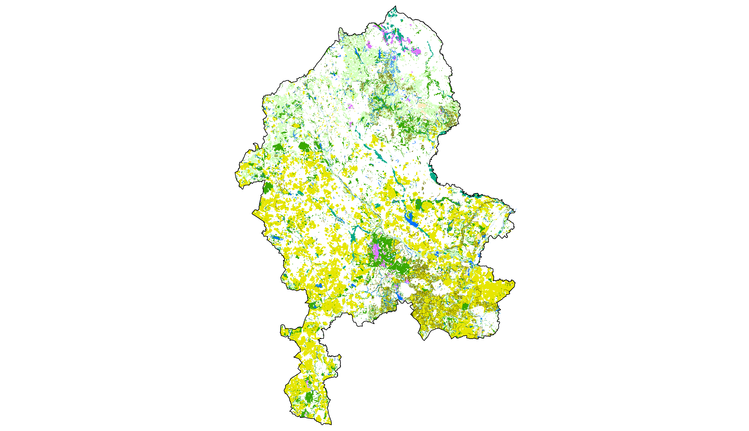

*Source:* ***Based on GIS data provided by Staffordshire Ecological Record, Staffordshire County Council, Stoke on Trent City Council, Natural England and the Forestry Commission.***

Available scientific evidence to date does not allow calculation of a robust monetary value for every ecosystem service provided by all of the habitat types in the County. Significant amongst the exclusions from this ecosystem assessment is ‘blue infrastructure’ including rivers, canals, open water and ponds, which the UK National Ecosystem Assessment, the UN Millennium Ecosystem Assessment, the Ramsar Commission and other authoritative sources suggest may be of substantial value both for multiple ecosystem services and also for the services provided by other adjacent habitats. Also excluded are 45% of the grassland habitats including semi-improved and amenity grassland.

The habitats evaluated within the scope of this Ecosystem Assessment are described along with their extent in Table 1.1. Some habitats, such as floodplain grazing marsh, fall within two habitat classes (wetland and grassland). To avoid double-counting, these habitats were included in only the most relevant habitat category used in this Ecosystem Assessment. The mapped assessed habitats are also shown in Figure 1.3.

Figure 1.3 Habitats Evaluated within this Ecosystem Assessment

© Crown Copyright and database rights 2013. Ordnance Survey 100019422.

You are not permitted to copy, sub-license, distribute or sell any form of this data to third parties in any form.

Use of this data is subject to the terms and conditions shown at www.staffordshire.gov.uk/maps.

Produced by Staffordshire Wildlife Trust

**Legend**

|  |  |  |
| --- | --- | --- |
| |  | | --- | |  | | Woodland |
| |  | | --- | |  | | Wetland |
| |  | | --- | |  | | Heathland |
| |  | | --- | |  | | Grassland |
| |  | | --- | |  | | Hedgerows |
| |  | | --- | |  | | Arable |
| |  | | --- | |  | | Habitats not included in the monetary evaluation |

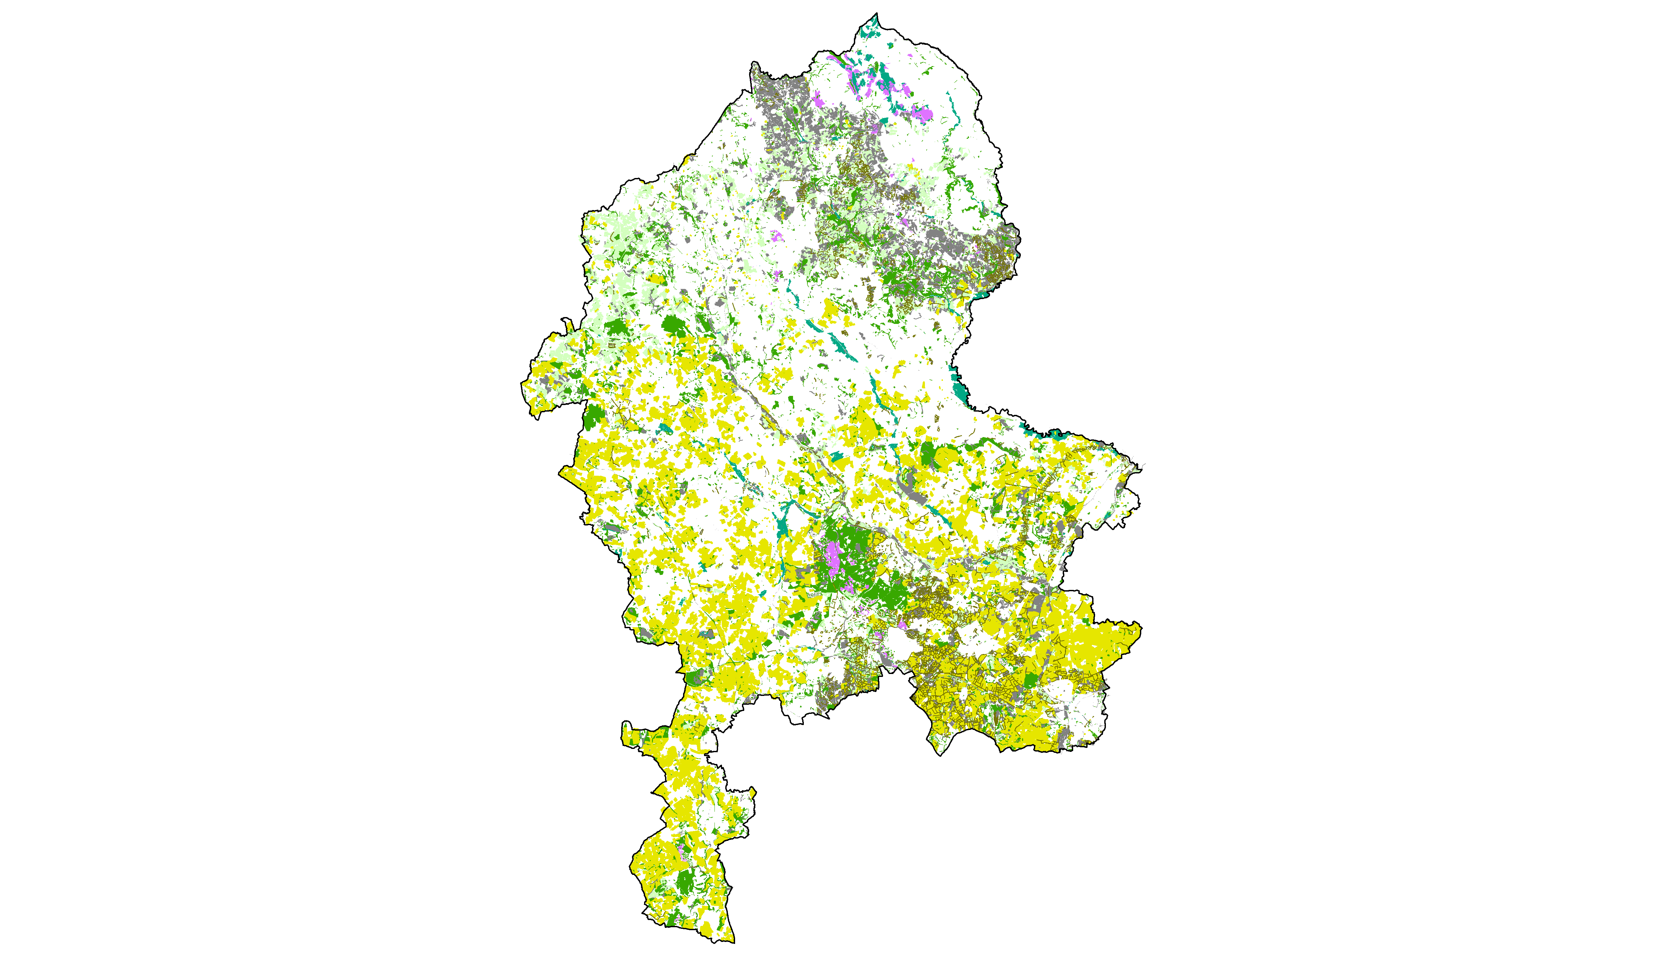

*Source:* ***Based on GIS data provided by Staffordshire Ecological Record, Staffordshire County Council, Stoke on Trent City Council, Natural England and the Forestry Commission.***

When comparing the two maps, one can see that not all of the habitats in Staffordshire have been assessed for the monetary analysis. However, the 95,603 ha assessed out of the total[60] 126,796 ha, represents more than 75% of the mapped habitats.

It should be acknowledged that the Ecosystem Assessment represents a minimum valuation of ecosystem services for the County. It is possible to assess a wider range of ecosystem services for some habitats than for others, and a complete evaluation of all ecosystem services was not possible for any habitat type. Where quantitative and monetary evidence is missing, such ecosystem services have been assessed in qualitative terms.

Table 1.1 Area of Habitats in Staffordshire

|  |  |
| --- | --- |
| **Broad habitat type** | **Area** |
| **Woodland** | **24,418.4 ha** |
| Broadleaved woodland | 15,196.6 ha |
| Ancient Semi-Natural Woodland (ASNW) | 3,028.3 ha |
| Other | 12,165.3 ha |
| Coniferious woodland | 5,781.0 ha |
| Mixed woodland | 1,137.7 ha |
| Shrub | 42.4 ha |
| Young trees | 1,385.8 ha |
| New planted woodland (assumed) | 878.0 ha |
| **Wetland** | **3,732.9 ha** |
| Inland marsh | 2,903.7 ha |
| Floodplain grazing marsh | 2,432.7 ha |
| Purple Moor-grass & Rush Pasture | 33.7 ha |
| Fens | 30.8 ha |
| Reedbeds | 1.9 ha |
| Mire | 88.6 ha |
| Swamp | 283.7 ha |
| Other | 32.3 ha |
| Peatbog | 829.1 ha |
| Blanket bog | 781,9 ha |
| Fen | 8,9 ha |
| Mire | 37,7 ha |
| Moss | 0,7 ha |
| **Heathland** | **2,047.0 ha** |
| **Grassland** | **33,854.5 ha** |
| Acid grassland*** | 108.2 ha |
| Calcareous grassland | 16.6 ha |
| Improved grassland | 18,134.3 ha |
| Semi-improved grassland** | 15,047.1 ha |
| Neutral grassland | 432.7 ha |
| Lowland meadows | 390.3 ha |
| Upland meadows** | 42.5 ha |
| Amenity grassland** | 112.2 ha |
| Grassland (unspecified)** | 3.4 ha |
| **Hedgerows\*** | **363.6 ha** |
| **Arable & Horticulture** | **57,971.0 ha** |
| Horticulture (allotments) | 1,255.0 ha |
| Arable fields | 56,716.0 ha |
| Cereals | 44,383.0 ha |
| Vegetables*** | 12,333.0 ha |
| **Other habitats\*\*** | **1,862.4 ha** |
| Open mosaic on previously developed land** | 266.2 ha |
| Parkland** | 608.9 ha |
| Rock** | 987.4 ha |
| **Water\*\*** | **2,545.9 ha** |
| Open water** | 1,721.2 ha |
| Rivers** | 617.2 ha |
| Canals** | 207.6 ha |
| Ponds (number)** | 242 |
| **TOTAL HABITAT AREA** | **130,150.8 ha** |
| *) The assumption underlies that 1.872km hedgerows recorded as linear features are in average 1.5m wide.  **) These habitat types have not been included in the monetary assessment.  ***) Acid grassland contains 11.7 ha and vegetables contain 8,049 ha which have not been evaluated in monetary terms. | |

*Source:* ***Based on GIS data provided by Staffordshire Ecological Record, Staffordshire County Council, Stoke on Trent City Council, Natural England and the Forestry Commission.***

# Provisioning Services

## Food & Bioenergy

This Section evaluated the ecosystem services of food and bioenergy provision. Here, we focus on the commercial agricultural production of food and energy plants rather than non-commercial uses of harvested products. Other ecosystem services are covered under ‘wild food’ in Section 2.3 and ‘ornamental resources & non-food products’ in Section 2.4. Energy production by woodlands (wood fuel) is also covered separately in Section 2.2.

In 2010, arable and horticultural land covered about 58,000 ha or 21% of the area of Staffordshire.[61] This is slightly above the estimated average of 19% in the UK.[62] Horticultural land covers only 1,250 ha whilst arable fields represent the majority with 56,700 ha. Covering almost 25,000 ha, in 2010 most of the arable land was used for wheat production, followed by barley (8,900 ha), oilseed rape (8,300 ha) and potatoes (2,500 ha). There are around 3,200 farm holdings in the County supporting a total labour force of 8,900 people.

The monetary evaluation within the scope of this Ecosystem Assessment covers the cereals wheat, barley and oats and oilseed rape as well as the vegetables potatoes, sugar beet, field beans and peas for harvesting dry. We have not evaluated other vegetables and horticultural land because relevant statistics are not available to a detail that would be necessary for the monetary valuation. However, 84% of the area (arable and horticulture) is valued in monetary terms.

Also excluded are livestock products such as cattle and pigs. In Staffordshire, the total livestock number has been assumed to be just above 1,750,000 in 2010 (see Table 2.1). However, a robust monetary valuation has not been conducted within the scope of this investigation. It is arguable that fodder production, representing the earliest harvested product in the supply chain of, for example, dairy, beef and poultry production, should be valued within scope of an habitat-based Ecosystem Assessment as it is more closely related to the ecosystem than the end product. Moreover, overlaps and double-counts with the monetary value of agricultural products would have occurred as a proportion of the harvested arable crop is also used as fodder. Additionally, fodder for livestock production is often imported and therefore not related to ecosystem services provided in the geographical area of Staffordshire. Because the framework focuses on ecosystem services provided in Staffordshire one would have to subtract the value of imported fodder – data which is not available. The same applies for the fodder produced in Staffordshire to avoid double-counting. Statistics about the value of fodder produced on rotational grassland in Staffordshire are also not available.

Table 2.1 Number of Livestock in Staffordshire

|  |  |
| --- | --- |
| **Livestock** | **Number in 2010** |
| Cattle | 233,669 |
| Pigs | 55,100 |
| Sheep & Lambs | 245,196 |
| Goats | 5,443 |
| Horses | 5,595 |
| Poultry | 1,206,800 |
| **Total** | **1,751,803** |

*Source:* ***Defra 2010a***

As agricultural products are marketable, market prices have been used to calculate the monetary value of the provisioning ecosystem services food and energy. The latest arable crops area data for Staffordshire has been derived from the structure of the agricultural industry in the UK for the year 2010.[63]

Table 2.2 Arable Crops Area in Staffordshire in 2010

|  |  |
| --- | --- |
| **Crops** | **Area** |
| Wheat | 25,481 ha |
| Winter Barley | 5,686 ha |
| Spring Barley | 3,254 ha |
| Oats | 1,665 ha |
| Oilseed Rape | 8,297 ha |
| Potatoes | 2,473 ha |
| Sugar Beet | 479 ha |
| Field Beans | 1,109 ha |
| Peas for harvesting dry | 223 ha |
| (Other) crops for Stockfeed | 748 ha |
| Maize | 5,530 ha |
| **Total** | **56,716 ha** |

*Source:* ***Defra 2010a***

Apart from crops for stockfeed and maize, all crops have been valued in monetary terms. In a first step, the crop yield has been calculated. To calculate the crop yields, the crop area has been multiplied by the average crop yields per hectare. For cereals, such statistics were available for the West Midlands Region.[64] For vegetables, relevant statistics were only available at the UK level.[65] Both statistics were available for the year 2012. Acknowledging a lack of alternatives, it has been assumed that these vegetable crop yield statistics also apply for Staffordshire.

Weather conditions can have a particularly significant impact on annual crop yields per hectare. Therefore, average crop yields for a five year period (2008 – 2012) have been applied to buffer such fluctuations. The standard derivation within that time period ranges between 2.3% for oats and 18.6% for peas (for harvesting dry). The average crop yields are summarised in Table 2.3.

Table 2.3 Arable Crops Yields per Hectare 2008 - 2012

|  |  |  |  |  |  |  |  |  |
| --- | --- | --- | --- | --- | --- | --- | --- | --- |
|  | 2008 | 2009 | 2010 | 2011 | 2012 | **Average 2008-2012** | *Standard derivation*  *(in tonnes)* | *Standard derivation*  *(in %)* |
| **Cereals** *(derived from the West Midlands level)* | | | | | | | | |
| Wheat | 7.8 | 7.4 | 7.3 | 7.5 | 6.3 | **7.3** | *0.6* | *7.9%* |
| Winter Barley | 6.1 | 6.0 | 6.4 | 6.1 | 6.0 | **6.1** | *0.2* | *3.1%* |
| Spring Barley | 5.0 | 5.3 | 4.7 | 5.3 | 4.8 | **5.0** | *0.3* | *5.1%* |
| Oats | 5.6 | 5.7 | 5.8 | 5.5 | 5.5 | **5.6** | *0.1* | *2.3%* |
| Oilseed Rape | 3.5 | 3.7 | 3.6 | 3.9 | 3.3 | **3.6** | *0.2* | *6.1%* |
| **Vegetables** *(derived from the UK level)* | | | | | | | | |
| Sugar Beet | 63.8 | 74.0 | 55.3 | 75.4 | 60.7 | **65.8** | *8.7* | *13.1%* |
| Peas for harvesting dry | 3.8 | 3.6 | 3.5 | 4.1 | 2.4 | **3.5** | *0.6* | *18.6%* |
| Field Beans | 4.5 | 3.7 | 3.5 | 3.4 | 3.5 | **3.7** | *0.4* | *12.1%* |
| Potatoes | 43.0 | 44.0 | 44.0 | 41.0 | 30.0 | **40.4** | *5.9* | *14.7%* |

*Source:* ***Defra 2012 & Defra et al. 2013***

The average crop yields for Staffordshire have been calculated by multiplying the crop area by the average crop yield per hectare. Altogether, it can be assumed that in 2010 more than 400,000 tonnes of crop have been yielded in Staffordshire. A break-down can be reviewed in Table 2.4 below.

Table 2.4 Arable Crop Yields in 2010

|  |  |
| --- | --- |
| **Crops** | **Yields** |
| Wheat | 184,989.7 t |
| Winter Barley | 34,797.2 t |
| Spring Barley | 16,325.8 t |
| Oats | 9,393.0 t |
| Oilseed Rape | 29,933.1 t |
| Potatoes | 99,909.2 t |
| Sugar Beet | 31,537.4 t |
| Field Beans | 4,125.5 t |
| Peas for harvesting dry | 776.0 t |
| **Total** | **411,786.9 t** |

*Source:* ***Author calculations***

Finally, the crop yields have been multiplied by the market prices to estimate the monetary value of the ecosystem services of food and bioenergy provided by arable fields in Staffordshire. Following the same logic applied to calculation of average crop yields, a five year average has been used for market prices to adjust for short-term fluctuations. Market prices for oilseed rape, sugar beet and potatoes were published annually by Defra. For wheat, barley and oats, different prices for milling (malting) crops and feed crops exist. Unfortunately, statistics about the proportion of wheat, oats and barley sold for milling and wheat are not available. However, referring to Defra, the proportion of milling wheat and milling oats is in the region of 60% compared to 40% for feed wheat and feed oats, whilst about 40% of barley is used for malting and 60% for feeding.[66] For field beans and peas for harvesting dry, no market prices have been published by Defra. The market price has been estimated by dividing the value of production at the UK level by the volume of harvested products. These statistics have been published by Defra on an annual basis.[67] All applied market prices have been summarised in Table 2.5.

Table 2.5 Average Market Prices per Tonne for Selected Crops

|  |  |  |  |  |  |  |  |  |
| --- | --- | --- | --- | --- | --- | --- | --- | --- |
|  | 2008 | 2009 | 2010 | 2011 | 2012 | **Average per tonne 2008-2012** | *Standard derivation (in £)* | *Standard derivation*  *(in %)* |
| Wheat | £142 | £116 | £118 | £164 | £171 | **£142** | £25 | 17.7% |
| Milling Wheat (60%) | £152 | £122 | £122 | £175 | £176 | £149 |  |  |
| Feed Wheat (40%) | £127 | £108 | £113 | £148 | £163 | £132 |  |  |
| Barley | £132 | £103 | £102 | £152 | £169 | **£132** | £30 | 22.7% |
| Malting Barley (40%) | £153 | £125 | £108 | £162 | £185 | £147 |  |  |
| Feed Barley (60%) | £118 | £88 | £98 | £146 | £159 | £122 |  |  |
| Oats | £114 | £97 | £93 | £154 | £183 | **£128** | £39 | 30.4% |
| Milling Oats (60%) | £114 | £97 | £93 | £150 | £182 | £127 |  |  |
| Feed Oats (40%) | £115 | £97 | £93 | £159 | £184 | £130 |  |  |
| Oilseed Rape | £320 | £249 | £302 | £402 | £386 | **£332** | £63 | 18.9% |
| Sugar Beet | £27 | £29 | £30 | £30 | £31 | **£29** | £1 | 4.8% |
| Peas for harvesting dry | £136 | £122 | £148 | £163 | £231 | **£160** | £42 | 26.4% |
| UK volume (‘000 tonnes) | 81 | 98 | 81 | 49 | 26 | 67 |  |  |
| UK value (£ million) | 11 | 12 | 12 | 8 | 6 | 10 |  |  |
| Field Beans | £139 | £121 | £159 | £172 | £235 | **£165** | £44 | 26.5% |
| UK volume (‘000 tonnes) | 526 | 688 | 580 | 419 | 336 | 510 |  |  |
| UK value (£ million) | 73 | 83 | 92 | 72 | 79 | 80 |  |  |
| Potatoes | £152 | £132 | £150 | £155 | £169 | **£152** | £13 | 8.7% |

*Source:* ***Defra 2012 & Defra et al. 2013***

The average annual value of food and bioenergy provided by arable fields has been calculated by multiplying the arable crop yields (Table 2.4) by the average market price per tonne (Table 2.5). Following this methodology the average annual value totals £61.1 million. If capitalised over 200 years this totals more than £3.9 billion.

As mentioned before in Section 1.2, this is a gross rather than a net value. The market price has not been adjusted for man-made inputs such as fertiliser, the use of agricultural machinery, energy, labour or potential subsidies. Virtually all ecosystem services have some kind of man-made input, but it is arguable that this proportion is higher in intensive industrial agriculture. We have also excluded from calculations negative external effects on other ecosystem services such as greenhouse gas emissions, diffuse water pollution and losses to biodiversity.[68] Limited data availability did not allow us to adjust the value for such man-made inputs and externalities, which should in theory be captured as disbenefits to other services though data shortages may mean that they evade valuation. Therefore the findings presented in Table 2.6 should be treated with some care, especially when comparing different ecosystem services.

Table 2.6 Food & Bioenergy Provision by Arable Fields

*Source:* ***Own calculations based on Christie et al. 2011***

The range for the sensitivity analysis has been calculated by adding up the standard derivation of the arable crop yields (Table 2.4) and the standard derivation for the average market price per tonne (Table 2.5). The range of the applied sensitivity analysis varies from 18% for sugar beet to 45% for peas for harvesting dry.

Whilst most crops are used as fodder or for food production, oilseed rape is commonly used as biomass to produce bioenergy. The market for oilseed rape in the UK is growing rapidly. Between 2004 and 2007, the area of oilseed rape plants in the UK rose from less than 11,000 ha to 240,000 ha.[69] During the more limited time period between 2009 and 2010, the area of oilseed rape in Staffordshire increased by 22%.[70] The rapidly increasing market for energy plants is one of the main drivers in UK agriculture, mainly driven by policy incentives and market opportunity for bioenergy.[71]

## Timber & Wood Fuel

Timber harvested from woodland is used for a variety of purposes including material for buildings, furniture and musical instruments, but also in paper, cardboards and other timber-based products. One can distinguish between softwood (from conifers) and hardwood (from broadleaves). Whilst softwood is easier to work, hardwood has a greater density which makes it useful for construction products requiring a long lifespan. The annually harvested hardwood in England has steadily declined within past decades from more than one million green tonnes in 1975 to less than 400,000 green tonnes in 2007. The amount of harvested softwood, on the other hand, has increased from about 1.0 million green tonnes to more than 1.8 million green tonnes within the same time.[72] The woodland products industry in the UK is heavily dependent on imports with 85% of timber, boards and other wood products being imported.[73]

Within the West Midlands region the woodland and forestry industry accounts for about 1.3% of total employment of which only a fraction (5%) is forestry and logging. The majority (65%) is related to manufacturing of woodland products such as furniture, pulp and paper. In the West Midlands Region at least 1,000 people are employed in primary production. The whole sector (including secondary and tertiary activities) provides jobs for about 12,500 people in the West Midlands Region.[74]

In Staffordshire about 2,600 people are employed in forestry related sectors. Most of them in secondary processing but about 200 jobs are in primary production (forestry, logging and related services).[75] In Cannock Chase Forest (located between Stafford and Birmingham) alone the forest industry provides an estimated 110 FTE jobs in forest management, standing sales, harvesting, production and hauliers.[76] In 2003/04 felling and thinning licenses were permitted for 200 ha of woodland in Staffordshire. Only a minority of these licenses were provided for clear-felling.[77]

As timber is a marketable good, market prices can generally be used as an indicator of the value of the ecosystem service timber provision. In the West Midlands Region, timber production in 2009 was estimated at 391.424 m3 with a gross product of £11.3 million.[78]

The current level of timber production from woodland in Staffordshire is in the region of 37,000 tonnes per annum. If adopted as annual figure, this can be seen as a conservative assumption because timber production is estimated to increase to over 40,000 tonnes annually within the next five years. The average timber price is £35/t (green weight) and is estimated to remain comparatively constant over time (in real prices) although fluctuations mainly due to exchange rate fluctuations.[79] This results in an annual value of timber provision of woodland in Staffordshire of almost £1.3 million.

To take fluctuations in market process but also risks and uncertainties related to diseases and natural hazards into account a range of 20% has been applied for the sensitivity analysis. The results of the sensitivity analysis and the capitalised values can be reviewed in Table 2.7 below.

Table 2.7 Timber Provision by Woodland



*Source:* ***Author calculations based on data provided by the Forestry Commission***

The wood fuel market in Staffordshire is less well analysed and relevant statistics are lacking. The roadside price can be expected to be in the region of £35-£40 per tonne but statistics about the annual volume produced in Staffordshire are not available.[80] Therefore a quantification of this ecosystem service was not possible within scope of this investigation. However, the value would only be a fraction of the timber value. Within the past five years the use of hardwood for wood fuel has increased in England, but it still occurs at a low level.[81] England’s wood fuel strategy contains plans to harvest about 2 million tonnes (Mt) of woodland annually at the national scale to produce wood fuel.[82]

## Wild Food

The ecosystem service ‘wild food’ mainly refers to the non-commercial use of food gathered or hunted from nature. Therefore the ecosystem service wild food provision can be distinguished from commercial food and agriculture as covered in Section 2.1. However, some game animals might still be sold to consumers or retailers after hunting. This ecosystem service is not restricted to the value of the harvested products; but also includes the value of the process of gathering or hunting, including for example the sense of wellbeing and community whilst gathering or hunting food from nature.

Wild animals hunted for sports in the UK include for example deer, hare, pheasant, and partridge; but also fish, mallard and other bird species. Most game species are eaten after being hunted. Although game species are wild animals, albeit not all native to the UK, their habitats are sometimes managed to enhance their population. Whilst the number of some game animals such as pheasants and red-legged partridges shot annually in the UK[83] has increased significantly over the past 50 years, the number of harvested game birds has declined between 1970 and 2000.[84]

To calculate the value of wild food benefits, findings of the study *“The Economic Valuation of the Ecosystem Service Benefits delivered by the UK Biodiversity Action Plan”*[85] have been recalculated for the purpose of this investigation. In Christie et al. (2011) ‘wild food’ is defined as *“non-rare food products that people might gather / hunt from nature”*.[86] These calculations were based on the extent of habitat available to support wild animals and food for harvesting. For further details about the methodology see Appendix I.B.

A direct link between the area of habitat and wild food provision has been assumed in the original study. For this Ecosystem Assessment only, the WTP per ha ‘within own region’ has been applied for the best guess estimate. It is arguable that most wild food products provided by habitats in Staffordshire are extracted by residents from the West Midlands region rather than visitors from outside. This assumption is in line with the general purpose of providing a conservative estimate. The total WTP (within and outside own region) has been applied for the high threshold of the sensitivity analysis. Additionally a range of 70% has been applied for the sensitivity analysis to take uncertainties, caveats and potential transfer errors into account. Such applied ranges have been judged by the authors and are based on the accuracy of baseline data as well as the accuracy of the primary valuation study. For calculations review Appendix B of this report.

The annual value of wild food collected and hunted including wild plants, fruit and fungi, and game animals in Staffordshire totals £1.6 million (£5.1m – 0.5m). When capitalised over 200 years, this results in almost £104 million; stating the best guess. The detailed findings are summarised in Table 2.8 below.

Table 2.8 Wild Food Provision by Different Habitats



*Source:* ***Author calculations based on Christie et al. 2011***

## Ornamental Resources & Non-food Products

Apart from food products and commercially harvested woodland products, ecosystems in Staffordshire also provide a range of ornamental resources and other non-food products e.g. used for artistic or educational purposes. This includes for example wild flowers and plants for garden and indoor decoration.[87] Ornamental resources also include stones, minerals, pieces of wood and fossils collected from the countryside. The non-commercial collection of firewood is also included in this category.

To calculate the value of non-food products, findings provided in Christie et al. (2011) have been recalculated for the purpose of this investigation. As for wild food a direct link between the area of habitat and the provision of non-food products has been assumed. For further details about the methodology see Appendix B.

Non-food products and ornamental resources provided by habitats in Staffordshire each year can be valued at £2.3 million, stating the best guess. If capitalised over 200 years this results in a value of £148.6 million. Detailed figures including the results of the sensitivity analysis are summarised in Table 2.9.

Such resources are often overlooked when assessing ecosystem services as studies usually focus on commercial provisioning services. However, non-commercial resources also provide a considerable value to human wellbeing in Staffordshire, and may be indicative of associated cultural services (such as enjoyment of the outdoor environment, of the formation of communities sharing common interest) which have been assessed in Chapter 3.

Table 2.9 Non-Food Products Provided by Different Habitats



*Source:* ***Author calculations based on Christie et al. 2011***

## Water Supply

The ecosystem service ‘water supply’ refers to the provision of fresh water and groundwater that is directly consumed by people, for example through private consumption, agriculture, aquaculture, industry or energy production. The regulatory services of flood or water quality regulation are evaluated respectively in Section 4.3and 4.4. In England and Wales, the amount of water abstracted for public water supply declined from more than 17 billion litres per day in 1990 to less than 15 billion litres per day in 2009.[88] This decline occurred despite population increasing over the same period. This can be explained by more efficient use of water and a reduced demand by industry. Another factor is that the leakage rate in the public supply network has declined from 23% in the late 1990s to 16% by 2009.[89]

In addition to the direct value to people of fresh water extraction, aquatic systems also support many other services, including the biodiversity that is instrumental in ‘producing’ many of these services, all of which also benefit human wellbeing though this supporting function is not covered within this section.[90] Its value is instead captured through its contribution to other services such as food production and biodiversity.

Neither have water bodies, including rivers and lakes, been evaluated in monetary terms within this investigation. Despite the importance of this ‘blue infrastructure’ for the provision, storage and distribution of water in the UK, data is lacking or unsuitable for assessment.

When considering wetland systems within this element of the Ecosystem Assessment, only direct water supply by wetlands was considered. With a value of about £10,000 annually, this contribution to the provision of fresh water is very small if compared to other ecosystem services (see Appendix A for calculations). Where the availability of fresh water is not constrained, this water supply service may be of low importance. However, this value is likely to increase in the future because water availability for immediate abstraction in the UK may be reduced by 10% by 2060.[91] This may also affect the availability of adequate provision of water at constant costs to the end-user. There are parts of Staffordshire where water supply may become a constraint on development due to impacts on statutory nature conservation sites, for example aquifers affecting Cannock Chase SAC, River Mease SAC abstraction.

# Cultural Services

## Recreation

The cultural ecosystem service of recreation is part of general leisure, and is not always easily distinguished from other services such as education or aesthetic appreciation. It usually refers to doing things and interacting with others.[92] Ecosystems and accessible greenspace provide the settings for a wide range of human activities including walking, running, cycling, climbing and horse riding and a range of less active pursuits in proximity to nature. It also provides space, for example, for picnicking or observing nature, including bird watching, and for informal relaxation. Notably, there are 4,400 km of footpath and bridleways in Staffordshire which can be used for walking and cycling.

Because of the physical activity and contributions to mental wellbeing when interacting with nature there are also overlaps with health benefits. Recreation raises individual wellbeing and is therefore a value in itself.[93] Additionally, an increase of accessible green infrastructure close to where people live is increasingly being recognised to improve people’s health by providing space for physical activity.[94] There are strong links between recreation and health benefits. To avoid double-counting, such health benefits have not been valued separately in monetary terms (see Section 3.4).

To value the recreational benefits of woodland in Staffordshire, a benefit transfer of the findings of Scarpa (2003) has been applied. These data are based on a UK primary contingent valuation study undertaken in 2002.[95] Visitors of woodland sites were asked how much they were willing to pay, if there were to be a charge for access to woodland sites.[96] The results show that the willingness to pay (WTP) for a visit differs by travelled distance to the site. The inflation adjusted WTP (2012 prices) to local woodland sites (within 10 miles from home) is £1.16 per visit.[97]

To estimate the number of visits to accessible woodland sites in Staffordshire, the ‘Monitor of Engagement with the Natural Environment’ (MENE) data has been used. For the purposes of this study, statistics for the survey periods 2009/10 through to 2011/12 have been used. Using data for more than one year has the advantage that the sample size is increased and inter-annual variability (for example where attitudes may be shaped by weather) are smoothed. Within the three year period, an average annual visitor count by Staffordshire residents to woodland of 7.7 million has been recorded. We assume that this is a reasonably good estimate for visits to woodland in Staffordshire as most visits to woodland occur within a short distance from home. Because the vast amount of visits to woodland in Staffordshire is within a travelled distance of 5 miles, this assumption seems reasonable.

The total value of the recreational benefits provided by woodland in Staffordshire has been calculated by multiplying the average annual visits with the mean WTP per visit. This results in an annual recreational value of woodland in Staffordshire of £8.9 million. This value is deliberately conservative; excluding higher WTP values for visits to woodland sites further than 10 miles away from home as the sample size was too small to produce reliable results.

To recognise uncertainties relating to the potential transfer error and the general scientific uncertainties, a range of 30 per cent has been applied for the sensitivity analysis, which leads to an annual value of between £6.2m and £11.6m (see Table 3.1).

Table 3.1 Recreational Benefits Provided by Woodland



*Source:* ***Author calculations based on Scarpa (2003) and MENE data provided by Natural England.***

Wetlands in Staffordshire provide space for many recreational activities such as bird watching. Because the applied value transfer function only allowed valuation of cultural services (recreation, aesthetic appreciation and biodiversity) together (see Appendix I.A), a break-down for recreation alone is not possible. The value of the ecosystem services recreation, aesthetic appreciation and biodiversity provided by wetlands in Staffordshire totals £691,000 annually.[98] Detailed findings are summarised in Table 3.2 below.

Table 3.2 Recreational, Aesthetic & Biodiversity Values Provided by Wetlands



*Source:* ***Author calculations based on Brander et al. 2008.***

As only a comparatively small proportion of inland marsh in Staffordshire is accessible and these services are dependent on accessibility, the value of ecosystem services provided by wetlands could potentially be significantly increased if access to more sites were enabled. It is likely that providing access to more wetland sites in Staffordshire could add significant value to residents’ wellbeing, especially if close to densely populated areas. Therefore, it might be desirable to evaluate whether such accessibility can be extended, for example on restored minerals sites.

To calculate cultural services (recreation, aesthetic appreciation, education and spiritual values) provided by grassland, heathland and hedgerows, the findings of Christie et al. (2011) have been used (see Appendix B for methods and calculations). Assuming a direct relation between area of habitat and value of cultural services would result in an undervaluation, because cultural values are strongly related to the number of people who can locally benefit from such services. To take this factor into account, the average value per hectare has been adjusted by the population density. In the absence of alternatives, the average value per hectare has been divided by the average population density per km2 in the UK (255.6/km2) and then multiplied by the average population density in Staffordshire (405.0/km2). In Staffordshire, cultural services provided by grassland, heathland and hedgerows total £3.8 million annually or £241.8 million capitalised, stating the best guess. The findings are summarised in Table 3.3.

Table 3.3 Cultural Services Provided by Grassland, Heathland and Hedgerows



*Source:* ***Author calculations based on Christie et al. 2011***

## Aesthetic Appreciation

The visual amenity and aesthetic appreciation of environmental landscapes can have a significant influence on human wellbeing and hence associated value.[99] A large body of evidence demonstrates that people prefer to live in areas with high quality environmental landscapes, and many studies suggest that such green landscapes increase for example property prices and land values.[100]

In environmental landscapes with trees, property values can increase by an average of 7%. This could also lead to an increase in council taxes and therefore support of public services.[101] A study in Berlin, Germany, found that street trees can increase land values by up to 17%.[102] More recently, a contingent valuation study conducted on Whitworth Street in Manchester showed that people are willing to pay a premium to the council tax of £2.33 per person per month for large street trees and grass areas along the street. 61% of respondents preferred this option over the status quo with no trees or other options with smaller trees and/or no grass.[103]

Research in the USA also suggests that a view of woodland can improve mental health by breaking down stress.[104] Ulrich (1984) found that the view of woodland from hospitals has a positive effect on recovery times.[105] For more information about health-related ecosystem services, see Section 3.4.

Within the scope of this investigation, findings from Garrod (2002) who valued the Willingness-To-Pay (WTP) for woodland views from home, have been applied for a benefit transfer. It is the most recent study of its kind available in the UK and represents the best primary valuation study for the UK context.[106] An additional advantage of this study is that overlaps and double-counts with other benefits such as recreation have been avoided.[107] The same primary valuation study has also been applied by Edwards et al. (2009) to value the social contribution of forests in Scotland.[108]

Robust WTP estimates were obtained only for urban fringe broadleaved forests[109]. Garrod (2002) calculated an annual WTP per household for a view of urban fringe broadleaved woodland of £346.55 in 2012 prices (inflation adjusted from a published baseline of £268.79 in 2002).[110] To make this assessment for Staffordshire, OS urban-rural land classification layers data were used to identify urban (fringe) areas. 50m and 100m buffers were created around broadleaved woodland sites and these were overlaid with the urban (fringe) data layer to identify which buffers are located within such areas. Figure 3.1 shows the urban (fringe) layers as well as the woodland buffers within such areas. Finally, the National Land and Property Gazetteer layer (residential only) has been used to identify the number of households within each buffer.[111] Altogether 19,764 households were counted as falling within the 50m buffer and an additional 29,217 within the 100m buffer.

Figure 3.1 Urban & Urban Fringe Woodland Buffers in Staffordshire

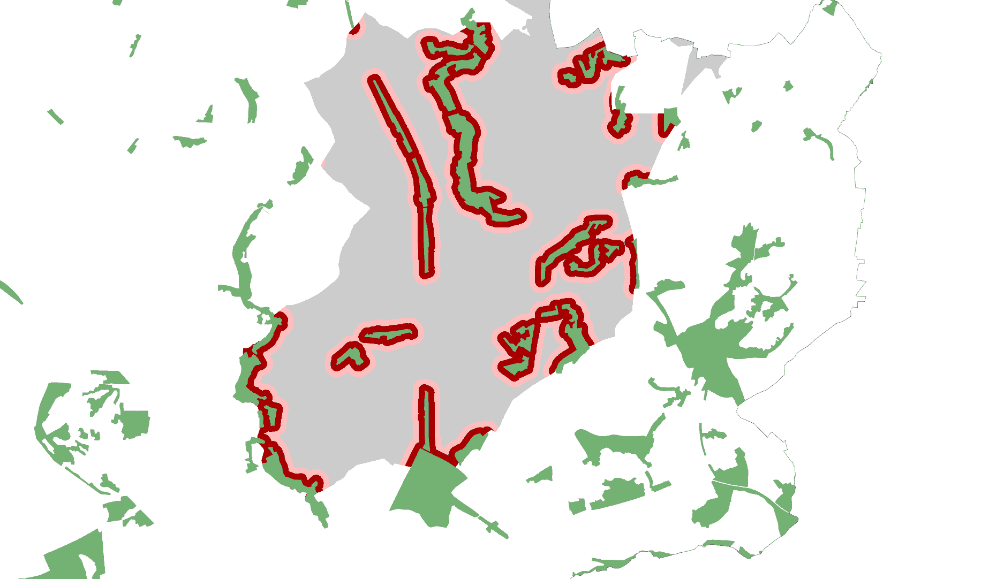

© Crown Copyright and database rights 2013. Ordnance Survey 100019422.

You are not permitted to copy, sub-license, distribute or sell any form of this data to third parties in any form.

Use of this data is subject to the terms and conditions shown at www.staffordshire.gov.uk/maps.

Produced by Staffordshire Wildlife Trust

**Legend**

|  |  |  |
| --- | --- | --- |
| |  | | --- | |  | | Woodland |
| |  | | --- | |  | | Urban (fringe) area |
| |  | | --- | |  | | 50m woodland buffer |
| |  | | --- | |  | | 100m woodland buffer |

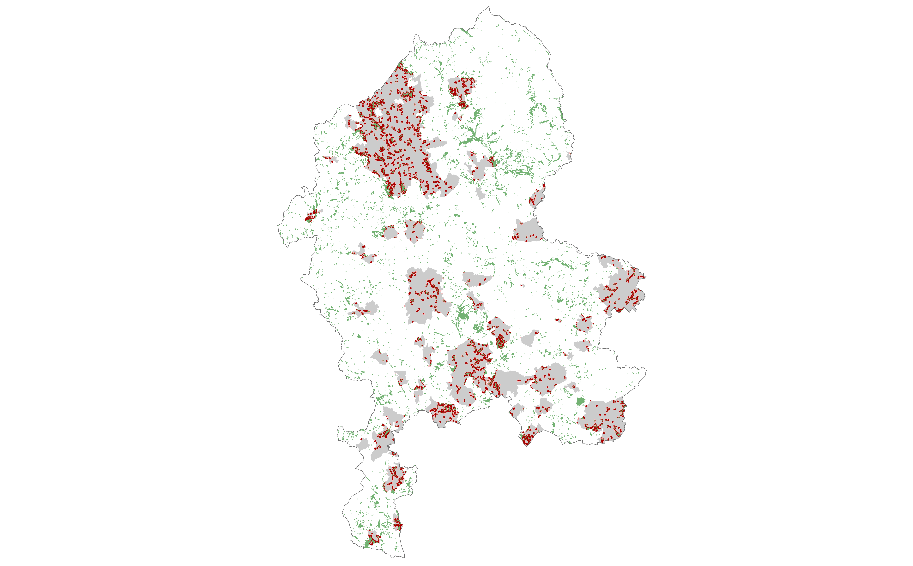

*Source:* ***Based on GIS data provided by Staffordshire County Council, Stoke on Trent City Council and the Forestry Commission.***

It is not likely that all households within these buffers have unimpeded views of the woodland sites. For example, especially in the urban (fringe) environment, the view from households onto woodland can be blocked or degraded by, for example, fences or other houses. Therefore, only a proportion of the total households has been taken into account for the valuation exercise, based on the assumption that 70% of households within the 50m buffer can have a free view of the woodland site whilst, for households within a distance between 50m and 100m from the woodland sites, 30% have been taken into account for the valuation. These are conservative assumptions when compared to Forest Research (2010) recommendations for applying the WTP for all households within 300m of woodland sites.[112]

Table 3.4 Aesthetic Appreciation Provided by Urban (Fringe) Broadleaved Woodland



*Source:* ***Author calculations based on Scarpa (2003) and MENE data provided by Natural England.***

It should be noted that, with 211 completed questionnaires within Garrod (2002), the sample size of completed questionnaires is comparatively small and no socio-economic adjustment is possible because corresponding information is not available.[113] To take such factors and potential transfer errors into account, a range of 50% has been applied for the sensitivity analysis. This results in a range from £11.7m to £3.9m for the annual value of aesthetic appreciation of broadleaved woodland in the urban (fringe) environments of Staffordshire. The values are summarised in Table 3.4.

Only broadleaved woodland in urban (fringe) settings has been valued in monetary terms. It is acknowledged that characteristic mosaic farmed landscapes also have aesthetic appeal as does ‘blue infrastructure’ and local tree clumps that may escape classification as forests, and other value domains, such as the aesthetic appreciation of a landscape as a whole, have not been evaluated. Also not included is the value of street and park trees.

Calculations for park trees in Islington (Highbury Fields) and Liverpool (Sefton Park) resulted in average capitalised values per tree of £77,787 and £12,825, respectively. Some mature plane trees were valued as £350,000.[114] Whilst data for aesthetic appreciation of broadleaved forests is indicative of the general quantum of value, when the above limitations are considered then the values presented in this section should be regarded as incomplete and a highly conservative lower boundary estimate.

Aesthetic values for other habitat types have been calculated as an element of ‘cultural services’ because a break-down for aesthetic values (excluding recreation, education etc.) was not possible. These values have been calculated in Appendix B and summarised in Section 3.1. Unfortunately a break-down for aesthetic appreciation is not possible.

## Spiritual Services

Ecosystems provide places and settings for spiritual enrichment, reflection and fulfilment. This includes spiritual values, moderated strongly by the highly heterogeneous beliefs and values of people experiencing these places and settings, which may include overtly ‘religious’ values as well as more diffuse ‘spiritual’ experiences. Such religious and spiritual values can also contribute to, and generally overlap with, other cultural benefits such as leisure and health.[115]

According to the UK NEA (2011), the importance of ecosystems in religious terms in the UK has almost certainly increased within the past 70 or so years.[116] One reason might be a shift from church religiosity to holistic spirituality.[117] People benefit from spirituality in many places, not just in churches. Such spiritual benefits are often perceived in natural settings, though may also flow from managed ‘green’ and ‘blue’ environments.

The Millennium Ecosystem Assessment (2005) found that spiritual services are of significant importance for many local communities around the world. This applies for indigenous communities, but also for communities in developing and industrialised countries.[118] Spiritual values act as a strong incentive for ecosystem conservation in many countries such as Peru, Costa Rica and India.[119]

There is no doubt that ecosystems and environmental landscapes and settings in Staffordshire provide important and valuable spiritual and religious services for many people, and that they are likely to do so on a highly heterogeneous basis reflecting such variables as race, creed, gender, age, health, etc. However, such values are often intangible and therefore very hard to quantify. An initial literature review undertaken by Cooper (2009) revealed that almost half of the published papers and reports on ecosystem services (63 out of 138) make reference to spiritual services. However the overall view formed by this review is that spiritual services would be hard and therefore unreliable to quantify; none of the publications cited above try to calculate a monetary value for spiritual ecosystem services.[120] We are therefore not attempting to quantify spiritual or other intangible services, though it is important to record that they should not be overlooked in decision-making. Spiritual and other related values are extremely heterogeneous in nature and may be of great importance to different social groups, evidence for which is revealed by the strength of societal mobilisation around safeguarding these shared societal values which thwarted government intent to sell off public forests in the England in 2012. More than 500,000 people signed a petition against this sell off.[121]

## Health benefits

Health benefit is always difficult to allocate within the ecosystem services framework, especially within an economic assessment of ecosystem services. Human health, if not just defined as the absence of diseases and infirmity, is a classical cross-cutting ecosystem service and is basically influenced by all ecosystem services as all ecosystem services have an impact on human wellbeing. The constitution of the World Health Organization defines health as follows:

*““Health is a state of complete physical, mental and social well-being and not merely the absence of disease or infirmity.”* [122]

This definition of health has also been adopted within the UK NEA.[123] Therefore all ecosystem services link to health benefits in one way or another, which makes it difficult to isolate health benefits from other ecosystem services. To avoid double-counting a monetary valuation of health benefits has not been conducted within the scope of this investigation. However, links between ecosystem services and human health have been analysed qualitatively. Additionally, quantitative case studies and estimates have been provided.

Accessible greenspace close to home is estimated to improve people’s health by providing space for physical activity such as jogging and other ‘green exercise’.[124] The Department of Health suggests that increased accessible open spaces could reduce healthcare costs in the UK by more than £2 billion annually, even if this figure cannot be taken as robust estimate because it is based on partial evidence.[125] Street trees can also encourage people to walk or cycle to work more often.[126] This in turn helps prevent the onset of diseases such as obesity, diabetes, heart diseases and strokes. Evidence also indicates that habitats with high biodiversity, especially within an urban environment, may encourage greater use.[127]

Several studies have proven that regular park users are healthier than their counterparts. This applies for a range of measures such as diastolic and systolic blood pressure, depression score and perception of general health.[128] Large scale studies undertaken in the Netherlands, Sweden and Japan have also provided a body of evidence that the availability of accessible local greenspace and human health are directly related.[129] About three out of four adults agree that green spaces are important for health.[130]

Adults in the West Midlands are thought to be the least physically active in England.[131] Between October 2011 and October 2012, only 33.5% of the surveyed population in the West Midlands Region has stated that they participate in at least one sports session a week[132]. In Staffordshire, the number of people who stated that they participate in at least one sports session a week varied between 28.4% (Cannock Chase) and 39.6% (Lichfield).[133]

Apart from the negative effects on human wellbeing and reduced life expectancy, physical inactivity causes significant expense to the healthcare system and therefore society. The annual costs of physical inactivity to the NHS are estimated to be between £1 billion and £1.8 billion. For Staffordshire[134], the annual costs are estimated to be in the region of £18 million.[135] These figures represent conservative estimates for the costs of inactivity based upon available published data. They exclude the cost implications of diseases and health problems influenced by physical activity, such as osteoporosis and falls which affect many older people.[136]

Ecosystems can not only improve physical activity by providing opportunities for exercise, they can also reduce illnesses caused by air pollution. Research carried out in New York suggests that a high tree density per square kilometre significantly reduces asthma prevalence in very young children.[137] Greenspace and especially trees contribute to purification of the air, therefore reducing the risk of related illnesses such as respiratory ailments, heart disease and cancer (see Section 4.5 for more information). A case study modelling the mitigation effects of particulate (PM10) pollution in East London estimates that an increase of grassland and tree cover could avert two PM10-related deaths and two hospital admissions annually in a 10 km2 area.[138]

Ecosystems also have restorative effects and thereby contribute to mental health.[139] Research carried out in the USA suggests that a view of woodland can improve mental health by breaking down stress.[140] A recently published study carried out in the UK found that a view of grassland from home has a positive influence on emotional wellbeing.[141] Ulrich (1984) also found that the view of woodland from hospitals can reduce recovery times.[142] There are numerous case studies, see for example Saraev (2012).[143]

A good example in Staffordshire about how engagement with nature can benefit mental health is the Newcastle Countryside Project. The project was established in 1982 and is based at Apedale Community Country Park. One element of this project is to help people living with learning difficulties or mental illness to gain control of their lives and to realise their full potential by actively engaging with the environment.[144]

A healthier population not only reduces healthcare costs or increases public wellbeing, it also increases economic productivity for example by reduced sickness absences. However, even if the links between environmental settings and human health were comparatively well researched in the past and positive relations have been observed, the exact causal connection between the provision of greenspace and human health is still uncertain.

*“Casual relationships can be hard to identify, partly because—as is the case in many epidemiological studies—directionality is unclear. Existing health can affect an individual’s use of greenspace or choice of residence near a particular environmental setting, and vice versa.”*[145]

Health and the existence of greenspace close to home could also be a dependent variable of education and income. It is arguable that people living in green areas are healthier because of the available greenspace close to home. However, one could also argue that people with higher education live healthier lifestyles in general and can more readily afford properties within green areas as they usually have a higher income. Therefore, one should not interpret a relationship between health and greenspace as implying causality; one also has to take account of additional variables.

It is also hard to measure whether, for example, outdoor exercise is directly related to greenspace availability. If accessible greenspace close to home is not available for exercise, it would still be possible that the exercise would occur, for example, in a sports hall.[146] This is another reason why a robust monetary valuation is not possible at present.[147]

The UK NEA stresses these limitations but provides some tentative values for health benefits related to contact with nature. A one per cent increase of broadleaved or mixed woodland within 1 km from home could be valued at between £8 and £12 per person per year. The monthly or more frequent use of non-countryside greenspace may be valued at between £112 and £377 annually per person.[148] However, these values are purely indicative and therefore are not robust enough to be implemented in this report.[149] The monetary valuation would also be likely to cause overlaps with ecosystem services such as recreation and aesthetic appreciation.

## Education

Gaining ecological knowledge is a key element of the educational system, and children benefit from this knowledge over their whole lifetime. In economic terms, *“formation of ecological knowledge […] can be seen as an investment in human capital.”*[150] A high level of ecological knowledge boosts average lifetime earnings. Furthermore it provides additional non-marketable benefits to human wellbeing. It is arguable that a good ecological education leads to more productive individual use of leisure by ‘enjoying the nature’.[151] Referring to the increase in lifetime earnings Mourato et al. (2010) approximate that

*“…the value of ecological knowledge embodied in this educational attainment at the end of the academic year 2009-10 [in the UK] was just over £2.1 billion.”*[152]

Along with more theoretical environmental education in the classroom, frequent interaction with the local environment is one key element of acquiring ecological knowledge.[153]

Within Staffordshire’s Local Economic Assessment, clusters have been identified as being particularly important to the Staffordshire economy. One of these clusters is tourism and leisure which account for 9.1% of the total in 2008. Another fast-growing sector is environmental technologies.[154] Both clusters demand a good knowledge of the environment and sustainability issues, which makes related education very important for local economic regeneration.

Especially in urbanised areas of Staffordshire, greenspace is capable of playing an even more important role in education, especially in urbanised areas of Staffordshire. Children who have grown up in cities do not have the same relationship with nature as their counterparts living in the countryside. This applies especially for minority ethnic groups in urban contexts.[155]

Unfortunately, research about the economic valuation of the benefits of outdoor education is scarce. In England, Land Use Consultants (2002) estimated the economic value of benefits from woodland for education.[156] Based on these published assumptions, the educational benefits in the West Midlands are estimated to be about £2 million annually.[157] However, the assumptions are very crude, so this valuation is highly uncertain.

More recently, education-related research has been undertaken within the UK National Ecosystem Assessment.[158] Using a cost-of-investment approach[159], organised school visits to Royal Society for the Protection of Birds (RSPB) reserves have been evaluated. Based on the travel costs method[160], a value of between £16 and £26 has been calculated per trip and child.[161] A similar assessment was not possible within scope of this Ecosystem Assessment for Staffordshire however. For many habitats, the value of overall cultural services, which includes educational benefits, has been assessed. These findings are outlined in Section 3.1. For calculations see Appendix B.

## Economy & Employment

Many studies suggest that a green environment has manifold positive impacts on the economy. Within a study in Northumberland, respondents reported that they shop about one hour longer in retail areas landscaped with greenery and trees than in areas without such amenities. About three out of four customers reported that they prefer such settings.[162]

*“Study results suggest that higher price valuations are mediated by psychological inferences of district character and product quality. Thus, creating and stewarding an urban forest canopy may enhance revenues for businesses in retail districts that offer diverse products at varied prices.”*[163]

A well-developed green infrastructure also attracts inward investment. In addition to the role of green infrastructure in regulating flooding and water quality, air quality and microclimate as well as noise regulation and visual screening, environmental setting is estimated to play a significant role for companies regarding to their location decision. This also attracts and retains especially high-skilled employees. The attraction of high-skilled workers by improving green infrastructure can be seen as an opportunity to adjust the socio-economic structure of the region. However, the scientific evidence does not allow a quantitative analysis of these effects.[164]

Another effect of a high-quality greenspace around work settings is increased productivity. A view of greenspace increases motivation and health which in turn decreases days of absence. The importance of green aesthetic amenity at work is also demonstrated by the fact that employees without a view of a green environment often hang up pictures of natural scenes.[165] These findings suggest that the environment has a significant influence on the local economy, even if these effects are difficult to quantify.

In Staffordshire, the tourism and leisure industry is one of the most important business clusters and employs about 24,000 people in the county. It is also one of the fastest-growing industries.[166] This cluster strongly depends upon a high quality environment and healthy ecosystems providing valuable amenities and recreation facilities for visitors. A decline (qualitatively and quantitatively) of ecosystem services may pose a high risk for this successful industry in Staffordshire. Improving and enhancing ecosystems on the other hand might increase the number of visitors and therefore the tourism and leisure industry as a whole.

## Wild Species Diversity

The term ‘biodiversity’ generally describes the diversity of life on earth, both between and within species. Biodiversity underpins all ecosystem services as all, at least partially, depend on living organisms and processes.[167] Within the framework of this investigation, we are making a slightly narrower distinction on valuation of biodiversity, relating it in particular to areas with a high diversity of species and related additional benefits. Therefore, the ecosystem services ‘wild species diversity’ in this specific context is largely a cultural service, though feeds the production of other categories of ecosystem services.

*“…this evidence shows that, in general terms, the level and stability of ecosystem services tend to improve with increasing biodiversity.”*[168]

The quantification of services flowing from wild species diversity is often inadequate due to limited data and scientific evidence.[169] Furthermore some valuation approaches are considered controversial.[170] One example is pollination (a regulatory service under the Millennium Ecosystem Assessment). On the one hand, we have evidence that pollinators are declining. On the other hand, we do not know how this loss influences pollination services, especially in agriculture[171], notwithstanding some large publicly- and politically-resonant ‘headline’ figures published by the UK NEA and TEEB.[172]

Nevertheless, some authors calculate values for ‘wild species diversity’ and often refer to ‘biodiversity’ or ‘habitat for species’. When they do so, they often refer to the occurrence of charismatic species. This usually reflects a non-use value of preferences for the pure existence of a species without using (watching/experiencing) it. This approach requires true altruism and its quantification is therefore considered controversial; assigning absolute values also raises theoretical problems. Additionally, overlaps with use-values commonly occur.[173] Human preferences for the pure existence and survival of species can also be explained by option-use values[174] or bequest values[175].

Some authors calculate values explicitly for ‘biodiversity’ or ‘wild species diversity’. Therefore, we adopt this category but findings should be interpreted with care. The values refer (partially) to other (bundles of) services such as aesthetic appreciation. Within this exercise we tried to rule out overlaps as far as possible.

Hanley et al. (2002) value the non-use benefits of UK woodland as habitat for species. They revealed human preferences for the existence of woodland as habitat for species in general. They used Willingness-To-Pay (WTP) methods to elucidate values for woodland habitats with different attributes, expressed by focus groups.[176] This study is considered appropriate as a source for benefit transfer into the Staffordshire study, even though the sample size was comparatively small and not representative of the whole population in the United Kingdom.[177] The study has also been used as a source for valuation of the social and environmental benefits provided by woodland in Great Britain as a whole.[178]

The mean WTP to protect and regenerate an area of 12,000 ha of lowland broadleaved Ancient Semi-Natural Woodland (ASNW) was £1.13 per household (in 2002 prices).[179] This equates to £1.46 per household in 2012 prices. Because this is a non-use value, the benefits are theoretically not restricted to local residents in Staffordshire.

*“There is no reason within standard economic theory why non-use values would also decrease with distance.”*[180]

However, as non-use values are controversial and may contain use values as well which are distance related. It is not clear at which level aggregation should stop.[181] A conservative approach has been undertaken by assuming that only residents in the West Midlands benefit from woodland in Staffordshire as ‘habitat for species’. Multiplying the WTP by the number of households in the West Midlands (1.7m) and breaking the result down to the regional area of ASNW, an annual value of £596,000 for 2,800 ha has been calculated. However, for the upper threshold of the sensitivity analysis, all UK households have been taken into account. The findings are summarised in Table 3.5.

The valuation of the other woodland habitats is more difficult because the focus group participants were asked explicitly for their WTP for an increase of woodland. There are confounding factors including: (1) woodland creation would entail loss of other habitat(s) set aside for tree planting; and (2) maintaining established woodland is at least worth the equivalent of planting new woodland. Furthermore, (3) if the amount of woodland and therefore the habitat for species declines, the marginal value increases, and (4) average species diversity in established woodlands is generally higher than in more recently planted woodlands. Following these arguments, the valuation of existing woodland in Staffordshire, applying the values for an increase of woodland, seems to be justifiable.

The WTP for 12,000 ha of lowland broadleaved woodland is £1.08 (2012 prices). Adopting the same methodology as for ASNW above, the annual value of lowland broadleaved woodland[182] in Staffordshire adds up to £596,000, stating the conservative best guess. Applying similar calculations for conifers, mixed woodland[183] and upland woodlands, a total annual value of woodland in Staffordshire as habitat for species (wild species diversity) of almost £3 million has been calculated. For the upper threshold of the sensitivity analysis, an annual value of £62 million has been calculated. The significant difference can be explained by the high range for the sensitivity analysis, but also because the value has been applied for all households in the UK and not just those in the West Midlands as for the best guess estimate. The findings are summarised in Table 3.5.

Table 3.5 Wild Species Diversity Benefits provided by Woodland



*Source:* ***Author calculations based on Hanley et al. 2002***

Because these are non-use values, people often have problems in expressing their own preferences.[184] On the one hand, such values are abstract and sometimes hard to grasp. On the other, the WTP for this form of ecosystem service is a very small fraction of income which leads to a comparatively wide variation of expressed values. Furthermore, the form of moderation of focus groups and the information provided about the habitats can have a strong influence on the expressed WTP. The comparatively small sample size and other caveats discussed above makes the application of a wide range of 80% reasonable for the sensitivity analysis.

Wetland habitats also have high biodiversity values and wetland species are under threat. Species diversity dependent on wetland habitats in many parts of the world are in continuing and accelerating decline.

*“The degradation and loss of wetlands is more rapid than that for other ecosystems. Similarly, the status of both freshwater and, to a lesser extent, coastal species is deteriorating faster than that of species in other ecosystems.”*[185]

Wild species diversity values provided by wetlands in Staffordshire have been valued at £1.6 million annually. The findings have been summarised in Table 3.6. For methods and calculations see Appendix B.

Table 3.6 Wild Species Diversity Benefits Provided by Wetland



*Source:* ***Author calculations based on Christie et al. 2011.***

These values for wetland explicitly refer to the non-use values based on the findings of Christie *et al.* (2011). Not included are the use-values for biodiversity based on the findings of Brander et al (2008). Because such use-values are dependent on site-visits and interaction with the ecosystem, the latter values have been included in cultural services such as recreation (see Section 3.1). Because non-use values were explicitly excluded by Brander et al. (2008), it can be assumed that no overlaps between these two value domains exist.

For heathland, grassland, hedgerows and arable fields, the data provided by Christie *et al.* (2011) has also been used (for calculations see Appendix B). The findings are summarised in Table 3.7 below. The total wild species diversity value of assessed habitats in Staffordshire adds up to more than £10 million annually or £661 million capitalised.

Table 3.7 Wild Species Diversity Benefits of Grassland, Heathland and Hedgerows



*Source:* ***Author calculations based on Christie et al. 2011***

# Regulating Services

## Global Climate Regulation (Climate Change Mitigation)

Global greenhouse gas (GHG) emissions due to human activity have increased by 70% between 1970 and 2004 and carbon dioxide (CO2) is the most important GHG, representing 77% of the global anthropocentric GHG emissions in 2004.[186] A large body of evidence exists that climate change caused by human GHG emissions has multiple net negative impacts on human wellbeing and ecosystems. In Europe, this includes for example increased risk of inland flash floods, increased health risks due to heat waves (see also Section 4.2 below), and extensive species losses (in some areas up to 60% under high emissions scenarios by 2080).[187]

Habitats play an important role in mitigating climate change and its negative impacts by sequestering and storing carbon. The photosynthetic activities of trees and other vegetation absorb carbon dioxide from the atmosphere and therefore act as a net carbon sink, especially when carbon is sequestered into soils.[188] The Forestry Commission estimates that increased UK woodland stock could contribute an emission abatement equivalent to 10% of the total UK greenhouse gas inventory in 2050. This could be achieved by replanting an additional 4% of the UK land cover with woodland.[189]

The estimated total carbon stock in UK forests and corresponding soils in 2007 was approximately 790Mt (million tonnes), equivalent to 2,897 Mt CO2e (carbon dioxide equivalent).[190] At that time, the estimated woodland area in the UK was 2.84 million hectares[191] which results in an average carbon stock in UK woodlands and corresponding soils of 278 t per ha.

The actual carbon stock in Staffordshire can be approximated by multiplying the average UK carbon stock by the area of woodland in Staffordshire. This is a very crude estimate because it does not for example account for species and soil types, but it gives us a ‘ballpark figure’. Applying the approach described above, the carbon stock in Staffordshire woodlands and corresponding soils can be assumed to be in the region of 6.8 Mt which equals 25 Mt CO2e. Multiplied by the actual price (2012 level) per tonne of CO2e of £59, recommended by the UK Department of Energy & Climate Change[192], the value of carbon stored in Staffordshire woodland and woodland soils is in the region of £1.5 billion.

However, this is a stock value and not a flow of ecosystem services. Because the framework of this investigation is focused on calculating the annual flow of ecosystem services, the value of £1.5 billion has not been adopted for the monetary valuation within scope of this study as it does not match the conceptual framework. It might have been possible to estimate the actual carbon sequestration by Staffordshire woodlands and also other habitats, but even that would not reflect the annual net value of the flow of the ecosystem service global climate regulation. After a certain time, woodland and other habitat types become saturated in their net capacity to capture additional carbon; they may still sequester carbon from the atmosphere but, on the other hand, carbon dioxide and other greenhouse gases are also released for example when trees die or when they are felled to produce timber and wood fuel or because of health and safety issues. Therefore, mature habitats reach a long-term carbon stock equilibrium.[193]

To calculate the annual value of the net carbon sequestration by woodland in Staffordshire, detailed information about the age structure of trees, species and soil structure, but also the amount and usage of felled trees (e.g. for energy production and furniture) including the substituted CO2 emissions (e.g. from replaced fossil fuel usage for energy production) would be necessary. It was not possible to gather such detailed information within the limited scope of this investigation.

To get a better understanding of the value of carbon captured and stored in trees in Staffordshire it is proposed that an ‘i-Tree’ Eco assessment shall be undertaken.[194] The i-Tree tool has been developed in the United States and allows, for example, an estimate to be made for the carbon stock and sequestration by trees within a specific geographical area. A sample of the woodland, but also for example street, park and garden trees, would be measured and the species structure would be recorded. This would allow robust figures for carbon stock and actual carbon sequestration to be calculated. However, issues like the long term equilibrium and substitutional effects remain, which makes it difficult to calculate the net value of the flow of this ecosystem service.

The complexity of calculating an accurate figure for carbon stocks and annual sequestration rates can also be explained using the example of wetlands. Globally, wetlands have one of the highest carbon stocks per ha. The Intergovernmental Panel on Climate Change (IPCC) estimates an average carbon stock in wetlands[195] globally at more than 750 tonnes per ha.[196] When applied to the area of wetlands in Staffordshire, this would result in a carbon stock of 2.8 Mt equivalent to 10.3 Mt CO2e and valued at more than £600 million. However, the impact of wetlands on the climate is complex and the benefits of wetland concerning climate change mitigation still remain uncertain.[197] On the one hand, wetlands act as carbon sink. However, on the other, wetland micro-organisms emit other greenhouse gases, especially methane, which are highly dependent upon the characteristics of the wetland (redox, hydrology, pH, etc.). Within a comparatively short time horizon of 20 years, new created wetlands in northern latitudes are estimated to have net negative effects on climate change. This effect decreases over time and may lead to a balanced greenhouse gas effect over 100 years. After they have existed for 500 years, northern wetlands are estimated to reduce the net greenhouse gas warming potential.[198]

Large former wetland areas in England are still emitting carbon dioxide although they were drained many years ago to provide agricultural land.[199] Agriculture is also a major source of other important greenhouse gasses, and is believed to be one of the main causes of the observed increase in methane concentration in the atmosphere.[200] In 2011, UK agriculture accounted for 84% of total nitrous oxide emissions and 43% of total methane emissions in the United Kingdom. However, greenhouse gas emissions caused by agriculture are declining. [201]

## Local Climate Regulation (Climate Change Adaptation)

Green vegetation has an influence on the local climate, and particularly so in urban areas such as Stafford or Stoke-on-Trent. Urban areas are usually warmer than their surroundings. This Urban Heat Island Effect (UHIE) is caused by the built environment retaining heat, which is released during the night, as well as the concentration of waste heat from warming and cooling. In the future, the UHIE will combine with global warming caused by climate change.

Green infrastructure and the urban forest in particular have a significant cooling effect on the local climate in cities. The temperature around vegetation is reduced by evapotranspiration. Furthermore, trees and scrub provide shading and protection from heat and UV radiation.[202] Research carried out in Manchester suggests that a 10% increase of green infrastructure in areas with the least greenery would reduce the UHIE by between 2.2 and 2.5%.[203] In summer 2006 during a heatwave, the UHIE caused more than 4 degrees of additional warmth within the most built up area of Birmingham. Around Sutton Park, the largest park in Birmingham, the temperature was about 3 degrees lower.[204] Other studies validate these effects.[205] Therefore green infrastructure has the potential to play a vital role in helping urban areas in Staffordshire to adapt to climate change.

The elderly sector of the population is thought to have lower tolerance of extreme temperatures, and so excessive heat can be a significant contributory factor to exacerbating illnesses and contributing to increased mortality.[206] Land-use planners should bear this in mind in developing policy for creating urban areas that are more resilient to the effects of warmer temperatures and more frequent extreme weather events such as heat waves, which are a likely consequence of climate change.

Not only do trees provide shading, potentially reducing costs associated with air conditioning, but they can also act as shelter belts reducing wind speeds which may result in lower heating costs. Kuppuswamy (2009) estimates that street trees provide a cooling effect of between 2% and 7% by providing building shade.[207] Research indicates that a medium-porosity green shelterbelt could reduce heating costs by about 4.5% for a typical two-story cellular office space in Scotland.[208] This in turn reduces carbon emissions, contributing to the mitigation of climate change. Reducing the UHIE also helps in reducing air pollution[209], including the potential heat-related transformation air pollutants.

However, the maximum expression of such effects is closely related to local settings and the location of trees and scrub. Unfortunately, the economic valuation of these effects in Staffordshire was not possible within the scope of this investigation. The scientific evidence to date is not robust enough to value the effect of green infrastructure on the local climate in monetary terms. [210] Given the potential significance of this service, this represents an important knowledge gap.

## Flood Regulation

In the UK, soil cover has changed significantly due to human activity, especially within the past 50 years.[211] The increase in surface sealing, especially in urban areas but also in rural areas due to soil compaction and other land-use changes reducing the extent of vegetation with high infiltration capacities, has increased soil erosion as well as reducing the natural capacity of ecosystems to retain and store water. Reduced vegetation cover also generates faster water run-off rates which promotes flooding events.[212]

*“The replacement of natural green spaces with concrete and impermeable pavements in urban areas reduces the effectiveness with which rainfall, snow melt and storm water are absorbed and returned to groundwater aquifers. […] This results in elevated levels of surface water run-off, which increases the likelihood of local flooding and sewers reaching overcapacity.”[213]*

Habitats and green vegetation can help to mitigate extreme weather events, and in particular risk of flooding. Wetland and floodplain habitats fill rapidly during flooding events, at least to a point of saturation, and then slowly filter back retained water to buffer surface flows. Total costs to UK insurers of flooding in 2007 flooding are expected to be in the order of £3 billion.[214] If no additional flood risk management action is taken, the costs in the UK caused by urban flooding alone could increase to between £1 billion and £10 billion annually under changing climate[215] with some extreme scenarios predicting annual costs arising from UK flooding of £20 billion by 2060.[216] Risk of flooding to urban and rural areas is not a new concern, but the increase in use of impermeable surfaces, rural land-use changes, population rise and more extreme weather events as a likely result of climate change is increasing the frequency and intensity of flooding and the number of properties at risk. Such flooding events can cause damage to properties and risk to human lives, and also worsen water quality in rivers as soil is eroded and pollutants are washed out from sewerage and transport systems and are dumped into rivers and other water bodies. The creation of habitats and green vegetation can reduce the volume of water run-off through infiltration and absorption, as well as evapotranspiration.

Wetlands are of particular importance for flood alleviation, contributing to suppressing flood generation, as well as damage and associated costs caused by flooding, due to their role in storing water during, and buffering flows after, flooding events.[217] To calculate the flood regulation service provided by wetlands in Staffordshire, the model of Brander et al. (2008) has been applied (see Appendix A for methods and calculations). Stating the best guess, wetland habitats provide flood risk regulation benefits worth £1.2 million annually or £77 million capitalised. Detailed findings are summarised in Table 4.1 below.

Table 4.1 Flood Risk Regulation Benefits Provided by Wetlands



*Source:* ***Author calculations based on Brander et al. 2008.***

These values are mainly based on replacement costs (avoided damage costs), applying a benefit transfer function.[218] However, it should be noted that flood risk regulation services are very site-specific and should be valued case-by-case.[219] More precise valuation of the contribution of wetlands to flood risk management in Staffordshire would be a valuable policy contribution to help identify the best flood risk reduction management options, though this is beyond the scope of the present study.

Apart from wetlands, other habitats also contribute to flood risk reduction. For these habitats, findings provided by Christie et al (2011) have been applied to calculate a monetary value (see Appendix B). The findings are summarised in Table 4.2.

Table 4.2 Flood Risk Regulation Benefits Provided by Different Habitats



*Source:* ***Author calculations based on Christie et al. 2011***

All evaluated habitats in Staffordshire cumulatively provide flood risk regulation services of £14.5 million annually. However, since neither expected future increase in number and magnitude of flooding events caused by climate change nor population growth have been taken into account, a capitalised lifetime value of £928.1 million is likely to be highly conservative.

By the 2080s, between £22 billion and £75 billion of new investments in engineering might be needed in the UK to ensure protection from higher flood risks caused by climate change.[220] A share of these ‘grey’ infrastructure investments might be avoidable through the creation of Sustainable Drainage Systems (SuDS) and the strategic protection or creation of vegetated areas such as woodland, grassland and wetland habitats. Often, this might represent a cost-efficient alternative if assessed purely in terms of flood risk benefits, but also delivering a range of potential additional benefits such as recreation, amenity, etc. There are good practice examples available around the world where SuDS have been successfully retrofitted in the urban environment to reduce the risk of flooding, and also where these additional service benefits have been optimised.[221] However, in contrast to the USA, applied research into the role of trees and vegetation in water management is relatively scarce in the UK and Europe, despite such government strategies as ‘Making space for water’.[222] Because hydrological studies are very site-specific this represents a major research gap in the UK.[223]

## Water Quality Regulation

Another significant benefit provided by ecosystems, especially wetlands, is the regulation of water quality. This occurs through processes such as the retention, removal and transformation of nutrients, organic matter and sediment, and bacterially-driven denitrification, nitrification and mineralisation, plant uptake and the trapping or filtering of particulates.[224] Furthermore, wetlands can capture pesticides and other complex organic pollutants.[225]

However, the UK’s wetland resource, and hence capacity to regulate water quality, has been in long-term decline. For example, 90% of UK wetlands have been lost since Roman times.[226] Former wetland habitats have often been drained to make the land usable for agricultural production.[227] The concentration of nitrates and phosphate in surface waters has been rapidly increasing over the same timescale, with agriculture being one of the major causes. The location and management of wetlands is also important to ensure its ability to regulate water quality.[228]

All habitats have a role in the water cycle, and hence make a contribution to the regulation of water quality. However, in Staffordshire, it was only possible to value the water quality regulation services of wetlands, as relevant data for other habitat types was lacking or missing. Within the scope of this investigation, the benefits of wetlands in regulating water quality have been valued at almost £1 million annually, using a benefit-transfer function provided by Brander et al. (2008) (see Appendix A for more details). Most primary valuation studies calculate this effect by taking avoided remediation costs of water purification by water suppliers into account.

Table 4.3 Water Quality Regulation Benefits Provided by Wetlands



*Source:* ***Author calculations based on Brander et al. 2008.***

A commonly cited example where ecosystem services are successfully managed to improve water quality is New York City. Instead of constructing a new water filtration plant, the city authority opted to develop a rural-urban partnership with land owners in the Catskills and Delaware area to improve farm management techniques in order to prevent run-off of wastewater and nutrients. This payment scheme has contributed towards securing a supply of good water quality in the watercourses from which New York City’s water supply is drawn, saving the water consumers in the city between US$ 4.5 billion and US$ 7 billion in capital costs (for conventional water filtration plant) plus additional annual treatment costs of between US$ 300 million and US$ 500 million.[229] New York City’s water supply provides a good example of how economic instruments like Payments for Ecosystem Services (PES) can provide cost-effective solutions by optimising the supply chain cost-efficiently and also achieving multiple additional ecosystem services, rather than using engineering solutions at ‘the end of the pipe’ to address single-issue concerns.

In addition to justifying regulating and influencing farming practices in other ways, wetland habitat creation in Staffordshire may be a cost-effective mechanism to deliver some of the water quality improvements required for compliance with the EU Water Framework Directive (see also Section 8.2) as well as delivering a range of other linked service benefits (flood risk management, green space provision, biodiversity, etc.) which may optimise public value.

## Air Quality Regulation

Complex vegetation and particularly trees have a positive effect on the regulation of local air quality. This applies especially in urban areas such as Stafford and Stoke-on-Trent where pollution emissions are comparatively high. The main sources for this pollution are vehicle exhaust, industry and intensive agriculture.[230]

Trees and other vegetation absorb, through physical deposition as well as chemical reactions, deleterious pollution such as carbon monoxide (CO), sulphur dioxide (SOx), nitrogen dioxide (NO2), ozone (03) and fine particulates (PM10) which are responsible for major illnesses such as respiratory ailments, heart disease and cancer.[231] Research carried out in New York, for example, suggests that a high tree density per square kilometre significantly reduces asthma prevalence in very young children[232] As well as delivering co-benefits for other services such as urban flood risk, visual and noise screening, etc. On the other hand, it is possible that specific tree species also have a negative impact on air quality by forming lowlevel ozone and by liberating pollen which can reduce the net air pollution absorption benefits.[233]

The species selection as well as the location and management of trees and woodland have a significant impact on the ability to regulate air quality. In general, trees and vegetation can capture, for example, more fine dust if located close to the source of fine dust emissions.[234]

*“...increasing deposition by the planting of vegetation in street canyons can reduce street-level concentrations in those canyons by as much as 40% for NO2 and 60% for PM.”[235]*

On the other hand, however, trees can also worsen local air quality, depending on their location. Trees directly located along frequently used streets such that there is a closed canopy can trap pollutants because the polluted air exchanges slower. This can have a negative effect on local air quality along such frequently used streets.[236] Therefore it can at times be appropriate to locate trees further away from the carriageway to gain the best outcomes.[237] However, most street tree management in urban areas of Staffordshire tends to prevent development of a closed canopy.

One can see that the ability of green vegetation and trees in regulating air quality is very context-specific, requiring detailed knowledge about location and species structure if a robust assessment of this ecosystem service is to be achieved. Such information was not available for this investigation. However, an i-Tree assessment generalises outcomes and so overcomes some of the data limitations for trees, albeit with uncertainties, and enables calculation of a monetary value for air quality regulation services by trees and woodland (see also Section 8.2.2).

# Staffordshire County Council Country Parks Subset

One additional element of this Ecosystem Assessment was to estimate the value of ecosystem services provided by Staffordshire County Council Country Parks in order to inform decisions regarding resource allocation for management and to improve understanding of the public benefits of these sites. The six Country Parks evaluated are (see Figure 5.1):

* Apedale Community Country Park
* Cannock Chase Country Park
* Chasewater Country Park
* Consall Nature Park
* Deep Hayes Country Park
* Greenway Bank Country Park

These Country Parks cumulatively cover an area of 1,973 ha, equivalent to 0.7% of the geographical area of Staffordshire. More than 1,500 ha (76% of the total Country Park area) could be valued in monetary terms. Notably, more than 50% of Staffordshire’s lowland heathland is located in these Country Parks. Please note that Table 5.1 and Figure 5.1 only show the area of habitat where a monetary valuation of ecosystem services was possible.

Figure 5.1 Habitats Evaluated within Staffordshire County Council Country Parks

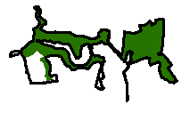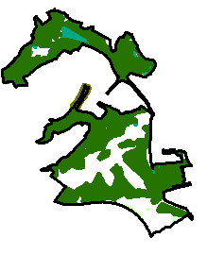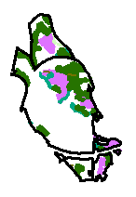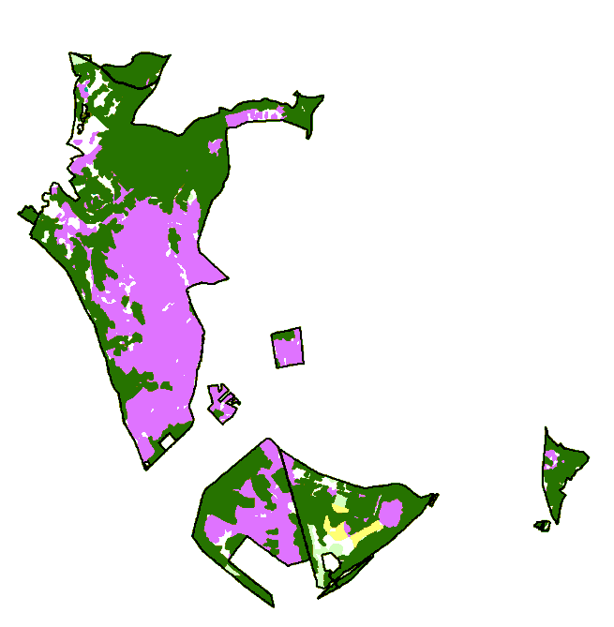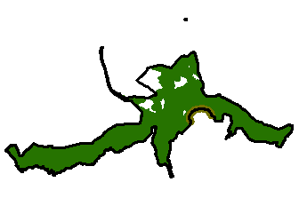

Chasewater Country Park

Greenway Bank Country Park

Apedale Country Park

Deep Hayes Country Park

Cannock Chase Country Park

Consall Nature Park

**Legend**

|  |  |  |
| --- | --- | --- |
| |  | | --- | |  | | Woodland |
| |  | | --- | |  | | Wetland |
| |  | | --- | |  | | Heathland |
| |  | | --- | |  | | Grassland |
| |  | | --- | |  | | Hedgerows |

© Crown Copyright and database rights 2013. Ordnance Survey 100019422.

You are not permitted to copy, sub-license, distribute or sell any form of this data to third parties in any form.

Use of this data is subject to the terms and conditions shown at www.staffordshire.gov.uk/maps.

Produced by Staffordshire Wildlife Trust

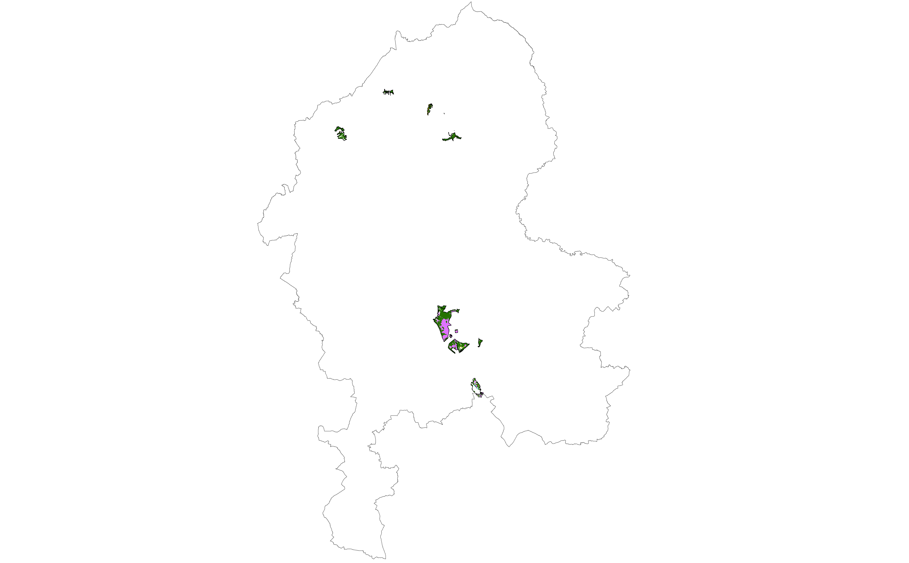

*Source:* ***Based on GIS data provided by Staffordshire Ecological Record, Staffordshire County Council, Stoke on Trent City Council, Natural England and the Forestry Commission.***

Table 5.1 Area of Evaluated Habitats in Staffordshire County Council Country Parks

|  |  |
| --- | --- |
| **Broad habitat type** | **Area** |
| **Woodland** | **889.3 ha** |
| Broadleaved woodland | 700.5 ha |
| Ancient Semi-Natural Woodland (ASNW) | 177.9 ha |
| Other | 522.6 ha |
| Coniferious woodland | 182.5 ha |
| Mixed woodland | 6.3 ha |
| **Wetland** | **10.2 ha** |
| Inland marsh | 9.5 ha |
| Fens | 3.7 ha |
| Swamp | 5.8 ha |
| Peatbog | 0.7 ha |
| Fen | 0.4 ha |
| Moss | 0.3 ha |
| **Heathland** | **561.2 ha** |
| **Grassland** | **39.2 ha** |
| Acid grassland | 7.5 ha |
| Improved grassland | 19.8 ha |
| Neutral grassland | 12.0 ha |
| Lowland meadows | 12.0 ha |
| **Hedgerows\*** | **0.5 ha** |
| **TOTAL HABITAT AREA EVALUATED** | **1,500.4 ha** |
| *) The assumption underlies that 3.5km hedgerows recorded as linear features are in average 1.5m wide. | |

*Source:* ***Based on GIS data provided by Staffordshire Ecological Record, Staffordshire County Council, Natural England and the Forestry Commission.***

To estimate the value of ecosystem services provided by habitats in Staffordshire County Council Country Parks, the calculated average per-hectare values of this Ecosystem Assessment have been applied for habitats in Country Parks. The underlying assumption is that the average value per hectare of habitats within the Country Parks is equivalent to the average value per hectare of habitat in Staffordshire as a whole. The average per-hectare value of each habitat category has been applied; not the average value of all habitats together.

This is a conservative estimate, acknowledging that habitats in Country Parks are generally well accessible, in better condition and better managed than other habitats outside of Country Park designations. Data limitations inhibited any more detailed and comprehensive assessment of Country Parks. Only for the ecosystem service of ‘aesthetic appreciation of urban (fringe) broadleaved woodland’ a comprehensive analysis was possible. For this purpose, households with a free view on urban (fringe) broadleaved woodland within Country Parks have been assessed[238] (for more details about the methodology see Section 3.2).

Applying the methodology described above, the minimum annual value of ecosystem services provided for all habitats assessed in Staffordshire County Council Country Parks adds up to £1.81 million annually, equating to £116.4 million capitalised over 200 years. More detailed findings are summarised in Table 5.2 below.

An important principle emerging from this assessment is that the provision and management of Country Parks is not simply a net cost to public coffers, but that it represents investment in a valuable asset providing a wide range of valuable benefits for the residents of Staffordshire in addition to the obvious recreation benefits. Furthermore, the integrity and proximity of these habitats may result in greater optimisation of outcomes across ecosystem services, enhancing cumulative public value. This value provided by the natural environment should also be recognised in public accounting.

Table 5.2 Annual Value of Ecosystem Services Provided by Assessed Habitats in Staffordshire County Council Country Parks

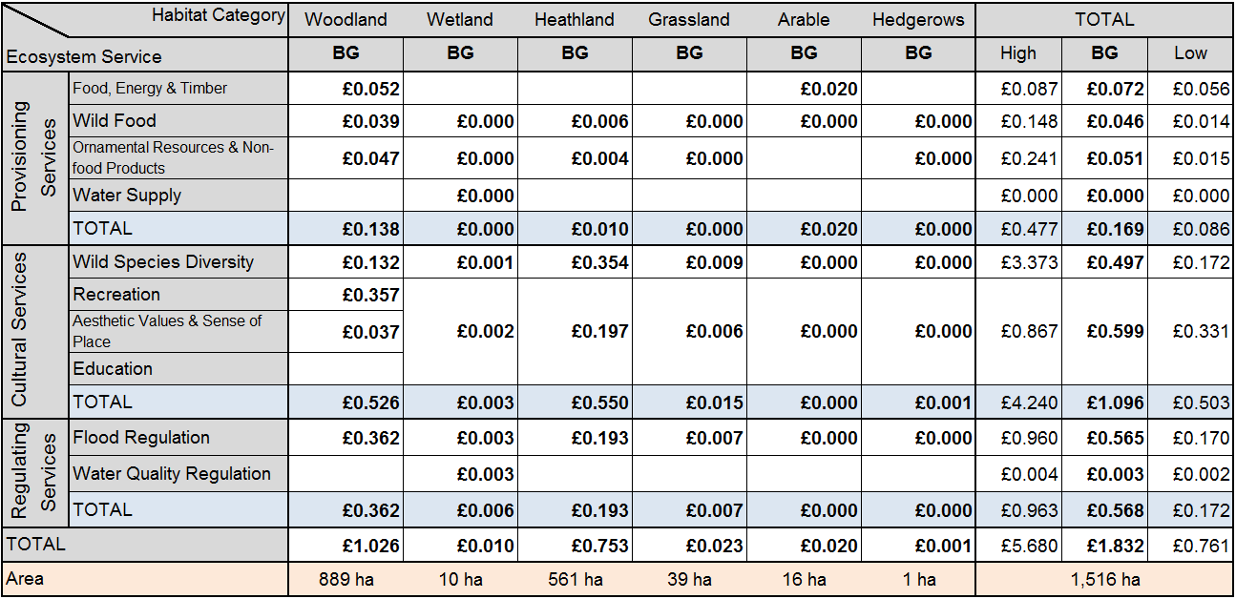

|  |  |  |
| --- | --- | --- |
| **Notes:** | | |
| All values are stated in million pounds (£m); 2012 prices. | | |
| Blank cells do not mean 'no value', but that a monetary value could not have been calculated within scope of this study. | | |
| **Legend:** | | |
| BG | Best Guess Estimate |  |
| High | Higher threshold of the sensitivity analysis (even if the real value could still exceed this threshold) |  |
| Low | Lower threshold of the sensitivity analysis |  |
| ***For the underlying assumptions, limitations and valuation methods see the relevant sections.*** | | |

*Source:* ***Author calculations***

# Stoke-on-Trent Countryside Sites Subset

One additional element of this Ecosystem Assessment was to estimate the value of ecosystem services provided by semi-natural sites that are owned by the council and managed by the council’s countryside staff to promote wildlife in Stoke-on-Trent. These sites provide city residents access to nature as they are composed of semi-natural habitats rather than more formal greenspace. The assessment of these specific sites begins to reveal the value of the benefits they provide to public so that informed decisions can be made when allocating resources for their management and planning for a successful great working city.

The 28 parks and open spaces evaluated are (see Figure 5.1):

* Acreswood
* Baddeley Green
* Bagnall Road Wood
* Bellerton Lane
* Berryhill Fields
* Birch Woods
* Bridgett’s Pool
* Carmountside
* Central Forest Park
* Cockster Brook Valley
* Cromer Road
* Easters Garden Wood
* Florence Park
* Glebedale Park
* Grange Park
* Hartshill Park
* Longton Brook
* Park Hall Country Park
* Ransome PlaceWood
* Scotia Valley
* Six Crowns Wood
* Smith’s Pool
* Smiths Pool
* Sneyd Hill
* Tank Field, Norton
* Trent Mill Nature Park
* Turnhurst Jubilee Wood
* Weston Sprink
* Westport Lake
* Whitfield Valley and Chatterley Whitfield Heritage Country Park

These Countryside sites cumulatively cover an area of 649 ha, equivalent to 7% of the geographical area of Stoke-on-Trent. Almost 500 ha (76% of the total countryside sites area) could be valued in monetary terms. Please note that Table 6.1 and Figure 6.1 only show the area of habitat where a monetary valuation of some ecosystem services was possible.

Figure 6.1 Habitats Evaluated within Stoke-on-Trent Countryside Sites

Whitefield Valley

Hartshill Park

Berryhill

Florence Park

© Crown Copyright and database rights 2013. Ordnance Survey 100019422.

You are not permitted to copy, sub-license, distribute or sell any form of this data to third parties in any form.

Use of this data is subject to the terms and conditions shown at www.staffordshire.gov.uk/maps.

Produced by Staffordshire Wildlife Trust

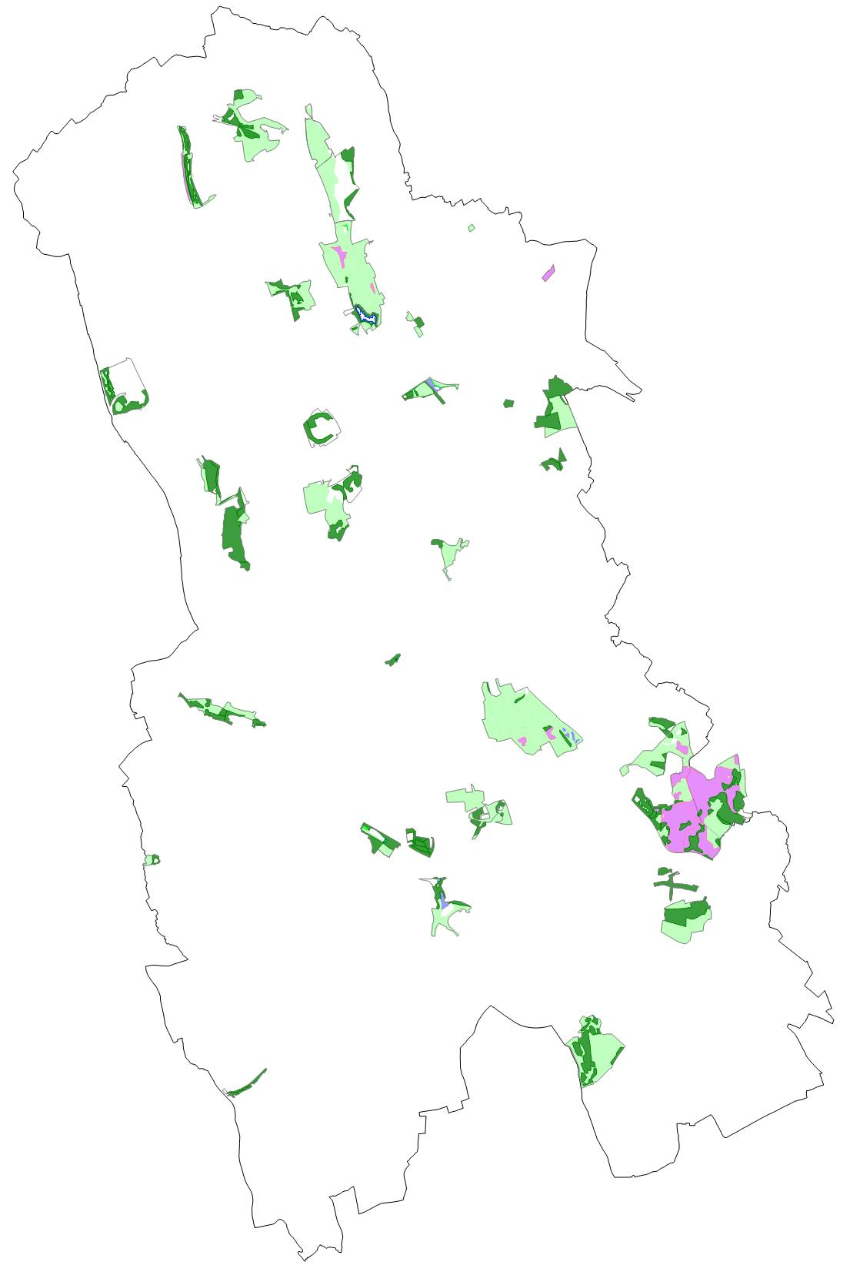

Westport Lake

Park Hall

Country Park

**Legend**

|  |  |  |
| --- | --- | --- |
| |  | | --- | |  | | Woodland |
| |  | | --- | |  | | Wetland |
| |  | | --- | |  | | Heathland |
| |  | | --- | |  | | Grassland |

*Source:* ***Based on GIS data provided by Staffordshire Ecological Record, Stoke on Trent City Council, Natural England and the Forestry Commission.***

Table 6.1 Area of Evaluated Habitats in Stoke-on-Trent Countryside Sites

|  |  |
| --- | --- |
| **Broad habitat type** | **Area** |
| **Woodland** | **160.6 ha** |
| Broadleaved woodland | 134.7 ha |
| Coniferious woodland | 13.4 ha |
| Mixed woodland | 12.5 ha |
| **Wetland** | **2.4 ha** |
| Inland marsh | 2.4 ha |
| Swamp | 2.4 ha |
| **Heathland** | **65.5 ha** |
| **Grassland** | **115.9 ha** |
| Acid grassland | 8.9 ha |
| Improved grassland | 9.2 ha |
| Neutral grassland | 97.8 ha |
| Lowland meadows | 97.8 ha |
| **TOTAL HABITAT AREA EVALUATED** | **344.4 ha** |

*Source:* ***Based on GIS data provided by Staffordshire Ecological Record, Stoke on Trent City Council and the Forestry Commission.***

To estimate the value of ecosystem services provided by habitats in Stoke-on-Trent countryside sites, the calculated average per-hectare values of this Ecosystem Assessment have been applied for habitats in countryside sites. The underlying assumption is that the average value per hectare of habitats within the countryside sites is equivalent to the average value per hectare of habitat in Staffordshire as a whole. The average per-hectare value of each habitat category has been applied; not the average value of all habitats together.

This is a conservative estimate, acknowledging that habitats in Stoke-on-Trent countryside sites are generally easily accessible and often in good management. Data limitations inhibited any more detailed and comprehensive assessment of Stoke-on-Trent countryside sites. Only for the ecosystem service of ‘aesthetic appreciation of urban (fringe) broadleaved woodland’ a comprehensive analysis was possible. For this purpose, households with a free view on urban (fringe) broadleaved woodland within countryside sites have been assessed[239] (for more details about the methodology see Section 3.2).

Applying the methodology described above, the minimum annual value of ecosystem services provided for all habitats assessed in Stoke-on-Trent countryside sites adds up to £406,186 annually, equating to £26.1 million capitalised over 200 years. More detailed findings are summarised in Table 6.2 below.

An important principle emerging from this assessment is that the provision and management of Stoke-on-Trent countryside sites is not simply a net cost to public coffers, but that it represents investment in a valuable asset providing a wide range of valuable benefits for the residents of Stole-on-Trent in addition to the obvious recreation benefits. Furthermore, the integrity and proximity of these habitats may result in greater optimisation of outcomes across ecosystem services, enhancing cumulative public value. This value provided by the natural environment should also be recognised in public accounting.

Table 6.2 Annual Value of Ecosystem Services Provided by Habitats in Countryside Sites

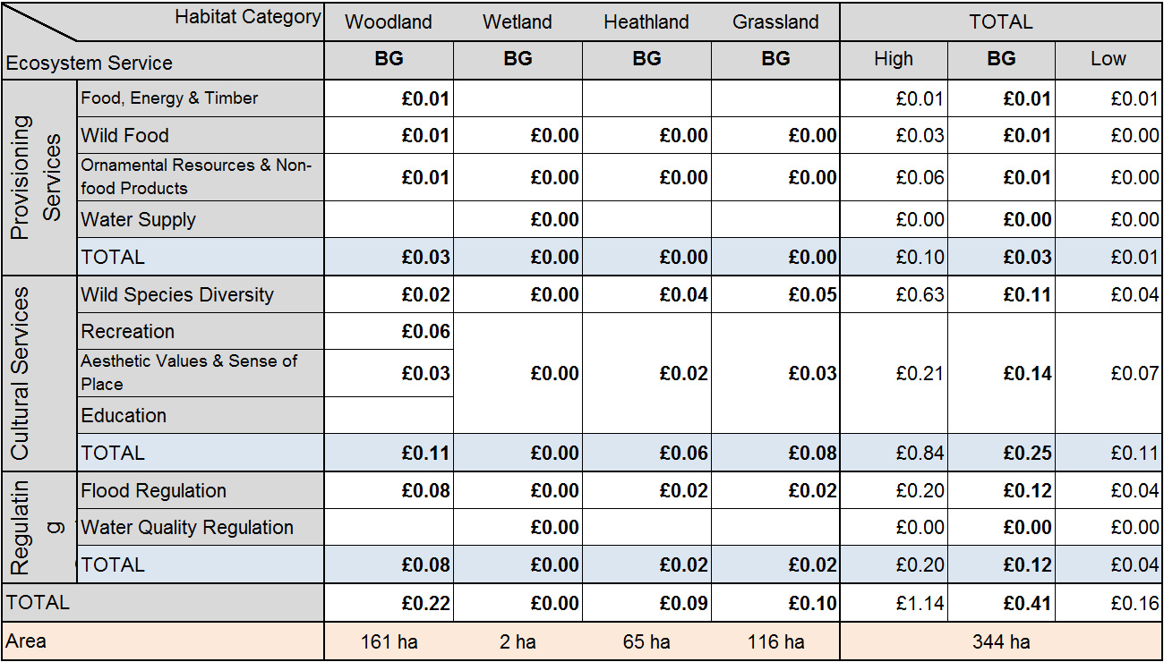

|  |  |  |
| --- | --- | --- |
| **Notes:** | | |
| All values are stated in million pounds (£m); 2012 prices. | | |
| Blank cells do not mean 'no value', but that a monetary value could not have been calculated within scope of this study. | | |
| **Legend:** | | |
| BG | Best Guess Estimate |  |
| High | Higher threshold of the sensitivity analysis (even if the real value could still exceed this threshold) |  |
| Low | Lower threshold of the sensitivity analysis |  |
| ***For the underlying assumptions, limitations and valuation methods see the relevant sections.*** | | |

*Source:* ***Author calculations***

# Staffordshire Wildlife Trust Reserves Subset

Another additional element of this Ecosystem Assessment is the estimation of the value of ecosystem services provided by Staffordshire Wildlife Trust (SWT) Reserves. SWT wished to understand how its annual investment of approximately £293,000[240] compared to the benefit that members of the public could derive from the Nature Reserves. This work also gives an indication of how future investment in habitat improvements or land acquisition could provide measurable benefit, compared to cost. These benefits are rarely considered, but we hope to represent a new departure for the Trust in understanding and promoting our Reserves work.

Ecosystem service values provided by habitats within the following 26 Wildlife Trust Reserves (see Figure 7.1) have been assessed:

* Black Brook
* Black Firs & Cranberry Bog
* Black Heath
* Brankley Pastures
* Burnt Wood
* Casey Bank
* Castern Wood
* Cotton Dell
* Croxall
* Doxey Marshes
* George's Hayes
* Harston Wood
* Hem Heath & Newstead Woods
* Highgate Common
* Jackson's Coppice
* Jackson's Marsh
* Loynton Moss
* Parrot's Drumble
* Pasturefields Saltmarsh
* Piggot's Bottom and Square Covert
* Radford Meadows
* Swineholes Wood
* The Roaches
* Thorswood
* Weag's Barn

These Wildlife Trust Reserves cover an area of 1,720.7 ha, equivalent to 0.6% of the geographical area of Staffordshire. Almost 1,050 ha (61% of the total Wildlife Trust Reserve area) could be valued in monetary terms. Comparing Table 1.1 and Table 7.1 reveals that almost all habitat types occurring in Staffordshire are also represented in Staffordshire’s Wildlife Trust Reserves. This includes almost 40% of Staffordshire’s purple moor-grass & rush pasture and 24% of Staffordshire’s upland heathland, respectively. Please note that Table 7.1 and Figure 7.1 only show the area of habitat where it was possible to ascribe a monetary valuation for ecosystem services.

Figure 7.1 Habitats Evaluated within Staffordshire Wildlife Trust Reserves

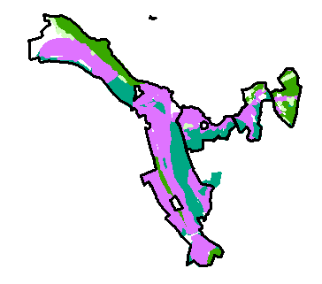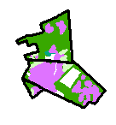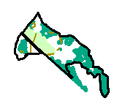

The Roaches & Black Brook

Cotton Dell

Highgate Common

Doxey Marshes

**Legend**

|  |  |  |
| --- | --- | --- |
| |  | | --- | |  | | Woodland |
| |  | | --- | |  | | Wetland |
| |  | | --- | |  | | Heathland |
| |  | | --- | |  | | Grassland |
| |  | | --- | |  | | Hedgerows |
| |  | | --- | |  | | Arable |

© Crown Copyright and database rights 2013. Ordnance Survey 100019422.

You are not permitted to copy, sub-license, distribute or sell any form of this data to third parties in any form.

Use of this data is subject to the terms and conditions shown at www.staffordshire.gov.uk/maps.

Produced by Staffordshire Wildlife Trust

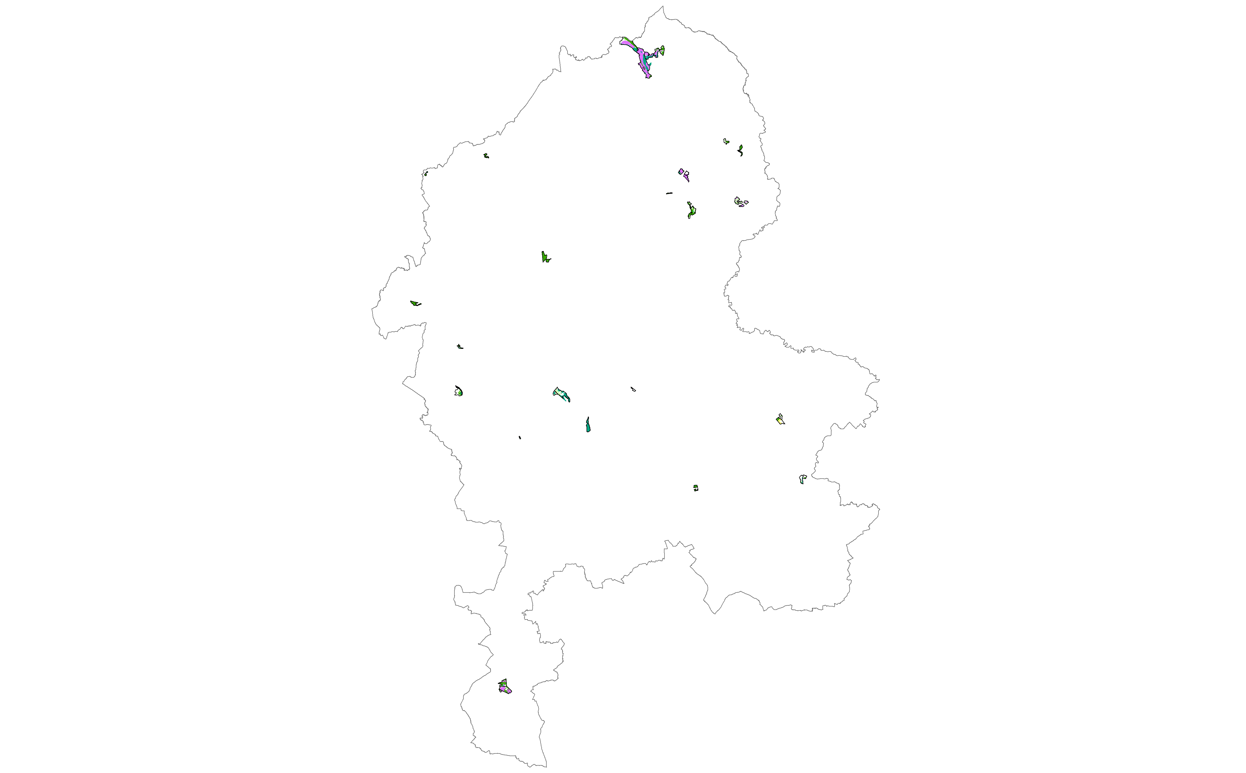

*Source:* ***Based on GIS data provided by Staffordshire Wildlife Trust, Staffordshire Ecological Record, Staffordshire County Council, Stoke on Trent City Council, Natural England and the Forestry Commission.***

Table 7.1 Area of Evaluated Habitats in Staffordshire Wildlife Trust Reserves

|  |  |
| --- | --- |
| **Broad habitat type** | **Area** |
| **Woodland** | **434.1 ha** |
| Broadleaved woodland | 360.7 ha |
| Ancient Semi-Natural Woodland (ASNW) | 94.9 ha |
| Other | 265.8 ha |
| Coniferious woodland | 65.6 ha |
| Mixed woodland | 6.5 ha |
| Shrub | 1.3 ha |
| **Wetland** | **273.5 ha** |
| Inland marsh | 112.3 ha |
| Floodplain grazing marsh | 42.4 ha |
| Purple Moor-grass & Rush Pasture | 13.0 ha |
| Fens | 5.1 ha |
| Mire | 14.4 ha |
| Swamp | 36.2 ha |
| Other | 1.1 ha |
| Peatbog | 161.2 ha |
| Blanket bog | 155.7 ha |
| Fen | 1.1 ha |
| Mire | 3.9 ha |
| Moss | 0.5 ha |
| **Heathland** | **273.4 ha** |
| **Grassland** | **50.8 ha** |
| Acid grassland | 7.1 ha |
| Improved grassland | 40.4 ha |
| Neutral grassland | 3.2ha |
| Lowland meadows | 3.2 ha |
| **Hedgerows\*** | **0.4 ha** |
| **Arable** | **15.2 ha** |
| Arable fields | 15.2 ha |
| **TOTAL EVALUATED HABITAT AREA** | **1,047.4 ha** |
| *) The assumption underlies that 2.7km hedgerows recorded as linear features are in average 1.5m wide. | |

*Source:* ***Based on GIS data provided by Staffordshire Wildlife Trust, Staffordshire Ecological Record, Staffordshire County Council, Stoke on Trent City Council, Natural England and the Forestry Commission.***

To estimate the value for ecosystem services provided by habitats in Staffordshire’s Wildlife Trust Reserves, the calculated average per-hectare values of this Ecosystem Assessment have been applied for habitats in Wildlife Trust Reserves. The underlying assumption is that the average value per hectare of habitats in Reserves is equivalent to the average value per hectare of habitat in Staffordshire as a whole. The average per-hectare value of each habitat category has been applied; not the average value of all habitats together.

This is a conservative estimate, acknowledging that habitats in Wildlife Trust Reserves are generally easily accessible and in better condition and management than other habitats, especially with respect to their capacity to support biodiversity. Data limitations inhibited any more comprehensive assessment. Only for the ecosystem service of ‘aesthetic appreciation of urban (fringe) broadleaved woodland’ was a comprehensive analysis was possible. For this purpose households, with a free view on urban (fringe) broadleaved woodland within Wildlife Trust Reserves have been assessed[241] (for more details about the methodology see Section 3.2).

Applying the methodology described above, the annual value of ecosystem services provided by habitats assessed within Staffordshire’s Wildlife Trust Reserves adds up to £1.16 million annually, or £74.5 million capitalised over 200 years. More detailed findings are summarised in Table 7.2 below. Furthermore, the integrity and proximity of these habitats may result in greater optimisation of outcomes across ecosystem services, enhancing cumulative public value. Akin to the assessment of Staffordshire’s Country Parks, this assessment of the ecosystem service values arising from Staffordshire’s Wildlife Trust Reserves reveals that their restoration, protection and management does not simply represent a cost, but that it represents investment in a valuable asset providing multiple human wellbeing benefit of the residents of Staffordshire as well as for the county’s biodiversity.

Table 7.2 Annual Value of Ecosystem Services Provided by Assessed Habitats in SWT Reserves

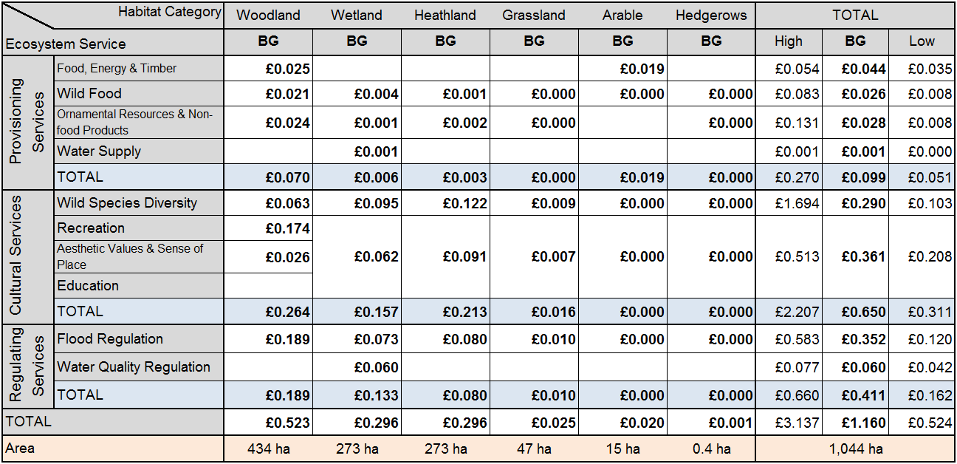

|  |  |  |
| --- | --- | --- |
| **Notes:** | | |
| All values are stated in million pounds (£m); 2012 prices. | | |
| Blank cells do not mean 'no value', but that a monetary value could not have been calculated within scope of this study. | | |
| **Legend:** | | |
| BG | Best Guess Estimate |  |
| High | Higher threshold of the sensitivity analysis (even if the real value could still exceed this threshold) |  |
| Low | Lower threshold of the sensitivity analysis |  |
| ***For the underlying assumptions, limitations and valuation methods see the relevant sections.*** | | |

*Source:* ***Author calculations***

# Conclusions and Guidance

## Key Findings and Interpretation

Altogether, 956 km2 of habitats have been evaluated within the scope of this Ecosystem Assessment for Staffordshire. This constitutes more than 35% of the total geographical area of Staffordshire. Stating the best guess, the ecosystem services assessed within this investigation have been valued at £111.89 million annually. The sensitivity analysis results in a range from £67.89 million to £218.70 million per year. The average annual value per hectare is £1,170 (£710 - £2,288). These figures refer to the annual flow of ecosystem services rather than the stock value of the natural capital.

When capitalised over a timeframe of 200 years, the value of those ecosystem services that could be assessed in Staffordshire stood at £7.19 billion (£2.15b - £43.74b), equivalent to £75,161 per hectare in average. The wide range of the sensitivity analysis for the capitalised value can be explained by the different discount rates applied. The main findings of this investigation are summarised in Table 8.1 (annual values) and Table 8.2 (capitalised values) below. All values are stated in million pounds (£m) and given in 2012 prices.

It should be stressed that this is a baseline or preliminary figure as  it has only been possible to value a proportion of ecosystem services for methodological or data limitation  reasons. These limitations also prevented quantitative valuation of some ecosystem services and, even for those ecosystem services assigned a monetary value, sometimes only a limited attribute of the service could be valued.   This applies for example for the aesthetic values and sense of place of broadleaved woodland (see Section 3.2). Within scope of this investigation only the visual amenity of woodland from home in urban areas has been valued. However, the ‘true’ amenity and sense of place value of woodland has many more attributes. Further work is recommended to fill gaps in the assessment (see Section 8.2).

The extent of this undervaluation is indicated in Figure 8.1. The green and light green fields indicate which ecosystem service/broad habitat combinations have been valued or partially valued in monetary terms, respectively. All red fields indicate that the broad habitat provides a valuable ecosystem service, but that this service has not been valued in monetary terms within scope of this Staffordshire Ecosystem Assessment. Because it was not possible to assign a monetary value to the majority of ecosystem services, the real value of ecosystem services in Staffordshire is likely to be significantly higher than the £112 million per annum calculated within this investigation. The real value may even well exceed the higher threshold of the sensitivity analysis as this is based on the assessed ecosystem services only.

Figure 8.1 Indicative Staffordshire Ecosystem Assessment Coverage



*Source:* ***Author assessment based on Haines-Young and Potschin 2008***

We also have to bear in mind that monetary values are purely indicative as most ecosystem services are not included in the market economy and cannot be ‘bought’. It should also be acknowledged that different methods have been used to value ecosystem services for different habitats. Therefore one cannot confidently make a direct comparison between the values of different habitats or ecosystem services. Such limitations should always be acknowledged when making reference to figures and values presented in this publication. When figures are quoted, the specific valuation methods, assumptions and caveats should be stated as well. For more information see the relevant chapters in this report.

Table 8.1 Annual Baseline Value of Ecosystem Services Provided by Assessed Habitats in Staffordshire

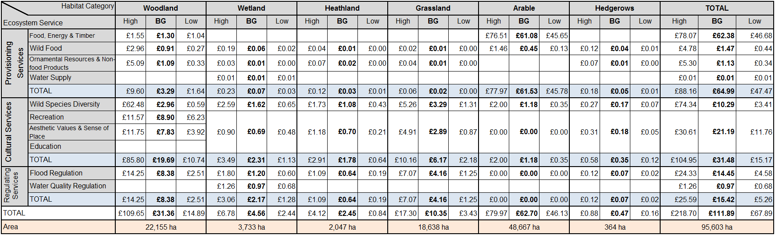

|  |  |  |
| --- | --- | --- |
| **Notes:** | | |
| All values are stated in million pounds (£m); 2012 prices. | | |
| Blank cells do not mean 'no value', but that a monetary value could not have been calculated within scope of this study. | | |
| **Legend:** | | |
| BG | Best Guess Estimate |  |
| High | Higher threshold of the sensitivity analysis (even if the real value could still exceed this threshold) |  |
| Low | Lower threshold of the sensitivity analysis |  |
| ***For the underlying assumptions, limitations and valuation methods see the relevant sections.*** | | |

*Source:* ***Author calculations***

Table 8.2 Capitalised Baseline Value of Ecosystem Services Provided by Assessed Habitats in Staffordshire

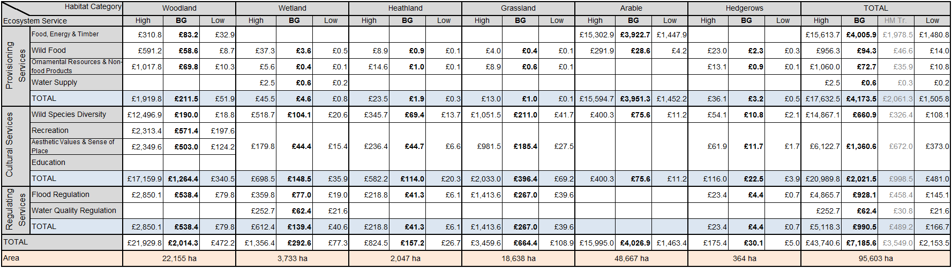

|  |  |  |
| --- | --- | --- |
| **Notes:** | | |
| All values are stated in million pounds (£m); 2012 prices.  All values have been capitalised over 200 years. | | |
| Blank cells do not mean 'no value', but that a monetary value could not have been calculated within scope of this study. | | |
| **Legend:** | | |
| BG | Best Guess Estimate |  |
| HM Tr. | Best guess estimate applying the discount rate recommended by HM Treasury (as for the lower threshold). This value has just been stated to allow comparison with other related studies in the UK. | |
| High | Higher threshold of the sensitivity analysis (even if the real value could still exceed this threshold). A discount rate of 0.0% has been applied. | |
| Low | Lower threshold of the sensitivity analysis. A discount rate of 3.5% has been applied for year 1-30. Afterwards the discount rate declines to 3.0% till year 75 and 2.5% afterwards. | |
| ***For the underlying assumptions, limitations and valuation methods see the relevant sections.*** | | |

*Source:* ***Author calculations***

Table 8.1 and Table 8.2 only cover ecosystem services for which it has been possible to value at least one habitat. However, other ecosystem services (such as climate regulation) provide significant benefits as well, even if these services could not be quantified in monetary terms. Such benefits are described qualitatively in the relevant preceding sections of this report.

A sensitivity analysis with a high and a low estimate has been applied. This range considers, for example, scientific uncertainties or possible value transfer errors. However, the sensitivity analysis has only been applied for ecosystem services which could be quantified in monetary terms. Therefore, the real value of ecosystem services/habitats may still exceed the upper threshold of the sensitivity analysis.

The value of ecosystem services was calculated as both annual value and capitalised values. For both, a *ceteris paribus* scenario is implicit. This means that other influencing quantities such as population growth, extent of habitats etc. are assumed to be constant over time.

Whilst the potential to manage some habitats to optimise services has been considered (for example wetland and floodplain management for flood risk or the contribution of urban trees to air quality), it is beyond of the scope of this study to identify how habitat could be best managed to optimise benefits across multiple ecosystem services. However, in terms both of identifying habitat in the most beneficial locations (such as noise buffering by urban trees) and habitat management to optimise benefits across multiple ecosystem services (such as wetland management for simultaneous flood risk, water quality, fishery recruitment, green space, and other benefits), there is a significant potential to optimise public value per unit of management intervention and expense representing cumulatively greater public value. Habitat optimisation for multiple benefits would be a valuable follow-on study. It may also serve as a valuable means to better target existing maintenance budgets to achieve greater returns to society.

## Recommendations and Conclusions

In this Section, we suggest some actions, policies and projects to better integrate the value of ecosystem services into decision-making in Staffordshire. We start with some best practice recommendations and policies that could enhance human wellbeing by improving the provision of ecosystem services and/or halt the loss of ecosystem services, respectively. Many of these actions could be implemented in the short term.

We acknowledge gaps in the scientific evidence and local information about the state, value and future trends in the provision of ecosystem services in Staffordshire. We recommend projects and research that can strengthen the evidence base, consequently enhancing decision-making relating to how ecosystems are affected. This can help support better-informed decisions in the future by incorporating more of the true value of ecosystems into decision-making processes at all scales.

### Practice & Policy

Collaboration and knowledge transfer

This Ecosystem Assessment process has revealed that, due to the diversity of values provided by ecosystems as well as the factors that influence them, organisations and sectors which are usually not engaged in nature conversation and environmental management may share common goals with the Staffordshire Local Nature Partnership. This particularly applies to institutions that may have formerly perceived ‘nature’ as a matter of altruistic conservation, rather than a source of multiple values supporting the local economy, public health and quality of life. Better coordination and collaboration and mutual understanding of the multiple values of nature among these institutions may offer opportunities to achieve common goals by partnership working, sharing knowledge and resources and optimising the outcomes of projects on the ground, taking into account the full range of ecosystem services, and including objectives for these within projects and initiatives.

One example is the public health sector. This Ecosystem Assessment has demonstrated that ecosystems provide a wide range of services enhancing and improving human health and wellbeing (see for example Section 3.4). Collaboration on greenspace delivery and enhancement projects and initiatives engaging communities with the environment may enhance effective delivery of public services and result in positive effects on wellbeing among, in particular, deprived communities and disadvantaged sectors. The creation and improvement of habitats could, for example, be targeted in areas with poor health indicators (see also ecosystem service supply and demand map below). This could help to avoid and mitigate illnesses related to physical inactivity before they require medical treatment at public expense. The integration of public health services within the County Council seems to offer a good opportunity to develop an integrated approach.

Potential opportunities also stem from enhanced cooperation between the public, private and voluntary sectors in the environmental management of Staffordshire. Businesses of all types have many impacts and dependencies on ecosystems of which they may be unaware, not only within the agricultural sector (see for example Section 3.6). A knowledge transfer programme could help businesses better understand their interrelationship with the environment, and may enhance public-private partnerships in environmental management. Tools such as Corporate Ecosystem Valuation (CEV) and Payments for Ecosystem Services (PES) may be applicable in this context.

Land-use planning and development management

The results of Ecosystem Assessments and ecosystem valuation will provide planning authorities with information about ecosystem impacts, especially for large-scale developments. The cumulative effects of smaller-scale developments have also to be recognised, and may effectively be addressed by reflecting ecosystems services values in planning policy and guidance, in line with the National Planning Policy Framework Core Planning Principles which requires the planning system to take account of ecosystem services.[242] This report may be appropriate to support inclusion of policy within Local Plans, the Minerals Plan or Supplementary Planning Guidance. The ecosystem services framework may also be integrated within tools such as environmental Cost-Benefit Analysis (CBA) and Multi-Criteria-Decision Analysis (MCDA), or a combination of both, to strengthen the evidence base for planning authorities. The National Ecosystem Assessment Follow-on (NEAFO) programme[243] offers some useful information and guidance on how to implement the Ecosystem Approach and the value of ecosystem services within policy tools, particularly those relating to planning.

It is important that relevant information is easy to access and provided in a format that is relevant and usable for planning authorities. Developing and implementing policy tools incorporating the marginal value of ecosystem services provision on a spatial scale should be seen as one of the logical next steps to implementing the Ecosystem Approach in decision-making.

This applies for example for planning decisions. Birmingham City Council is developing a tool to assess the impact of new developments with the aim to improve the overall impact of developments on the provision of ecosystem services. Such tools might be developed for Staffordshire as well, or be developed in a generically applicable format.

It is essential that ecosystems and their services are no longer, as they have often been, perceived as a constraint on development but as assets that add value including for example natural flood management, proximity to ‘green spaces’ that can enhance real estate value, improvement of visual and air quality, etc.

Street tree (re)planting

Street trees are of particular importance as they provide a wide range of ecosystem services that have often been significantly degraded in urban environments. These services include regulation of air quality and of the local and global climate, habitat for species, amenity values, noise buffering, improved visual aesthetics, and many more (see for example Section 3.2, Section 3.4 and Section 4.5 of this report). Valuation of the services provided by street trees elsewhere (for example in a survey in New York City[244]) strongly indicates that, where street trees need to be removed for health and safety, transport infrastructure development or operation, or other reasons, they should be replaced and that opportunities to plant substantial new street trees should be taken, especially in areas with low canopy cover and high population density.

To address the way that street trees and their management are usually accounted for as costs rather than asset under current accounting systems, the value of street trees should be better included in public accounting. Tools like CAVAT (Capital Asset Value for Amenity Trees) or i-Tree (see below) can be used to estimate the value of such trees. For more information see for example Forestry Commission (2010).[245]

Payments for Ecosystem Services (PES)

A diversity of mechanisms are in development to bring some of the formerly overlooked values provided by nature into markets, including for example nascent carbon markets, natural floodwater retention and tradable biodiversity offsets. One of the more promising and globally pervasive tools to bring specific ecosystem service values into markets is ‘payments for ecosystem services’ (PES).

PES is a market-based instrument founded on creation of markets between the ’providers’ of ecosystem services, generally comprising land and other resource managers whose actions influence the protection or enhancement of ecosystem services of interest, and principal ‘users’ (or ‘consumers’ or ‘beneficiaries’) of those services. Practical examples include win-win PES markets established between farm business ‘providers’ whose activities influence the quality of raw water produced by catchment landscapes and water company ‘users’ who benefit from reduced costs associated with treatment of water abstracted for public supply.

By 2010, over 300 PES markets were identified globally.[246] This number has since accelerated massively to many thousands, many mediated by governments in combination with wider social goals such as regional regeneration.[247] Opportunities for PES within Staffordshire can be further explored including better targeting of statutory funding (agri-environment schemes, urban greenspace maintenance, flood engineering, etc.) to work with natural processes to achieve more beneficial outcomes across a spectrum of ecosystem services. Inclusion of the value of ecosystems and their services into regeneration projects; as well as engagement of businesses in markets for services such as enhanced amenity and real estate value due to proximity to green spaces in mixed developments, natural flood management, protection of reliable water supply, etc. are other opportunities One related initiative is already occurring under the TULIP project at Stoke-on-Trent along the Fowlea Brook, where ecosystem services are being considered as an integrating framework for urban redevelopment.

‘Green first’ policy

For public expenditure, for example for infrastructure projects, a presumption should always be made in favour of ‘green’ solutions that might provide the same benefits or solve the problem at equal or lower costs. There are many robust examples of where the creation of green infrastructure is more cost-effective than man-made engineering solutions. This applies for example in flood defence or water quality treatment (see for example Section 4.4).

Everard and McInnes (in press)[248] also recognise substantial potential for the extension of ‘systemic solutions’ which they define as “…*low-input technologies using natural processes to optimise benefits across the spectrum of ecosystem services and their beneficiaries*”. This has already been recognised in Section 7.1 in terms of the potential to manage some habitats to optimise outcomes in terms of services, in terms both of habitat in the most beneficial locations and habitat management to optimise benefits across multiple ecosystem services.

The development of guidance and options for the protection, restoration or management of habitat to achieve optimal benefit realisation across multiple ecosystem services, and hence greatest return on public investment for all in society, would constitute a valuable follow-on study. This form of targeted investment in habitat and the beneficial processes that it performs provides an ecosystem-based means to maximise public value in urban redevelopment initiatives, in line with the ‘systemic solutions’ principles outlined previously, and also to improve the targeting of subsidies and other interventions for achieve the greatest cumulative public benefit.

Staffordshire Green Infrastructure Strategy

The Staffordshire Local Nature Partnership has the vision to make Staffordshire a more prosperous and healthy environment to live in and believes that economic development can and must go hand-in-hand with protection of the County’s important environmental assets. This investigation provides evidence about the importance of these environmental assets and how people benefit from them. The next step is to establish a county-wide strategy on how to protect and enhance the green infrastructure in Staffordshire and how to improve people’s wellbeing by using this valuable asset in a sustainable way. Staffordshire’s Green Infrastructure Strategy would be the first one in Staffordshire at the county level and will be driven by the local demand for ecosystem services applying the principles of the Ecosystem Approach and informed by sound science. The main advantages of a county-wide GI strategy are that cross-boundary issues can be better resolved and that key stakeholders relevant to the whole county can be better involved in the process.

### Research & Evaluation

Trend and Scenario Analysis

This Ecosystem Assessment provides advanced information about the state and value of ecosystem services in Staffordshire. However, robust information about trends and future changes in the provision of ecosystem services is lacking, and this information is important for consideration of vulnerabilities and future aspirations. To overcome this shortcoming, it is recommended that a further trend and scenario analysis should be undertaken for the ecosystem services in Staffordshire in order to ‘future-proof’ the sustainable provision of ecosystem services.

Such an investigation would reveal how the provision of ecosystem services has changed within the past 25 years or so. It would also analyse the main drivers of change such as climate change and population growth as the basis for scenario development about how the provision of ecosystem services might change in the future due to the influence of external factors such as climate change models and policy scenarios. The scenarios framework developed by the UK NEA could be used for this purpose, as it produces simple and easily accessible outcomes. The findings could be presented in the same format as in Figure 8.1 below, but with different broad habitat categories.

Figure 8.2 Relative Importance of Broad Habitats in Delivering Ecosystem Services

and Overall Direction of Change in Service Flow Since 1990 in the UK

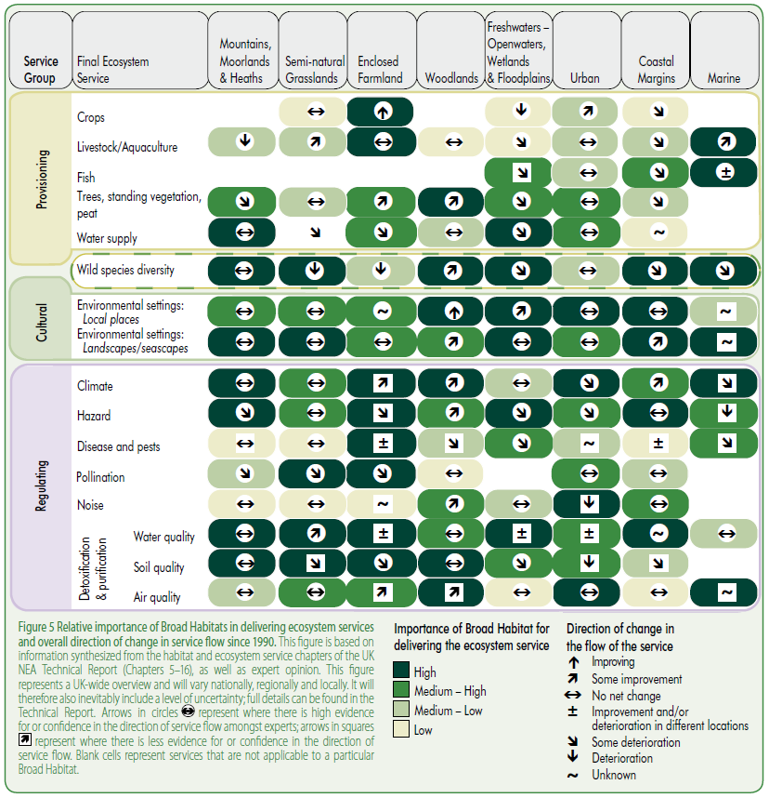

*Source:* ***Adopted from UK NEA 2011a, p. 11***

Accessible Natural Greenspace Standard (ANGSt)

The Accessible Natural Greenspace Standard (ANGSt) was developed in the early 1990s by Natural England. It is a framework assessing the current level of accessible natural greenspace within a specific area as well as the population that can benefit from such accessible greenspace.[249] One main element is evaluating the distance between households and accessible natural greenspace. The ANGSt framework recommends, for example, that everyone should have accessible natural greenspace within 300m (or 5 minutes walk) from home. The steering group for this Ecosystem Assessment has recommended that, where this has not already been carried out, an ANGSt analysis should be undertaken for all residential areas in Staffordshire. A County-wide integrated ANGSt assessment could be realised in the short term and such information could also inform an ecosystem services supply and demand map (see below).

Ecosystem Services Supply & Demand Map (ESSDM)

This study provides a general view of the value of ecosystem services, but not spatially explicit information about the value of specific areas and habitats. However, such information could be very useful to plan and manage greenspaces and ecosystems in Staffordshire, particularly for ecosystem services that are ‘consumed’ locally to where they are produced (such as amenity and recreational services). Therefore, the steering group recommends the development of an ecosystem services supply and demand map for Staffordshire. This would enable better targeting of actions for nature conservation as well as for the creation and protection of important habitats, potentially optimising public benefits across ecosystem services.

Such an ecosystem services supply and demand map would initially identify areas where the creation and/or improvement of ecosystems and habitats would deliver the most benefit due to proximity to the greatest demand. It would also highlight where ecosystems provide the most valuable services which could justify protection of key habitats, even if these productive habitats are not subject to any formal spatial designation. In contrast with other approaches, an ecosystem services supply and demand map of this nature would not focus simply on just one or a few agenda items or ecosystem services, but would address provision of multiple benefits supported by a wide range of ecosystem services cumulatively delivering the greatest societal value along the lines described by Everard and McInnes (2013) for ‘systemic solutions’. This would support a more strategic allocation of public expenditure to deliver best value for money.

An ecosystem services supply and demand map has recently been developed for the City of Birmingham, and the approach used could be further developed and adapted to the specific circumstances and demands of Staffordshire. An ecosystem services supply and demand map could be further developed to incorporate a habitat opportunity map, identifying areas in Staffordshire, especially in urban areas, where creation or improvement of habitats could optimally enhance human wellbeing. This could also include, for example, technical solutions relating to valuable natural processes such as SuDS, green roofs and green infrastructure. These maps could become a powerful tool to improve the targeting of optimally beneficial actions on the ground and to deliver ecosystem services where they are most demanded.

i-Tree Eco assessment

It is recommended that an i-Tree Eco assessment should be carried out. i-Tree is a peer-reviewed tool which has been developed by the US Forest Service. The i-Tree tool calculates a monetary value of air pollution control, carbon stock as well as annual carbon uptake of trees within a specific geographical area. Additionally, it supports quantification of the structural value of the tree population as well as energy cost savings and impacts on water run-off. This could be undertaken for Staffordshire as a whole or for focal case study areas, for example in urban areas where the urban forest provides ecosystem services of particular local value. Applying the i-Tree tool would add additional evidence regarding the value of ecosystem services in Staffordshire and close some knowledge gaps identified by this study. It could also provide robust evidence as to why trees should be accounted for as assets rather than merely as management costs.

Primary valuation studies and blue infrastructure

As mentioned throughout this Ecosystem Assessment, significant gaps have been identified in the evidence base, and this has hence enabled evaluation of only a proportion of the ecosystem services provided by habitats in Staffordshire. Where values deriving from this study are used for external purposes, monetary value should always be accompanied by a statement that these are partial estimates that omit significant elements of overall ecosystem value.

Highly significant amongst the exclusions from this Ecosystem Assessment is ‘blue infrastructure’ (rivers, canals, open water and ponds), which the UK National Ecosystem Assessment, the UN Millennium Ecosystem Assessment, the Ramsar Convention and other authoritative sources suggest may be of substantial value both for multiple ecosystem services and also for the services provided by other adjacent habitats.[250]

This assessment also excluded some grassland habitats, including semi-improved and amenity grassland which cover extensive areas in the County. Further research should focus on such gaps and optimise findings for a benefit-transfer application to make it useful for decision-making purposes. Research should provide evidence which can be applied using data and statistics which are available, such as the Monitor of Engagement with the Natural Environment (MENE) survey. These additional data sources could, for example, be used to assess the recreational value of blue infrastructure. We strongly recommend that such habitats are included in a subsequent study when relevant primary studies become available to apply the benefit transfer approach.

### Conclusions

This Ecosystem Assessment has shown how important and valuable habitats and ecosystems are for human wellbeing in Staffordshire. It cannot be stressed enough that the calculated value of ecosystem services provided by habitats in Staffordshire of almost £112 million per annum is still incomplete and therefore represents a partial indication only of the true value of ecosystem services in Staffordshire. Even the high-end estimate of £219 million p.a. may still be an underestimation.

Staffordshire County Council, Stoke-on-Trent City Council and the District and Borough Councils have a duty to maximise the wellbeing of their inhabitants. The findings of this study have shown that, in many cases, the protection, creation and improvement of ecosystems can be seen as a cost-effective way of achieving this goal. This is particularly so when habitats and other natural assets are managed to optimise outcomes across multiple ecosystem services, contributing to overall cumulative public value. Government has now put in place a number of initiatives which promote the incorporation the value of ecosystem services into decision-making. These include for example the Natural Environment White Paper (NEWP), the National Planning Policy Framework, the UK National Ecosystem Assessment (UK NEA) and the PES Best Practice Guide.[251]

Implementing the true value of ecosystem services and natural assets in decision-making can help to mitigate the continuing loss of ecosystems and their beneficial services, thereby enhancing human wellbeing and security. This Ecosystem Assessment can be seen as an initial step towards a sustainable future for Staffordshire. However, further steps are necessary to make use of such values and information. Some feasible next steps have been outlined in Section 8.2.1 above. We recommend a clear set of follow-on activities, including for example a dissemination and discussion workshop for key staff of Local Nature Partnership constituent organisations (LEPs, Environment Agency, Natural England, local authorities, etc.) to spread learning and develop practical measures to internalise ecosystems services values and thinking into mainstream practice. A workshop might usefully be run in collaboration with related ecosystem-based initiatives, such as the TULIP project in Stoke-on-Trent.

# Abbreviations

ANGSt Accessible Natural Greenspace Standard

ASNW Ancient Semi-Natural Woodland

b Billion (£)

BAP Biodiversity Action Plan

BG Best Guess

DECC Department of Energy and Climate Change

Defra Department for Environment, Food and Rural Affairs

EFTEC Economics for the Environment Consultancy

GIS Geographic Information System

m Million (£)

MENE Monitor of Engagement with the Natural Environment

NEWP Natural Environment White Paper

PES Payments for Ecosystem Services

SPD Supplementary Planning Document

SSSI Site of Specific Scientific Interest

SuDS Sustainable Drainage System

SWT Staffordshire Wildlife Trust

TBT Tributyl tin

TEEB The Economics of Ecosystems and Biodiversity

TEV Total Economic Value

UHI Urban Heat Island

UHIE Urban Heat Island Effect

UK NEA UK National Ecosystem Assessment

UK NEAFO UK National Ecosystem Assessment Follow-On

WTA Willingness-To-Accept

WTP Willingness-To-Pay

# References

APHO. 2010. West Midlands Health Profile 2010. Association of Public Health Observatories. Available from <http://www.apho.org.uk/resource/view.aspx?RID=95272>.

Van den Berg, Agnes E., Sander L. Koole, and Nickie Y. van der Wulp. 2003. Environmental preference and restoration: (How) are they related? *Journal of Environmental Psychology* 23 (2): 135–146.

Birol, Ekin, Nick Hanley, Phoebe Koundouri, and Yiannis Kountouris. 2007. *The optimal management of wetlands: quantifying trade-offs between flood risks, recreation and biodiversity conservation*. Environmental Economy and Policy Research Working Paper. University of Cambridge, Department of Land Economics.

Boyd, James, and Spencer Banzhaf. 2007. What are ecosystem services? The need for standardized environmental accounting units. *Ecological Economics* 63 (2–3): 616–626.

Brander, L. M., A. Ghermandi, O. Kuik, A. Markandya, P. Nunes, M. Schaafsma, and A. Wagtendonk. 2008. Scaling up ecosystem services values - methodology, applicability and a case study.

Broadmeadow, Mark, and Robert Matthews. 2003. *Forests, Carbon and Climate Change: the UK Contribution*. Edinburgh: Forestry Commission.

Buccolieri, Riccardo, Christof Gromke, Silvana Di Sabatino, and Bodo Ruck. 2009. Aerodynamic effects of trees on pollutant concentration in street canyons. *Science of The Total Environment* 407 (19): 5247–5256.

CABE Space. 2009. Making the invisible visible – the real value of park assets. CABE. Available from <http://www.cabe.org.uk/files/making-the-invisible-visible-full.pdf>.

Christie, Mike, Tony Hyde, Rob Cooper, Ioan Fazey, Peter Dennis, John Warren, Sergio Colombo, and Nick Hanley. 2011. *Economic Valuation of the Benefits of Ecosystem Services delivered by the UK Biodiversity Action Plan*. Report to Defra. London: Aberystwyth University.

Church, Andrew, Jacquelin Burgess, Neil Ravenscroft, William Bird, Kirsty Blackstock, Emily Brady, Michael Crang, et al. 2011. UK National Ecosystem Assessment of Cultural Services. In *The UK National Ecosystem Assessment Technical Report*. Cambridge: UNEP-WCMC.

CJC Consulting, Ken Willis, and Liesl Osman. 2005. *Economic Benefits of Accessible Green Spaces for Physical and Mental Health: Scoping study*. Final report for the Forestry Commission. Oxford.

Cooper, Nigel. 2009. *The spiritual value of ecosystem services: an initial Christian exploration.* Working Paper. Anglia Ruskin University. Available from <http://angliaruskin.openrepository.com/arro/handle/10540/288687>.

Costanza, Robert, Ralph d’ Arge, Rudolf de Groot, Stephen Farber, Monica Grasso, Bruce Hannon, Karin Limburg, et al. 1997. The value of the world’s ecosystem services and natural capital. *Nature* 387 (6630): 253–260.

DCLG. 2012. *National Planning Policy Framework*. London: Department for Communities and Local Government.

DECC. 2009. Carbon Valuation in UK Policy Appraisal: A Revised Approach. Department of Energy and Climate Change. Available from <http://www.decc.gov.uk/assets/decc/what%20we%20do/a%20low%20carbon%20uk/carbon%20valuation/1_20090715105804_e_@@_carbonvaluationinukpolicyappraisal.pdf>.

Defra. 2007. An introductory guide to valuing ecosystem services. Department of Environment, Food and Rural Affairs. Available from <http://www.defra.gov.uk/environment/policy/natural-environ/documents/eco-valuing.pdf>.

Defra. 2005. *Making space for water: Taking forward a new Government strategy for flood and coastal erosion risk management in England*. London: Department for Environment, Food and Rural Affairs. Available from <http://archive.defra.gov.uk/environment/flooding/documents/policy/strategy/strategy-response1.pdf>.

Defra. 2010. Structure of the agricultural industry in England and the UK. Available from <https://www.gov.uk/government/statistical-data-sets/structure-of-the-agricultural-industry-in-england-and-the-uk-at-june>.

Defra. 2012. Structure of the agricultural industry in England and the UK. Available from <https://www.gov.uk/government/statistical-data-sets/structure-of-the-agricultural-industry-in-england-and-the-uk-at-june>.

Defra, DARD, Welsh Assembly Government, The Department for Rural Affairs and Heritage, and The Scottish Government, Rural and Environment Research and Analysis Directorate. 2013. *Agriculture in the United Kingdom 2012*.

Department of Health. 2009. Be active, be healthy: a plan for getting the nation moving. Available from <http://www.dh.gov.uk/en/Publicationsandstatistics/Publications/PublicationsPolicyAndGuidance/DH_094358>.

Donovan, Rossa. 2003. The Development of an Urban Tree Air Quality Score (UTAQS) using the West Midlands, UK Conurbation as a Case Study Area. Doctoral thesis, University of Lancaster.

Edwards, Dawid, Anna Elliot, Max Hislop, Suzanne Martin, Jake Morris, Liz O’Brien, Andrew Peace, Vadims Sarajews, Maud Serrand, and Gregory Valatin. 2009. *A valuation of the economic and social contribution of forestry for people in Scotland*. Forestry Commission Research Report. Edinburgh.: Forestry Commission Scotland. Available from <http://www.forestry.gov.uk/pdf/fcrp101.pdf/$FILE/fcrp101.pdf>.

Edwards-Jones, Gareth, Paul Cross, Nicola Foley, Ian Harris, Mike Kaiser, Lewis Le Vay, Mark Rayment, Matt Scowen, and Paul Waller. 2011. UK National Ecosystem Assessment of Provisioning Services. In *The UK National Ecosystem Assessment Technical Report*. Cambridge: UNEP-WCMC.

EEA. 2011. *Green infrastructure and territorial cohesion: The concept of green infrastructure and its integration into policies using monitoring systems*. EEA Technical report. Copenhagen: European Environment Agency.

EFTEC. 2010. *Flood and Coastal Erosion Risk Management: Economic Valuation of Environmental Effects*. Handbook prepared for the Environment Agency for England and Wales. EFTEC. Available from <http://publications.environment-agency.gov.uk/pdf/GEHO0310BSFH-e-e.pdf>.

EFTEC. 2007. *Policy Appraisal and the Environment: An Introduction to the Valuation of Ecosystem Services. Wareham Managed Realignment Case Study*. Case Study submitted to the Department of Environment Food and Rural Affairs. EFTEC.

Ekosgen, and Lockhart Garratt. 2009. Regional Forestry Economic Baseline for the West Midlands. Ekosgen in association with Lockhart Garrott. Available from <http://www.advantagewm.co.uk/Images/Regional%20Forestry%20Economic%20Baseline%20for%20the%20West%20Midlands%20-%20November%202009_tcm9-27609.pdf>.

Elliman, Christopher, and Nathan Berry. 2007. Protecting and restoring natural capital in New York City’s Watersheds to safeguard water. In *J. Aronson, S. Milton and J. Blignaut ‘Restoring Natural Capital: Science, Business and Practice’*, 208–215. Washington DC: Island Press.

ERM, and Kenneth Willis. 2004. *Woodland - its contribution to Sustainable Development and the Quality of Life*. Report prepared for the Woodland Trust. Environmental Resources Management. Available from <http://www.woodlandtrust.org.uk/SiteCollectionDocuments/pdf/policy-and-campaigns/woods-for-people/qol.pdf>.

European Commission. 2012. *The Multifunctionality of Green Infrastructure*. Science for Environmental Policy.

Evans, E., R. Ashley, J. Hall, E. Penning-Rowsell, A. Saul, P. Savers, C. Thorne, and A. Watkinson. 2004. *Foresight. Future flooding. Scientific Summary. Volume I: Future risks and their drivers*. London: Office of Science and Technology. Available from <http://www.bis.gov.uk/assets/bispartners/foresight/docs/flood-and-coastal-defence/vol1chapter2.pdf>.

Everard, Mark, and Robert McInnes. 2013. Systemic solutions for multi-benefit water and environmental management. *Science of The Total Environment* 461–462: 170–179.

Firbank, Les, Richard Bradbury, Davy McCracken, Chris Stoate, Keith Goulding, Ralph Harmer, Tim Hess, et al. 2011. UK National Ecosystem Assessment of Enclosed Farmland. In *The UK National Ecosystem Assessment Technical Report*. Cambridge: UNEP-WCMC.

Flanders, J., and S. Lawley. 2012. *Application to DEFRA for Local Nature Partnership Status*. Staffordshire Local Nature Partnership.

Forest Research. 2010. *Benefits of green infrastructure*. Report to Defra and Communities and Local Government. Farnham: Forest Research. Available from <http://www.forestresearch.gov.uk/pdf/urgp_benefits_of_green_infrastructure_main_report.pdf/$FILE/urgp_benefits_of_green_infrastructure_main_report.pdf>.

Forestry Commission. 2007. A Woodfuel Strategy for England. Forestry Commission. Available from <http://www.forestry.gov.uk/pdf/fce-woodfuel-strategy.pdf/$FILE/fce-woodfuel-strategy.pdf>.

Forestry Commission. 2010. *The case for trees*. Available from <http://www.forestry.gov.uk/pdf/eng-casefortrees.pdf/$FILE/eng-casefortrees.pdf>.

Forestry Commission. 2008. *Woodland area, planting and restocking*. Edinburgh: Forestry Commission. Available from <http://www.forestry.gov.uk/pdf/area08.pdf/$FILE/area08.pdf>.

Garrod, Guy. 2002. *Social and environmental benefits of forestry phase 2: landscape benefits*. Report to the Forestry Commission. Centre for Research in Environmental Appraisal & Management University of Newcastle. Available from <http://www.forestry.gov.uk/pdf/fclscaperep.pdf/$FILE/fclscaperep.pdf>.

German Federal Environment Agency. 2008. *Economic Valuation of Environmental Damage – Methodical Convention for Estimates of Environmental Externalities*. Dessau-Rosslau: German Federal Environment Agency.

Gill, S. E., J. F. Handley, A. R. Ennos, and S. Pauleit. 2007. Adapting cities for climate change: the role of the green infrastructure. *Built Environment* 33: 115–133.

Gorte, Ross W. 2009. *Carbon Sequestration in Forests*. US Congress Research Service Report. Available from <http://www.fas.org/sgp/crs/misc/RL31432.pdf>.

Grahn, Patrik, and Ulrika A. Stigsdotter. 2003. Landscape planning and stress. *Urban Forestry & Urban Greening* 2 (1): 1–18.

Haines-Young, R., and M. Potschin. 2008. *England’s Terrestrrial Ecosystem Services and the Rationale for an Ecosystem Approach*. Full Technical Report.

Hanley, Nick, Ken Willis, Neil Powe, and Maggie Anderson. 2002. *Valuing the Benefits of Biodiversity in Forests. Social & Environmental Benefits of Forestry Phase 2*. Report to the Forestry Commission. Edinburgh: Centre for Research in Environmental Appraisal and Management, University of Newcastle upon Tyne. Available from <http://www.cbd.int/doc/case-studies/inc/cs-inc-uk7-en.pdf>.

Heelas, Paul, Linda Woodhead, Benjamin Seel, Bronislaw Szerszynski, and Karin Tusting. 2005. *The spiritual revolution: why religion is giving way to spirituality*. Malden, Mass. [u.a.: Blackwell.

Heerwagen, Judith H., and Gordon H. Orians. 1986. Adaptations to Windowlessness. *Environment and Behavior* 18 (5): 623 –639.

HM Government. 2011. *The Natural Choice: securing the value of nature*. Available from <http://www.official-documents.gov.uk/document/cm80/8082/8082.pdf>.

HM Treasury. 2003. *The Green Book: appraisal and evaluation in central government*. TSO, London. Available from <http://www.hm-treasury.gov.uk/d/green_book_complete.pdf>.

Ho, Ching-Hua, Laura Payne, Elizabeth Orsega-Smith, and Geoffrey Godbey. 2003. *Parks, recreation and public health: parks and recreation improve the physical and mental health of our nation. (Research Update).: An article from: Parks & Recreation*. National Recreation and Park Association. Available from <http://findarticles.com/p/articles/mi_m1145/is_4_38/ai_100960607/pg_4/>.

Hölzinger, Oliver. 2010. *Institutionenökonomische Analyse des Politikversagens beim Klimaschutz: Warum dem Marktversagen ‘Klimawandel’ ein massives Politikversagen ‘Klimaschutz’ entgegensteht*. VDM Verlag Dr. Müller.

Hulme, Mark, and Gavin Siriwardena. 2010. *Breeding Bird Diversity as a Function of Land Cover*. UK NEA Economic Analysis Report.

IPCC. 2007. *Climate Change 2007: Synthesis Report*. Geneva, Switzerland: Intergovernmental Panel on Climate Change. Available from <http://www.ipcc.ch/publications_and_data/ar4/syr/en/contents.html>.

Kaplan, Stephen. 1995. The restorative benefits of nature: Toward an integrative framework. *Journal of Environmental Psychology* 15 (3): 169–182.

Kazmierczak, Aleksandra, and Jeremy Carter. 2010. *Adaptation to climate change using green and blue infrastructure - A database of case studies*. Manchester: University of Manchester.

Kuppuswamy, Hemavathy. 2009. Improving health in cities using green infrastructure: A review. *FORUM Ejournal* 9: 63–76.

Land Use Consultants. 2002. *South West Woodland and Forestry Strategic Economic Study*. Final Report Prepared for the South West Regional Development Agency and the Forestry Commission. Bristol. Available from <www.southwestlandscapes.org.uk/download.asp?DocId=53>.

Land Use Consultants, and GHK Consulting. 2009. *Provision of Ecosystem Services Through the Environmental Stewardship Scheme*. Bristol. Available from <http://www.hedgelaying.ie/images/1253357089.pdf>.

Lovasi, Gina Schellenbaum, James W Quinn, Kathryn M Neckerman, Matthew S Perzanowski, and Andrew Rundle. 2008. Children living in areas with more street trees have lower asthma prevalence. *Journal of Epidemiology and Community Health*. Available from <http://jech.bmj.com/content/early/2008/05/01/jech.2007.071894.abstract>.

Luther, M., and D. Gruehn. 2001. Putting a price on urban green spaces. *Landscape Design*.

Maltby, Edward, Steve Ormerod, Mike Acreman, Martin Blackwell, Isabelle Durance, Mark Everard, Joe Morris, et al. 2011. UK National Ecosystem Assessment of Freshwaters – Openwaters, Wetlands and Floodplain. In *The UK National Ecosystem Assessment Technical Report*. Cambridge: UNEP-WCMC.

McInnes, Rob. 2007. *Integrating ecosystem services within a 50-year vision for wetlands*. WWT Report to the England Wetland Vision Partnership. Slimbridge. Available from <http://www.wetlandvision.org.uk/userfiles/File/Annex2_EcosystemServicesScopingReport.pdf>.

McPherson, E. G., Javid J. Nowak, and A. R. Rowan. 1994. *Chicago’s urban forest ecosystem - results of the Chicago Urban Forest Climate Project*. General Technical Report. Radnor: U.S. Department of Agriculture. Available from <http://www.nrs.fs.fed.us/pubs/gtr/gtr_ne186.pdf>.

Mell, Ian, Berna Keskin, Sigrid Hehl-Lange, and John Henneberry. 2012. *Valuing Attractive Landscapes in the Urban Economy - Street tree investments on Whitworth Street West, Manchester*. Case study report. Sheffield: Department of Town and Regional Planning, University of Sheffield.

Millennium Ecosystem Assessment. 2005. *Ecosystems and human well-being*. Synthesis Report. Available from <http://www.maweb.org/documents/document.356.aspx.pdf>.

Mourato, Susana, Giles Atkinson, Murray Collins, Steve Gibbons, George MacKerron, and Guilherme Resende. 2010. *Economic Analysis of Cultural Services*. UK NEA Economic Analysis Report. London: London School of Economics and Political Science.

Natural England. 2008. *Carbon Management by Land and Marine Managers*. Research Report. Available from <http://naturalengland.etraderstores.com/NaturalEnglandShop/NERR026>.

Natural England. 2010. *‘Nature Nearby’ - Accessible Natural Greenspace Guidance*. Natural England.

Norris, Ken, Mark Bailey, Sandra Baker, Richard Bradbury, David Chamberlain, Callan Duck, Martin Edwards, et al. 2011. Biodiversity in the Context of Ecosystem Services. In *The UK National Ecosystem Assessment Technical Report*. Cambridge: UNEP-WCMC.

O’Gorman, S., and C. Bann. 2008. *Valuing England’s Terrestrial Ecosystem Services*. Final report to Defra. Jacobs. Available from <http://www.fires-seminars.org.uk/downloads/valuation_englands_ecosystem_services.pdf>.

OECD. 2010. *Paying for Biodiversity: Enhancing the Cost-Effectiveness of Payments for Ecosystem Services*. OECD Publishing.

Van Oudenhoven, Alexander P.E., Katalin Petz, Rob Alkemade, Lars Hein, and Rudolf S. de Groot. 2012. Framework for systematic indicator selection to assess effects of land management on ecosystem services. *Ecological Indicators* 21 (0): 110–122.

Peper, Paula J., E. Gregory McPherson, James R. Simpson, Shelley L. Gardner, Kelaine E. Vargas, and Qingfu Xiao. 2007. *New York City, New York Municipal Forest Resource Analysis*. New York City: Center for Urban Forest Research USDA Forest Service.

Perino, Grischa, Barnaby Andrews, Andreas Kontoleon, and Ian Bateman. 2011. *Urban Greenspace Amenity - Economic Assessment of Ecosystem Services provided by UK Urban Habitats*. Report to the Economics Team of the UK National Ecosystem Assessment. Norwich: University of East Anglia.

Perrot-Maître, Danièle, and Davis Patsy. 2001. *Case Studies of Markets and Innovative Financial Mechanisms for Water Services from Forests*. Washington DC: Forest Trends. Available from <http://www.forest-trends.org/publication_details.php?publicationID=134>.

Pitt, Michael. 2007. *Learning Lessons from the 2007 floods*. Interim Report. Available from <http://www.coulthard.org.uk/hullfloods/Pitts_interim_flood_report_web.pdf>.

Pugh, Thomas A. M., A. Robert MacKenzie, J. Duncan Whyatt, and C. Nicholas Hewitt. 2012. Effectiveness of Green Infrastructure for Improvement of Air Quality in Urban Street Canyons. *Environmental Science & Technology* 46 (14): 7692–7699.

Read, D. J., P. H. Freer-Smith, J. I. L. Morison, Nick Hanley, C. C. West, and P. Snowdon. 2009. *Combating climate change - a role for UK forests. An assessment of the potential of the UK’s trees and woodlands to mitigate and adapt to climate change*. The synthesis report. Edinburgh: The Stationery Offi ce. Available from <http://www.tsoshop.co.uk/gempdf/Climate_Change_Synthesis_Report.pdf>.

Regeneris. 2009. *The Economic Contribution of the Mersey Forest’s Objective One-Funded Investments*. Final Report. Available from <http://www.merseyforest.org.uk/files/Economic%20Contribution%20of%20The%20Mersey%20Forest%27s%20Objective%20One-Funded%20Investments.pdf>.

Rskensr. 2003. *Business Case for the Environment Research Study: Summary of Principle Findings*.

RSPB, Amphibian & Reptile Conservation, Association of British Fungus Groups, Bat Conservation Trust, Biological Records Centre/Centre for Ecology, & Hydrology, Botanical Society of the British Isles, et al. 2013. *State of Nature*.

Saraev, Vadim. 2012. *Economic benefits of greenspace: A critical assessment of evidence of net economic benefits*. Research Report. Edinburgh: Forestry Commission.

SBAP. 2011. *Staffordshire Biodiversity Action Plan (3rd ed.) - Ecosystem Action Plans*. Available from <http://www.sbap.org.uk/>.

Scarpa, Riccardo. 2003. *The Recreation Value of Woodlands - Social & Environmental Benefits of Forestry Phase 2*. Report to the Forestry Commission. Edinburgh: Centre for Research in Environmental Appraisal & Management University of Newcastle. Available from <http://www.forestry.gov.uk/pdf/nmbrecrep.pdf/$FILE/nmbrecrep.pdf>.

Schomers, Sarah, and Bettina Matzdorf. 2013. Payments for ecosystem services: A review and comparison of developing and industrialized countries. *Ecosystem Services*. Available from <http://www.sciencedirect.com/science/article/pii/S221204161300003X>.

Smith, Pete, Mike Ashmore, Helaina Black, Paul Burgess, Chris Evans, Rosemary Hails, Simon Potts, et al. 2011. UK National Ecosystem Assessment of Regulating Services. In *The UK National Ecosystem Assessment Technical Report*. Cambridge: UNEP-WCMC.

Smith, S., P. Rowcroft, M. Everard, L. Couldrick, M. Reed, H. Rogers, T. Quick, C. Eves, and C. White. 2013. *Payments for Ecosystem Services: A Best Practice Guide*. London: Department for Environment, Food and Rural Affairs.

Sport England. 2012. *Active People Survey 6*. Sport England. Available from <http://www.sportengland.org/research/active_people_survey/active_people_survey_6.aspx>.

Staffordshire County Council. 2007. *Newcastle Countryside Project Business Plan 2008-2011. Summary & Action Plan*. Newcastle. Available from <http://www.staffordshire.gov.uk/resources/documents/b/businessplansummary.pdf>.

Staffordshire County Council. 2000. *Planning for Landscape Change: An Introduction and User’s Guide to Supplementary Planning Guidance to the Staffordshire and Stoke on Trent Structure Plan, 1996 – 2011*. Stafford.

Staffordshire County Council. 2010. *Staffordshire Local Economic Assessment 2010: Education and Skills Thematic Issues Paper*. Stafford: Staffordshire County Council.

Stern, Nicolas. 2006. *Stern Review on The Economics of Climate Change*. London: HM Treasury. Available from <http://webarchive.nationalarchives.gov.uk/+/http://www.hm-treasury.gov.uk/stern_review_report.htm>.

Takano, T, K Nakamura, and M Watanabe. 2002. Urban residential environments and senior citizens’ longevity in megacity areas: the importance of walkable green spaces. *Journal of Epidemiology and Community Health* 56 (12): 913 –918.

TEEB. 2010. *The Economics of Ecosystems and Biodiversity: Mainstreaming the Economics of Nature: A synthesis of the approach, conclusions and recommendations of TEEB*. Available from <http://www.teebweb.org/LinkClick.aspx?fileticket=bYhDohL_TuM%3D&tabid=924&mid=1813>.

Tiwary, Abhishek, Danielle Sinnett, Christopher Peachey, Zaid Chalabi, Sotiris Vardoulakis, Tony Fletcher, Giovanni Leonardi, Chris Grundy, Adisa Azapagic, and Tony R. Hutchings. 2009. An integrated tool to assess the role of new planting in PM10 capture and the human health benefits: A case study in London. *Environmental Pollution* 157 (10): 2645–2653.

Tomlinson, Charlie. 2009. *Climate Change and Heat Risk in Urban Areas: A Birmingham Case Study*. Birmingham: School of Engineering, University of Birmingham. Available from <http://www.universitas21.com/GRC/GRC2009/Tomlinson.pdf>.

Tomlinson, Charlie, Lee Chapman, John Thornes, and Christopher Baker. 2011. Including the urban heat island in spatial heat health risk assessment strategies: a case study for Birmingham, UK. *International Journal of Health Geographics* 10: 42.

UK NEA. 2011a. *UK National Ecosystem Assessment: Synthesis of the Key Findings*. Cambridge: UNEP-WCMC. Available from <http://archive.defra.gov.uk/environment/natural/documents/UKNEA_SynthesisReport.pdf>.

UK NEA. 2011b. *UK National Ecosystem Assessment: Technical Report*. Cambridge: UNEP-WCMC.

Ulrich, R S. 1984. View through a window may influence recovery from surgery. *Science (New York, N.Y.)* 224 (4647): 420–421.

Ulrich, R. S., and R. F. Simons. 1986. Recovery from Stress During Exposure to Everyday Outdoor Environments. In *The cost of Not Knowing*. Barnes, R. et al.

Vries, Sjerp de, Robert A Verheij, Peter P Groenewegen, and Peter Spreeuwenberg. 2003. Natural environments -- healthy environments? An exploratory analysis of the relationship between greenspace and health. *Environment and Planning A* 35 (10): 1717 – 1731.

Wang, Fan, Theadore Hunt, Ya Liu, Wei Li, and Simon Bell. n.d. *Reducing Space Heating in Office Buildings Through Shelter Trees*. Edinburgh: The Research Centre for Inclusive Access to outdoor environments, Edinburgh College of Art. Available from <https://www.cibse.org/pdfs/8cwang.pdf>.

Whiting, Gary J., and Jeffrey P. Chanton. 2001. Greenhouse carbon balance of wetlands: methane emission versus carbon sequestration. *Tellus B* 53 (5): 521–528.

Willis, Kenneth, Guy Garrod, Riccardo Scarpa, Neil Powe, Andrew Lovett, Ian J. Bateman, Nick Hanley, and Douglas C. Macmillan. 2003. *Social & Environmental Benefits of Forestry Phase 2: The Social and Environmental Benefits of Forests in Great Britain*. Report to Forestry Commission. Edinburgh: Centre for Research in Environmental Appraisal & Management University of Newcastle. Available from <http://www.forestry.gov.uk/pdf/sebreport0703.pdf/$file/sebreport0703.pdf>.

Wolf, Kathleen. 2003. Social Aspects of Urban Forestry: Public Response to the Urban Forest in Inner-City Business Districts. *Journal of Arboriculture* 29 (3): 117–126.

Woodland Trust. 2012. *Urban Air Quality*. Lincolnshire: Woodland Trust.

World Health Organization. 1948. Preamble to the Constitution of the World Health Organization. New York, United States of America.

# Appendix

## Calculation of Wetland Benefits

To value the benefits provided by wetlands in Staffordshire, a value transfer function has been applied. This is based on the findings of Brander et al. (2008) who calculated on the base of a meta-analysis including 78 European studies. It is acknowledged that this introduces uncertainties as it is based on a coarse assessment of a ‘basket’ of services. However, more precise methods on a service-by-service basis are lacking. For this reason, the same value transfer function has also been applied for the UK National Ecosystem Assessment:

*“A review of recent meta-analyses of wetland valuation concludes that Brander et al. (2008) provide the most appropriate benefit transfer function for the UK case.”*[252]

The valuation techniques involved in the studies reviewed are hedonic pricing, the travel cost method, contingent valuation, choice experiments, market prices, net factor incomes, production functions, replacement costs as well as opportunity costs.[253]

Wetland habitats in Staffordshire are highly fragmented. One practical problem was to estimate the average size of the different wetland habitats. It is likely that the primary valuation studies included in the Brander et al. (2008) meta-analysis have assessed larger wetland habitats rather than small and fragmented ones. The average size of a wetland site has a significant influence on the value transfer function. However, linearity cannot be assumed, with some wetland services, such as habitat for scarce species, potentially served well by small habitat mosaics whilst others, such as carbon sequestration, are likely to increase in proportion to wetland size. Other services, such as nutrient cycling, will depend strongly on the location of the wetland in landscapes and particularly along drainage lines. Whilst these complexities are acknowledged, availability of data precluded more fine-scaled analysis. As a workable generalisation, only wetland sites larger than 0.5 ha have been included when estimating the number of sites in this study. Applying this method, the average size of inland marsh is 8.0 ha (362 sites) and the average size of peatbog sites is 6.1 ha (136 sites). Figure A.1 provides an overview of counted wetland sites in Staffordshire.

Another distinction has been made regarding the accessibility of sites. The underlying assumption is that ecosystem services such as recreation and aesthetic appreciation can only be experienced if the site is publicly accessible. Because non-use values are explicitly excluded in the meta-analysis provided by Brander et al. (2008)[254], one has to infer that accessibility to the habitat is necessary to profit from the ecosystem service biodiversity as well.

Staffordshire County Council provided a layer of publicly accessible land. This layer includes County Council parks, National Trust property, registered parks and gardens as well as open access and common land. Wetland sites which are predominantly located on public accessible land have been classified as accessible.

Altogether 122 inland marsh and 133 peatbog sites are classified as public accessible. Interestingly, only a small fraction of inland marsh (11.4%) is publicly accessible whilst almost all peatbog sites (99.1%) are located on publicly accessible land. However, it is recognised that this is a highly conservative estimate as many wetlands may be accessible from footpaths or by informal or tacit agreements with landowners. It should also be acknowledged that land managed by local authorities (such as district and brought parks) or organisations such as RSPB have not been included when analysing the area of public accessible land in Staffordshire. Publicly accessible wetland sites provide significantly higher values than non-accessible wetland sites because of the additional cultural services. A map showing the accessibility of sites is provided in Figure A.1.

Figure A.1 Public Accessibility of Wetland Sites >0.5 ha

**Legend**

|  |  |  |
| --- | --- | --- |
| |  | | --- | |  | | Public accessible inland marsh |
| |  | | --- | |  | | Inland marsh without public access |
| |  | | --- | |  | | Public accessible peatbog |
| |  | | --- | |  | | Peatbog without public access |

© Crown Copyright and database rights 2013. Ordnance Survey 100019422.

You are not permitted to copy, sub-license, distribute or sell any form of this data to third parties in any form.

Use of this data is subject to the terms and conditions shown at www.staffordshire.gov.uk/maps.

Produced by Staffordshire Wildlife Trust

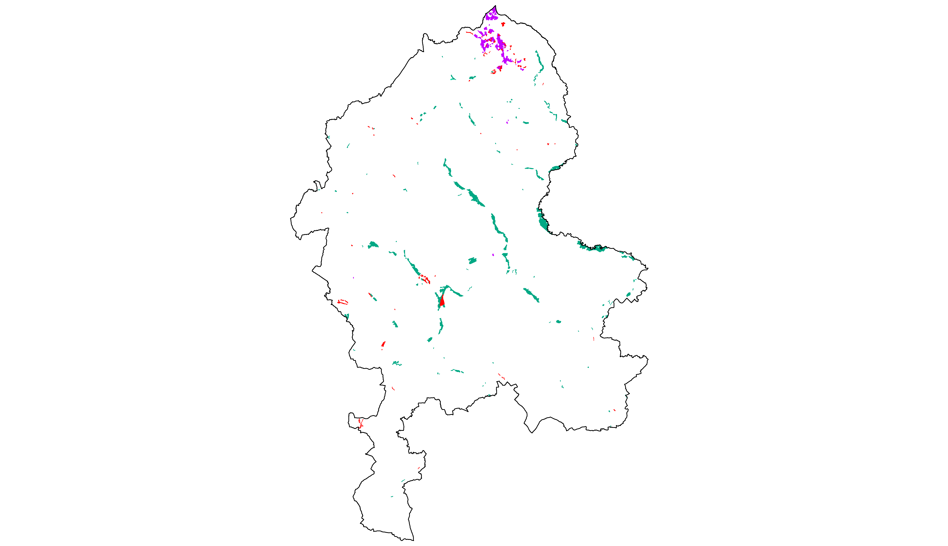

*Source:* ***Based on GIS data provided by Staffordshire Ecological Record, Staffordshire County Council and Stoke on Trent City Council.***

The Brander et al. (2008) value transfer function allows taking different socio-economic variables and context-specific attributes into account. Table A.1 below outlines how the Brander et al. (2008) benefit transfer function has been applied. The underlying assumptions and variables are also explained in the comments section of this table.

Table A.1 Value Function and Corresponding Assumptions

|  |  |  |  |
| --- | --- | --- | --- |
| **Variable** | **Coefficient value** | **Value of explanatory variable** | **Comment** |
| **Constant a** | -3.078 | 1 |  |
| **Wetland type:**  **Inland marsh** | 0.114 | 1 | The function has also been applied for peatbog habitats. The assumptions were similar to the ones outlined below. |
| **Wetland size:** | -0.297 | *ln* 8.0 | Average size of wetland sites |
| **Flood risk reduction and storm buffering:** | 1.102 | 1 | These services are occurring independently from accessibility of the site. |
| **Water quality improvement:** | 0.893 | 1 |
| **Surface and ground water supply:** | 0.009 | 1 |
| **Biodiversity:** | 0.917 | 0/1 | These services only occur if the wetland site is accessible. Therefore the variable has only been applied for accessible sites. Note that recreational fishing has a negative influence on the total value. |
| **Recreational fishing:** | -0.288 | 0/1 |
| **Non-consumptive recreation:** | 0.340 | 0/1 |
| **Amenity and aesthetic services:** | 0.452 | 0/1 |
| **GDP per capita**  **(2003 US$):** | 0.468 | *ln* 24,028 | GDP is approximated from the Shropshire and Staffordshire level with €21,000 (in 2003, real prices, NUTS 2 level, source: EuroStat). Converted to 2003 US$ using OECD purchasing power parity (PPP) exchange rates (factor 0.87) this results in US$24,028. |
| **Population density per km2 within 50 km:** | 0.579 | *ln* 431 | Simplifying the population density of 431/km2 for the West Midlands region (12998 km2) has been applied. |
| **Wetland area within 50 km:** | -0.023 | *ln* 3,000 | Considering the marginal influence on the result it has conservatively been allowed a generous wetland area of 3,000 ha within 50 km radius of each wetland site. |

*Source:* ***Brander et al (2008) and author assumptions/calculations (see also comments within the table).***

Applying the value function for inland marsh and for peat bog, the annual value of the ecosystem services of flood regulation, water supply, water quality regulation as well as recreation, aesthetic appreciation and biodiversity provided by wetland in Staffordshire can be valued at £2.87 million annually. Note that additional ecosystem services provided by wetland in Staffordshire have been calculated applying a different methodology. This includes the services wild food, non-food products as well as wild species diversity.

Note also that this is the totalised marginal value rather than the totalised average value. The marginal value describes a marginal loss (extent) of the total area of habitat. For the purposes of this study, ecosystem services are valued assuming a 10% loss of wetland which yields a total annual value of £287.000. If we assume a 100% loss of wetlands in Staffordshire, the total average annual value of ecosystem services provided by wetland would equal the much higher figure of £8.42 million, though there is no realistic policy scenario where all wetland in Staffordshire would be destroyed (see also Section 1.2).

In the next step, the value attributable to each ecosystem service can be approximated. This step is not necessary but has been chosen to maintain consistency within this study. By setting every variable standing for an ecosystem service to equal zero and viewing the difference in the sum, an estimate can be made of the attributable value for each ecosystem service.[255]

For the sensitivity analysis, uncertainties regarding the estimations taken, as well as the scientific evidence, have been considered. For the ecosystem services of fresh water supply, water quality regulation, recreation, aesthetic appreciation and biodiversity, a range of 30 per cent has been applied. As mentioned previously in Section 4.3, uncertainties for flood regulation are generally higher because they are more context-specific. Taking this circumstance into account, a range of 50 per cent has been applied for this ecosystem service. The findings have not been outlined in this appendix, but in the referring Sections of the main report.

## Calculation of Benefits Provided by Habitats of Principal Importance

To calculate ecosystem services provided by habitats of principal importance (formerly ‘BAP priority habitats’) the findings of the study *“The Economic Valuation of the Ecosystem Service Benefits delivered by the UK Biodiversity Action Plan”*[256] have been recalculated for the purpose of this investigation. It should be noted that the list of habitats of principal importance has been revised after that study has been undertaken and therefore not all actual habitats of principal importance were included. On the other hand improved grassland and arable fields which are not classified as habitats of principal importance have been covered.

The aim of that primary valuation study was to estimate the value of changes in biodiversity and associated ecosystem services which result directly from the delivery of the UK Biodiversity Action Plan (UK BAP). Specific objectives were to assess the marginal value of ecosystem services per habitat associated with the UK BAP and the marginal value of conservation activities associated with different scenarios.

The values for that investigation have been calculated in two steps. The first step entailed a choice experiment to determine the values people place on ecosystem services delivered by UK BAP habitats. Choice experiments are surveys that present people with different policy scenarios, where scenarios are described in terms of different environmental characteristics and different ‘prices’. Analysis of people’s choices for these scenarios reveals values associated with the different preferences or choices.

The second step entailed a weighting matrix evaluating the proportion of ecosystem service provision related to habitat and ecosystem service (group). Experts were asked to identify the relative levels of ecosystems services delivered by the habitats with which they were most familiar across 19 broad UK BAP habitats. These results were then pooled. Experts were also asked to identify the proportion of ecosystem service values that were directly attributed to UK BAP conservation activities. The primary outcome was the marginal change of ecosystem services provided by different UK BAP priority habitats in relation to different scenarios. [257]

Although the data warrants some caveats, it has been judged sufficiently robust to inform this investigation. The study results have been applied in cases where no other robust primary valuation data were available. For the purpose of this investigation, the marginal change of ecosystem services related to land use changes was crucial. Therefore the values for a marginal change in conservation activities needed to be recalculated. Fortunately the available data allowed this step. Below we outline the calculation using the example of wild food provided by native woodland. The following paragraphs should be read in line with Christie et al. 2011.[258]

In the first step, marginal change from scenario D (UK with BAP, but no further spending) to scenario A (full delivery of the UK BAP) has been calculated by adding the values from table C30 and C31.[259] Below an example for the aggregate value of ‘wild food’ benefits provided by native woodland has been outlined to clarify the calculation.

£8.33m + £9.77m = £18.10m

In the second step, the non-marginal WTP associated with scenario D has been calculated. The marginal value from above has been divided by the weighting score (Table C26) for ‘additional service due to BAP’ and then multiply by the ‘services without BAP’.

£18.10m / 0.063 * 0.318 = £91.36m

Following that the average value of the current level of ecosystem services provided by UK BAP priority habitats has been calculated by adding up the WTP associated with scenario D and the marginal value for the current spent scenario (change from scenario D to C; Table C31).

£91.36m + £9.77m = £101.13m

In a last step the average value per hectare could have been calculated by dividing the total value by area of habitat from Table C56.

£101.13m / 1,059,180 = £95.48

This value reflects the annual value per hectare of ecosystem services provision - in this example ‘wild food’ provided by native woodland.

The values for ecosystem services provided by habitats in Staffordshire have been derived from UK-wide values rather than the values derived specifically for the West Midlands Region. Crucial for this decision was the bigger sample size for the choice experiment as well as the higher degree of accuracy of habitat data used in the main study. However, just applying average per-hectare values is not always the best solution. Therefore additional assumptions have been made for each ecosystem service. These assumptions are summarised below. The calculations have been outlined below but the detailed findings including sensitivity analysis and capitalised values are outlined in the main Sections of this report.

**Wild food**

In Christie et al. (2011), ‘wild food’ is defined as *“non-rare food products that people might gather / hunt from nature”*.[260] Agricultural food production on farms is not included. The ecosystem service ‘wild food’ mainly refers to the non-commercial use of food. Also included within this ecosystem service is a sense of wellbeing whilst gathering food from nature. This ecosystem service is not restricted to the value of the product; but also to the value of the process of gathering or hunting.

A direct link between the area of habitat and wild food provision has been assumed in the original study. For this Ecosystem Assessment only the WTP per ha ‘within own region’ has been applied for the best guess estimate. It is arguable that most wild food products provided by habitats in Staffordshire are extracted by residents within the West Midlands region rather than outside. This assumption is in line with the general purpose of providing a conservative estimate. The total WTP (within and outside own region) has been applied for the high threshold of the sensitivity analysis. The calculation for different habitats is summarised in Table A2 below.

Table A.2 Wild Food benefits provided by UK BAP priority habitats

|  |  |  |  |
| --- | --- | --- | --- |
|  | **Native Woodland**  (scrub, broadleaved & mixed woodland) | **Heathland**  (lowland & upland) | **Grassland**  (lowland meadows, lowland dry acid grassland & upland calcareous grassland) |
| Area of Habitat | 16,374 ha | 2,047 ha | 502 ha |
| *Annual WTP per ha (2009 prices)* | *£50.20* | *£2.74-£8.92* | *£0.35-£13.89* |
| Annual WTP per ha (2012 prices) | £55.73 | £3.04-£9.90 | £0.39-£15.42 |
| Annual value (BG) | **£912,449** | **£13,537** | **£6,072** |
|  | **Wetland**  (floodplain grazing marsh, purple moor-grass & rush pasture, fen, reedbeds & blanket bog) | **Hedgerows** | **Arable**  (arable fields) |
| Area of Habitat | 3,290 ha | 364 ha | 56,716 ha |
| *Annual WTP per ha (2009 prices)* | *£10.03-£68.93* | *£87.25* | *£7.07* |
| Annual WTP per ha (2012 prices) | £11.14-£76.52 | £96.86 | £7.85 |
| Annual value (BG) | **£56,436** | **£35,222** | **£445,271** |

*Source:* ***Author calculations based on Christie et al. 2011***

**Non-food products**

This category covers natural products such as timber for firewood as well as plants, fibre cones shells, stones etc. for artistic and educational purposes as well as for ornamental purposes. The commercial use of fibre or timber is not covered by this ecosystem service category.

As for wild food a direct link between the area of habitat and the provision of non-food products has been assumed in the original study. We applied the same methodology as for wild food. For this Ecosystem Assessment only the WTP per ha ‘within own region’ has been applied for the best guess estimate. The total WTP (within and outside own region) has been applied for the high threshold of the sensitivity analysis. The calculation for different habitats is summarised in Table A3.

Table A.3 Non-Food benefits provided by UK BAP priority habitats

|  |  |  |  |
| --- | --- | --- | --- |
|  | **Native Woodland**  (scrub, broadleaved & mixed woodland) | **Heathland**  (lowland & upland) | **Grassland**  (lowland meadows, lowland calcareous grassland & lowland dry acid grassland) |
| Area of Habitat | 16,374 ha | 2,047 ha | 488 ha |
| *Annual WTP per ha (2009 prices)* | *£59.76* | *£6.63-£7.04* | *£0.55-£21.85* |
| Annual WTP per ha (2012 prices) | £66.34 | £7.36-£7.81 | £0.61-£24.25 |
| Annual value (BG) | **£1,086,295** | **£15,505** | **£9,539** |
|  | **Wetland**  (purple moor-grass & rush pasture, fen, reedbeds & blanket bog) | **Hedgerows** |  |
| Area of Habitat | 857 ha | 364 ha |  |
| *Annual WTP per ha (2009 prices)* | *£3.93-£41.54* | *£34.97* |
| Annual WTP per ha (2012 prices) | £4.36-£46.12 | £38.82 |
| Annual value (BG) | **£6,083** | **£14,116** |  |

*Source:* ***Author calculations based on Christie et al. 2011***

**Climate regulation**

The Findings provided by Christie et al. 2011 to calculate climate regulation benefits provided by UK BAP priority habitats have not been applied within scope of this study. See Section 4.1 for more information.

**Water regulation (flood regulation)**

Within the Christie et al. (2011) study ‘water regulation’ stands for the ecosystem service ‘flood regulation’ as defined in this investigation (see Section 4.3). Impacts on water quality or water provision are not covered within this category.[261] We have explained this effect in Section A for wetland habitats. However, apart from wetlands other habitats contribute to flood risk reduction as well. We assume that the contribution of UK BAP habitats to flood regulation is directly related to the area of habitat.

To calculate the flood regulation benefits provided by UK BAP priority habitats the WTP estimate per ha (Table A2) has been adjusted to 2011 prices and then multiplied by the area of habitat. For the sensitivity analysis a range of 70% has been applied.

Table A.4 Water regulation (flood regulation) provided by UK BAP priority habitats

|  |  |  |  |
| --- | --- | --- | --- |
|  | **Native Woodland**  (scrub, broadleaved & mixed woodland) | **Heathland**  (lowland & upland) | **Grassland**  (improved grassland, lowland meadows & lowland dry acid grassland) |
| Area of Habitat | 16,374 ha | 2,047 ha | 18,621 ha |
| *Annual WTP per ha (2009 prices)* | *£461.18* | *£254.56-£309.56* | *£0.00-£202.86* |
| Annual WTP per ha (2012 prices) | £511.96 | £282.59-£343.65 | £0.00-£225.20 |
| Annual value (BG) | **£8,382,668** | **£643,572** | **£4,157,723** |
|  | **Wetland** | **Hedgerows** |  |
| Area of Habitat | *Has been calculated seperately in Section A* | 364 ha |  |
| *Annual WTP per ha (2009 prices)* | *£170.27* |
| Annual WTP per ha (2012 prices) | £189.02 |
| Annual value (BG) |  | **£68,736** |  |

*Source:* ***Author calculations based on Christie et al. 2011***

**Sense of place (cultural services)**

In the Christie et al. 2011 the category ‘sense of place’ captures all cultural services such as aesthetic, spiritual, educational and recreational benefits. We assume that in Staffordshire the same proportion of habitat in favourable condition applies as in the UK average. Therefore no further adjustments regarding quality are necessary.

Here assuming a direct relation between area of habitat and value would result in an undervaluation because especially cultural values are strongly related to the number of people who can locally benefit from such services.[262] To take this factor into account the average value per hectare has been adjusted by population density. In absence of alternatives the average value per hectare has been divided by the average population density per km2 in the UK (256/km2) and then multiplied by the average population density in Staffordshire (405/km2). This approach can be judged as sufficient robust proxy. However, this approach has only been applied for the value ‘within own region’. For the WTP stated for ‘outside own region’ it can be estimated that this value is more related to non-use values and therefore not related to population density. Therefore the average value per hectare has been applied for the latter.[263] Because the degree of accuracy of assumptions made is comparatively low a range of 70% has been applied for the sensitivity analysis.

Table A.5 Cultural services provided by UK BAP priority habitats

|  |  |  |  |
| --- | --- | --- | --- |
|  | **Native Woodland** | **Heathland**  (lowland & upland) | **Grassland**  (improved grassland, lowland meadows and up- & lowland calcareous grassland) |
| Area of Habitat | *Has been calculated seperately in Chapter 3* | 2,047 ha | 18,541 ha |
| *Annual WTP per ha (2009 prices)* | *£116.37-£124.06* | *£138.24-£233.90* |
| Annual WTP per ha (2012 prices) | £129.18-£137.72 | £153.46-£259.66 |
| Annual value (BG) |  | **£695,440** | **£2,886,801** |
|  | **Wetland** | **Hedgerows** |  |
| Area of Habitat | *Has been calculated seperately in Section A* | 364 ha |  |
| *Annual WTP per ha (2009 prices)* | *£451.31* |
| Annual WTP per ha (2012 prices) | £501.01 |
| Annual value (BG) |  | **£182,188** |  |

*Source:* ***Author calculations based on Christie et al. 2011***

**Charismatic and non-charismatic species (wild species diversity)**

Christie et al. 2011 made a distinction between ‘charismatic species’ and ‘non-charismatic species’. The former include terrestrial mammals, birds, amphibians, reptiles, butterflies, and moths. The latter incorporates vascular plants, non-vascular plants, terrestrial invertebrates (excluding butterflies and moths), and fungi (including lichens).[264] Not surprisingly the average WTP for charismatic species is significant higher than for non-charismatic species.

To keep consistency within this investigation the two categories have been combined as ‘wild species diversity’. In absence of alternatives the assumption has been made that this ecosystem service directly relates to the area of habitat. Table A6 summarises the calculation.

Table A.6 Wild species diversity benefits provided by UK BAP priority habitats

|  |  |  |  |
| --- | --- | --- | --- |
|  | **Native Woodland** | **Heathland**  (lowland & upland) | **Grassland**  (improved grassland, lowland meadows, lowland dry acid grassland and up- & lowland calcareous grassland) |
| Area of Habitat | *Has been calculated seperately in Chapter* 3 | 2,047 ha | 18,638 ha |
| *Annual WTP per ha (2009 prices)* | *£375.25-£567.60* | *£27.90-£431.99* |
| Annual WTP per ha (2012 prices) | £416.57-£630.10 | £30.97-£479.56 |
| Annual value (BG) |  | **£1,080,431** | **£3,285,866** |
|  | **Wetland**  (floodplain grazing marsh, purple moor-grass & rush pasture, fen, reedbeds & blanket bog) | **Hedgerows** | **Arable**  (arable fields) |
| Area of Habitat | 3,290 ha | 364 ha | 56,716 ha |
| *Annual WTP per ha (2009 prices)* | *£296.43-£467.63* | *£418.49* | *£18.70* |
| Annual WTP per ha (2012 prices) | £329.07-£519.12 | £464.56 | £20.76 |
| Annual value (BG) | **£1,620,943** | **£168,936** | **£1,177,221** |

*Source:* ***Author calculations based on Christie et al. 2011***

All findings have also been outlined in the referring Chapters of the main body of the report as well as in the summary tables in Section 8.1. These tables also include the sensitivity analysis and the capitalised values.

## Steering & Advisory Group

The report to hand and the investigation as a whole has been supported by a Steering Group and an Advisory Group. The authors would like to take this opportunity to thank all members for their valuable contributions to this project. The members of the groups are outlined below (in alphabetic order).

**Steering Group Members**

* Ali Glaisher (Principal Ecologist, Staffordshire County Council)
* Dr Sue Lawley (Head of Living Landscapes, Staffordshire Wildlife Trust)
* Bernadette Noake (Biodiversity Coordinator, Staffordshire Biodiversity Partnership)
* Suzanne Wykes (Ecologist/Environment Officer, Stoke-on-Trent City Council)

**Advisory Group Members**

* Julia Banbury (Principal Landscape Officer, Staffordshire County Council)
* Alan Carr (Climate Change Officer, Staffordshire County Council)
* James Cartwright (Biomass & Woodfuel Supply Manager, Staffordshire County Council)
* Helen Dale (Head of People and Place, Staffordshire Wildlife Trust)
* Shona Frost (Spatial Information Team Manager/ Corporate GIS Officer Staffordshire County Council)
* Noreen Moore (Rural Access Manager, Staffordshire County Council)
* Craig Slawson (Staffordshire Ecological Record)
* Pete Wells (Newcastle Countryside Project, Staffordshire County Council & Newcastle City Council)
* Simon West (Partnership and Expertise Manager, Forestry Commission)
* Stephanie Wickison (Principal Forestry Officer, Staffordshire County Council)
* Paul Wilkinson (Ecologist, Canals & Rivers Trust)
* Ian Wykes (Commissioner for the Rural County, Staffordshire County Council)

1. UK NEA 2011a.
2. <http://uknea.unep-wcmc.org/NEWFollowonPhase/tabid/123/Default.aspx>
3. See Smith et al. 2013.
4. UK NEA 2011b.
5. RSPB et al. 2013.
6. Flanders and Lawley 2012.
7. Within scope of this report we use the definition of Ecosystem Approach as defined by the 12 principles of the Convention on Biological Diversity (BCD). See <http://www.cbd.int/ecosystem/principles.shtml>
8. Millennium Ecosystem Assessment 2005.
9. The term ‘Staffordshire’ throughout this report generally encompasses the study area of Staffordshire and Stoke-on-Trent except where explicitly stated .
10. The guidance is due to be published in 2014. For transparency reasons it should be noted that the principal investigator of this report is also the main contributor to the Ecosystem Assessment Guidance produced as part of the NEAFO.
11. No bespoke surveys were carried out under this research project.
12. HM Government 2011.
13. UK NEA 2011b.
14. Millennium Ecosystem Assessment 2005.
15. TEEB 2010.
16. EEA 2011.
17. Defra 2007, 2.
18. The term ‘ecosystem service’ it not used entirely consistent within literature. We use the term consistent to the ‘final ecosystem service’ in the framework of the UK National Ecosystem Assessment (UK NEA 2011b. Within this publication the term ‘ecosystem service’ has been used because of simplification and because it is more commonly used.
19. Millennium Ecosystem Assessment 2005.
20. Boyd and Banzhaf 2007.
21. It should be stressed, however, that such operating figures are usually based on more or less robust assumptions as well and therefore not certain. Presenting monetary figures often suggests a higher degree of certainty which is a misjudgement. Therefore it is important to review corresponding assumptions as well to make a deliberate judgement. This applies for marketable goods and services as does it for non-marketable ecosystem services.
22. When referring to ‘(ecosystem) services’ we include ‘goods’ as well within this publication.
23. Costanza et al. 1997, 269.
24. Ignoring that optimising human welfare is not always the main incentive for decision makers and bureaucrats (Hölzinger 2010.)
25. HM Treasury 2003, 57.
26. As far as the authors are aware.
27. Staffordshire County Council 2000. (Update in progress 2013).
28. SBAP 2011.
29. Staffordshire County Council 2000.
30. Ibid., 8.
31. DCLG 2012.
32. UK NEA 2011b, 1072.
33. This effect is not implemented in the sensitivity analysis. Therefore the real value of ecosystem services may even exceed the upper treshold of the sensitivity analysis.
34. Sometimes also referred as ‘value transfer approach’.
35. Defra 2007, 38.
36. Defra 2007.
37. See also UK NEA 2011b, 1076.
38. The loss of one greenspace might be substituted for by traveling to another greenspace.
39. The distance decay describes the effect of distance on cultural and/or spatial interactions. Usually one would for example prefer an accessible greenspace site on the doorstep rather than 20 miles away. This has an effect on the value of the ecosystem services such sites provide.
40. Assuming that type, quality and extent of greenspace are equal.
41. The first 10% decline reduces human wellbeing less than the second 10% (from -10% to -20%).
42. The interviewees may like to make out that they value an ecosystem service more than they actually do
43. If not stated otherwise values are always stated as ‘best guess’.
44. EFTEC 2010, 35.
45. Defra 2007, 12.
46. You might never be able to see a whale in nature, but you can nevertheless benefit from the pure existence of whales.
47. You might never see a whale in nature, but you can benefit from the ability to see whales in the future.
48. You might never see a whale in nature, but you can benefit from the ability of future generations to see whales in the future.
49. UK NEA 2011b, 1185.
50. Due to be published in 2014.
51. See for example HM Treasury 2003.
52. See also German Federal Environment Agency 2008.
53. HM Treasury 2003, 97.
54. Ibid., 26.
55. German Federal Environment Agency 2008, 30.
56. HM Treasury 2003, 26.
57. For a more extensive discussion of the discount rate recommended by HM Treasury; other discount rates and criticisms of the HM Treasury discount rate see for example Stern 2006, 48; Perino et al. 2011, 22.
58. Statistics were provided by Stoke-on-Trent City Council.
59. SBAP 2011.
60. The total habitat area is still incomplete and does not include for example private gardens.
61. Defra 2010.
62. Firbank et al. 2011, 198.
63. Defra 2010.
64. Defra 2012.
65. Defra et al. 2013.
66. Personal comment, Allan Howsam, Defra, 07/06/2013.
67. Defra et al. 2013.
68. Firbank et al. 2011, 198.
69. Edwards-Jones et al. 2011, 606.
70. Defra 2010.
71. Edwards-Jones et al. 2011, 606.
72. Ibid., 616.
73. Ibid., 617.
74. Ekosgen and Lockhart Garratt 2009, 2.
75. Ibid., 47–48.
76. Personal comment, Simon West, Forestry Commission.
77. Ekosgen and Lockhart Garratt 2009, 31.
78. Ibid., 32.
79. Based on statistics provided by the Forestry Commission (Gordon Wyatt) and personal comments provided by Simon West, Forestry Commission.
80. Personal comment, James Cartwright, Staffordshire County Council
81. Edwards-Jones et al. 2011, 616.
82. Forestry Commission 2007.
83. per 100 ha of total estate area in the UK from 1961 to 2005
84. Edwards-Jones et al. 2011, 612–614.
85. Christie et al. 2011.
86. Ibid., 121.
87. The commercial production of flowers is not included in this section.
88. Edwards-Jones et al. 2011, 621.
89. Ibid.
90. UK NEA 2011b, 1088.
91. Ibid., 1089.
92. Church et al. 2011, 657.
93. See e.g. UK NEA 2011b.
94. Coombes, Jones, and Hillsdon 2010.
95. Scarpa 2003, 16.
96. An open-ended questionnaire has been used and protest bids have been excluded.
97. Scarpa 2003, 16.
98. See Appendix I.A for calculations
99. Church et al. 2011.
100. See e.g. Saraev 2012 for an overview.
101. Forest Research 2010, 19.
102. Luther and Gruehn 2001, 23.
103. Mell et al. 2012, 5.
104. Ulrich and Simons 1986.
105. Ulrich 1984.
106. Forest Research 2010, 22.
107. Garrod 2002, 2.
108. Edwards et al. 2009.
109. Garrod 2002, 20.
110. Ibid., 12.
111. The authors like to thank Shona Frost, Spatial Information Team Manager, Staffordshire County Council, for undertaking this analysis.
112. Forest Research 2010.
113. Garrod 2002, 9 & 13.
114. CABE Space 2009, 37 & 40.
115. Church et al. 2011, 672.
116. Ibid., 673.
117. Heelas et al. 2005.
118. Millennium Ecosystem Assessment 2005, 9.
119. Ibid., 120.
120. Cooper 2009, 2.
121. <http://www.38degrees.org.uk/page/s/save-our-forests#petition>
122. World Health Organization 1948.
123. Church et al. 2011, 662.
124. Coombes, Jones, and Hillsdon 2010.
125. pers comm., Mallika Ishwaran, Defra, 2011, cited in UK NEA 2011b, 1104.
126. van den Berg, Koole, and van der Wulp 2003.
127. UK NEA 2011b, 1154.
128. Ho et al. 2003.
129. Vries et al. 2003.; Grahn and Stigsdotter 2003.; Takano, Nakamura, and Watanabe 2002.
130. Kuppuswamy 2009, 64.
131. APHO 2010, 1.
132. At least 4 sessions of at least moderate intensity for at least 30 minutes in the previous 28 days
133. Sport England 2012.
134. North Staffordshire PCT, South Staffordshire PCT and Stoke-on-Trent PCT. Based upon 2006/2007 figures.
135. Department of Health 2009.
136. Department of Health 2009.
137. Lovasi et al. 2008, 647.
138. Tiwary et al. 2009.
139. Kaplan 1995.
140. Ulrich and Simons 1986.
141. Mourato et al. 2010, 71.
142. Ulrich 1984.
143. Saraev 2012.
144. Staffordshire County Council 2007.
145. Church et al. 2011, 663.
146. CJC Consulting, Willis, and Osman 2005, 22.
147. See also Mourato et al. 2010.
148. UK NEA 2011b, 1105.
149. See also Saraev 2012.
150. Mourato et al. 2010, 31.
151. Ibid.
152. Ibid., 34.
153. Ibid., 30.
154. Staffordshire County Council 2010, 12–13.
155. UK NEA 2011a, 34.
156. Land Use Consultants 2002.
157. ERM and Willis 2004, 26.
158. UK NEA 2011a.
159. This does not necessarily reflect the welfare benefits but can be estimated to reflect a baseline of that.
160. This includes transport, time costs as well as entrance fees.
161. Mourato et al. 2010, 42.
162. Rskensr 2003.
163. Wolf 2003, 124.
164. Regeneris 2009, 24.
165. Heerwagen and Orians 1986, 623.
166. Staffordshire County Council 2010, 12.
167. Norris et al. 2011, 64.
168. Ibid.
169. Ibid., 65.
170. UK NEA 2011b, 1186.
171. Norris et al. 2011, 68.
172. TEEB 2010; UK NEA 2011a.
173. UK NEA 2011b, 1186.
174. You might never see a whale in nature, but you can benefit from the ability to see whales in the future.
175. You might never see a whale in nature, but you can benefit from the ability of coming generations to see whales in the future.
176. Hanley et al. 2002.
177. Willis et al. 2003, 15.
178. Willis et al. 2003.
179. Hanley et al. 2002, 18.
180. Brander et al. 2008, 18.
181. Saraev 2012, 25.
182. Including a small amount of Scrub.
183. In Hanley et al. (2002) the category ‘lowland conifer forest’ also covers ‘mixed conifer and broadleaved forest’. Therefore the same WTP as for conifer forest has been applied for mixed woodland as well.
184. See also Saraev 2012.
185. McInnes 2007, 8.
186. IPCC 2007, 36.
187. Ibid., 50.
188. Read et al. 2009, xii.
189. Ibid., ix.
190. Ibid., 7.
191. Forestry Commission 2008.
192. DECC 2009.
193. Broadmeadow and Matthews 2003, 3.
194. http://www.itreetools.org/
195. Including wetland soils down to 1 metre.
196. Gorte 2009, 5.
197. EFTEC 2007, 12.
198. Whiting and Chanton 2001, 521; O’Gorman and Bann 2008, 61.
199. Natural England 2008, 9.
200. IPCC 2007, 37.
201. Defra et al. 2013, 73.
202. Forest Research 2010, 86.
203. Gill et al. 2007, 122.
204. Tomlinson 2009, 180.
205. Forest Research 2010, 87.
206. Tomlinson et al. 2011.
207. Kuppuswamy 2009, 66.
208. Wang et al. 8.
209. Beckett, Freer-Smith, and Taylor 1998.
210. Forest Research 2010, 90.
211. Smith et al. 2011, 546.
212. Ibid., 547.
213. European Commission 2012, 22.
214. Pitt 2007, 64.
215. Evans et al. 2004.
216. UK NEA 2011b, 1069.
217. Birol et al. 2007.
218. Brander et al. 2008, 33.
219. Land Use Consultants and GHK Consulting 2009, 132.
220. Pitt 2007, 32.
221. Kazmierczak and Carter 2010.
222. Defra 2005.
223. Saraev 2012, 23.
224. Maltby et al. 2011, 312.
225. EFTEC 2010, 12.
226. Maltby et al. 2011, 333.
227. Ibid., 297.
228. Ibid., 312.
229. Perrot-Maître and Patsy 2001; Elliman and Berry 2007.
230. van Oudenhoven et al. 2012, 115.
231. McPherson, Nowak, and Rowan 1994, 63.
232. Lovasi et al. 2008, 647.
233. Donovan 2003, 233.
234. van Oudenhoven et al. 2012, 115.
235. Pugh et al. 2012, 7692.
236. Buccolieri et al. 2009.
237. Woodland Trust 2012, 2.
238. 87 households within a 50m buffer and 152 households within a 100m buffer have been counted.
239. 72 households within a 50m buffer and 85 households within a 100m buffer have been counted.
240. This figure is based on the total annual costs for Staffordshire Wildlife Trust Reserves, divided by the total area of SWT Reserves (1,721 ha) and then multiplied by the area of Staffordshire Wildlife Trust Reserves assessed in monetary terms (1,050 ha).
241. 62 households within a 50m buffer and 110 households within a 100m buffer have been counted.
242. DCLG 2012.
243. http://uknea.unep-wcmc.org/NEWFollowonPhase/tabid/123/Default.aspx
244. Peper et al. 2007.
245. Forestry Commission 2010.
246. OECD 2010.
247. Schomers and Matzdorf 2013.
248. Everard and McInnes 2013.
249. Natural England 2010, 6.
250. UK NEA 2011b; Millennium Ecosystem Assessment 2005.
251. HM Government 2011; UK NEA 2011b; DCLG 2012; Smith et al. 2013.
252. Hulme and Siriwardena 2010, 7.
253. EFTEC 2010, 125.
254. Brander et al. 2008, 33.
255. The negative influence of recreational fishing has been distributed equally to recreation+amenity and biodiversity.
256. Christie et al. 2011.
257. Ibid., 11.
258. Christie et al. 2011.
259. Tables with the ‘C’ refer to tables in Christie et al. (2011)
260. Christie et al. 2011, 121.
261. Ibid., 126.
262. See also Church et al. 2011.
263. Because of data availability issues for ‘UK BAP priority grassland’ only Lowland Meadows have been taken into account. However, this category covers more than 90% of the UK BAP priority grasslands.
264. Christie et al. 2011, 131.